Data Update for Eastern Georges Bank Cod in 2019
M. Barrett¹, C.M. Legault², F. Irvine¹, I. Andrushchenko¹
¹Fisheries and Oceans Canada
125 Marine Science Drive
St. Andrews, New Brunswick E5B 0E4
Canada
²NOAA/NMFS Northeast Fisheries Science Center
166 Water Street
Woods Hole, Massachusetts 02543
USA

Table of Contents
ABSTRACT iv
INTRODUCTION 1
COMMERCIAL FISHERY INDICATORS 1
SIZE AND AGE COMPOSITION 2
RESEARCH SURVEYS 2
SURVEY CATCH AT AGE AND AT LENGTH 2
SWEPT AREA SURVEY BIOMASS 3
CONDITION FACTOR 3
TOTAL MORTALITY (Z) AND RELATIVE F 3
ACKNOWLEDGEMENTS 4
REFERENCES CITED 4
TABLES 6
FIGURES 22

ABSTRACT
The combined 2018 Canada/USA Atlantic Cod catches were 565 mt with a quota of 951 mt. Three research survey indices were examined: the National Marine Fisheries Service (NMFS) spring and fall surveys and the Fisheries and Oceans, Canada (DFO) spring survey. Two of the three research survey biomass indices increased from last year, but all three remain below their time series average. Condition factor is at or above the long-term mean for two surveys but remains at low levels for the other survey. Large Cod continue to be missing from both fishery and survey catch compared to historical distributions. Relative fishing mortality continues to be low while survey total mortality continues to be high recently indicating that something other than reported fishing is driving the increase in total mortality for Eastern Georges Bank Cod.

INTRODUCTION
This document provides an update of biological and fishery indicators for Eastern Georges Bank Cod (Figure 1) with 2018–2019 data, and it is intended to address the following 2019 Transboundary Resources Assessment Committee (TRAC) Terms of Reference (ToR):
- Update the following biological and fishery indicators of the state of Cod in the Eastern GB management area with 2018–2019 data: condition factor, swept area survey biomass indices, fishery and survey catch at length, relative F, total mortality (Z), and catch.
- Identify and comment on changes in survey and fishery indicators (relative to the 2018 TRAC).
The third term of reference:
- Investigate alternative methodologies of providing catch advice, and report on the most promising approaches. Describe plans for further investigation of the identified approach, which will be reviewed at the 2020 TRAC and will then provide catch advice until a benchmark assessment can be completed for this resource.
is addressed separately in TRAC document TRACRD2019/02, “Alternative Methodologies for Providing Interim Catch Advice for Eastern Georges Bank Cod” (Andrushchenko et al. 2019).

COMMERCIAL FISHERY INDICATORS
Combined Canada/USA catches averaged 17,200 mt between 1978 and 1993, peaked at 26,463 mt in 1982, and then declined to 1,683 mt in 1995. Catch values fluctuated around 3,000 mt until 2004 and subsequently declined again. Combined catches were 565 mt in 2018, and this included 9 mt of discards (Table 1; Figure 2). This combined catch was 59% of the 951 mt 2018 quota.
In 2018, the total Canadian catch was 517 mt and amounted to 74% of the 694 mt quota (Table 1; Figure 2). The landings occurred primarily during the third and fourth quarter, using longline (41%), otter trawl (33%), gillnet (25%), and handline (<1%) gears (Figure 3; Figure 4). All 2018 landings were subject to dockside monitoring.
Discarding of Cod from the Canadian groundfish fishery on Eastern Georges Bank (EGB) is not permitted, but estimates of discards are routinely calculated using the observed ratio of Cod to Haddock catch (Van Eeckhaute and Gavaris 2004; Hunt et al. 2005; Gavaris et al. 2006, 2007a; Clark et al. 2008). In 2018, discards of Cod from the groundfish fishery were estimated as 2 mt (Table 1). Since 2005, the discards of Cod from the scallop fishery have been estimated following the method outlined in Gavaris et al. (2007b) and were calculated as 5 mt in 2018 (Table 1; Figure 5).
Total USA catch (landings and discards combined) was 48 mt for 2018 (Table 1; Figure 2). The majority of USA landings were taken in the second and third quarters (40% in each) with otter trawl gear accounting for 97% of the 2018 landings and handline accounting for the remaining 3% (Figure 3; Figure 4).
Discard ratios (discard Cod:kept of all species, d:k) in the US fisheries are calculated on a trip basis (Wigley et al. 2008), with total discards (mt) estimated by multiplying discard ratios by total commercial landings. In the 2012 SAW55 Cod benchmark meeting (NEFSC 2013), ‘Delphi’ determined mortality rates (otter trawl: 75%) were applied to the final estimates of USA discards (Table 1). The estimated discards of Cod in the 2018 groundfish fishery were 2 mt in 2018 (Table 1; Figure 5).
The US Eastern Georges Bank Cod quota for fishing year 2018 (1 May 2018 to 30 April 2019 for groundfish) was set at 257 mt. Monitoring of the US catches relative to the quota was based on Vessel Monitoring Systems (VMS) and a call-in system for both landings and discards. Reporting on the Regional Office webpage (NOAA Fisheries Northeast Multispecies (Groundfish) Monitoring Reports) indicates the US groundfish fishery caught 41.4% of its 257 mt quota.

SIZE AND AGE COMPOSITION
Details of the methodology used for the determination of size and age composition of USA and Canadian fishery landings and discards on Eastern Georges Bank are described in Wang et al. (2015). Past comparisons of age readings have indicated generally good agreement between DFO and NMFS age readers
The size and age compositions of the 2018 fishery catches (landings and discards) were derived from the pooled port and at-sea samples from all principal gears and seasons (Table 2). Catches by length for the Canadian fishery peaked at 61 cm (24 in) in 2018, as compared to 58 cm (23 in) in 2017 (Figure 6). Catches for the US fishery peaked at 65 cm (26 in), as compared to 68 cm (28 in) in 2017 (Figure 7).
The 2013 year class at age 5 was the biggest contributor to the combined US and Canada 2018 fishery catch, constituting 37% of the fish by number and 45% by weight (Table 3; Figure 8). The second biggest contributor was the 2014 year class at age 4, with 29% of the numbers and 27% of the weight (Table 3; Figure 8). The prevalence of these year classes in the 2018 catch was expected, based on their persistence in the 2017 fishery catch (Figure 9). The contribution of older fish (ages 7+) to the fishery catch reached a series low in 2014, accounting for <0.2% of the fish caught (Figure 9). In 2018, fish ages 7+ accounted for approximately 5% of the individuals caught in the fishery (Figure 8; Figure 9).

RESEARCH SURVEYS
Surveys of Georges Bank have been conducted by DFO every February/March since 1986, and by NMFS each spring (April–May) since 1968 and fall (October) since 1963. All surveys use a stratified random design (Figure 10; Figure 11) and past changes in vessels and nets are documented in Wang et al. (2015).
The spatial distributions of ages 3 and older Cod caught during the 2018 NMFS fall, 2019 DFO and NMFS spring surveys were consistent with previous years, with most fish concentrated along the northern part of Georges Bank (Figure 12; Figure 13; Figure 14).

SURVEY CATCH AT AGE AND AT LENGTH
The swept area abundance from the DFO survey decreased from 3.5 million fish in 2018 to 2.5 million in 2019, remaining below the series mean of 5.5 million fish (1986–2019) (Table 4). The 2016 year class (age 3) contributed the most to the catch (40% by number), followed by the 2015 year class at age 4 (23%). A low signal existed at age 9, consistent with the 2010 year class exiting the population, but there were few fish older than age 6 in the DFO Spring Survey catch at age; a trend evident in the recent few years (Table 4). Length frequency of the survey catch in the 2019 DFO spring survey peaked at a smaller size of 52 cm (20.5 in) compared to 58 cm in 2018 (23 in), and the recent surveys continue to see fewer large individuals, as compared to the previous ten years (Figure 16).
The NMFS spring survey catch increased from 1.7 million in 2018 to 5.3 million in 2019 but remains below the time series mean (5.6 million fish, 1970–2019) (Table 5). The 2015 year class (age 4) contributed the most to the catch (37%), followed by 2017 (age 2; 22%) and 2016 year classes (age 3; 19%). There were no fish older than age 7 and no evidence of an upcoming large recruitment event (Table 5; Figure 15). Length frequency of the NMFS spring 2019 survey catch peaked at approximately 55 cm (22 inches) in both 2018 and 2019 (Figure 16).
The NMFS fall survey catch increased from 348 thousand fish in 2017 to 1.3 million fish in 2018, remaining below the series mean of 2.2 million (1970–2018) (Table 6). The 2017 year class (age 1) was predominant in the fall survey catch by number (24%) but was closely followed by the 2014 (age 4; 22% by number) and 2015 (age 3; 21% by number) year classes (Table 6; Figure 15). The catch at length from the 2018 NMFS fall survey showed a small peak at 12 cm (5 in), and two more at 34 cm (13 in) and 58 cm (23 in) (Figure 16). Although this is quite different from the 2017 catch, it is consistent with the longer-term mean for the survey (Figure 16).
The Coefficient of Variation (CV) of stratified mean catch number per tow for the three surveys is shown in Figure 17. The catch from all three surveys became more variable after the mid-1990s, which can be caused by patchy distribution of Cod at low abundance. Both the DFO and NMFS fall surveys CVs in the most recent year were consistent with trends observed in the previous five years; however, the NMFS spring survey CVs reached particularly high levels (Figure 17).

SWEPT AREA SURVEY BIOMASS
Survey swept area biomass showed a decrease from the previous year for the DFO spring survey and an increase for the NMFS fall and spring surveys (Table 7; Figure 18). All three surveys are currently below their respective series means (DFO: 1986–2019; NMFS spring: 1970–2019; NMFS fall: 1970–2018) (Table 7; Figure 18).

CONDITION FACTOR
Fulton’s condition factor (K) for all three surveys showed a notable downward trend throughout the series until 2009, when condition either stabilized or began to increase in all three surveys (Figure 19). Cod condition is currently at or above the long-term mean for the NMFS fall and spring surveys, but it continues to remain at low levels for the DFO survey (Figure 19).

TOTAL MORTALITY (Z) AND RELATIVE F
The total mortality (Z) was calculated by two age groups (ages 4–5 and ages 6–8) using DFO survey and NMFS spring survey abundance indices separately, and fitted with a LOESS smooth to help track trends (Error! Reference source not found.). Total mortality on ages 4 and 5 has been lower than the older group since the 1990s in both surveys, but it has begun to converge for the NMFS spring survey in recent years; DFO spring survey continues to show a higher Z on the older ages (Error! Reference source not found.). Total mortality on ages 4–5 remains around 1, as it has been in the past few years (Error! Reference source not found.). The total mortality is based on ages 6–8; however, the absence of age 7 and 8 fish in both 2019 spring surveys makes the calculated total mortality reliant on just age 6 fish, thus the 2018 value is unrepresentative of Z on fish ages 6–8.
Total survey Z was also calculated using the Sinclair (2001) approach for all three surveys, as was suggested for Georges Bank Yellowtail Flounder at the 2016 TRAC (Sinclair 2001; Brooks and Curran 2016). Age groups used in the calculation varied by survey (DFO: ages 6–9; NMFS spring: ages 5–9; NMFS fall: ages 3–6). In general, Z values on older age groups from the DFO and NMFS spring surveys have remained high, except for the most recent NMFS spring values (Figure 20). Total mortality on the younger ages from the NMFS fall survey remains at low values (Figure 20). The increasing occurrence of year and age combinations with no Cod observed in the surveys, particularly for the older ages, is problematic for these simple calculations of survey Z.
In general, total mortality on older age groups has remained high throughout the assessment time period, while relative F (fishery catch at age per survey abundance indices; Figure 21) has declined significantly since the 1990s. The divergent trend between total and relative fishing mortality is indicating that something other than reported fishing is driving the increase in total mortality for Eastern Georges Bank Cod.

ACKNOWLEDGEMENTS
We thank E. MacEachern and B. Hatt of DFO, and N. Shepherd of NMFS for providing ageing information for the DFO and NMFS surveys and Canadian and USA fisheries. We would also like to thank D. Frotten and D. d’Entremont of DFO, and at-sea observers from Javitech Ltd. and Atlantic Catch Data Ltd. for providing samples from the Canadian fishery.

REFERENCES CITED
Andrushchenko, I, C.M. Legault, and M.A. Barrett. 2020. Alternative Methodologies for Providing Interim Advice for Eastern Georges Bank Cod. TRAC Ref. Doc. 2019/02: 27 p.
Brooks, E.N. and K.J. Curran. 2016. Proceedings of the Transboundary Resource Assessment Committee for Eastern Georges Bank Cod and Haddock, and Georges Bank Yellowtail Flounder. TRAC Proceedings 2016/01.
Clark, K., L. O'Brien, Y. Wang, S. Gavaris, and B. Hatt. 2008. Assessment of Eastern Georges Bank Atlantic Cod for 2008. TRAC Ref. Doc. 2008/01: 74p.
Gavaris, S., L. O'Brien, B. Hatt, and K. Clark. 2006. Assessment of Eastern Georges Bank Cod for 2006. TRAC Ref. Doc. 2006/05: 48p.
Gavaris, S., L. Van Eeckhaute, and K. Clark. 2007a. Discards of Cod from the 2006 Canadian groundfish fishery on Eastern Georges Bank. TRAC Ref. Doc. 2007/02: 19p.
Gavaris, S., G. Robert, and L. Van Eeckhaute. 2007b. Discards of Atlantic Cod, Haddock and yellowtail flounder from the 2005 and 2006 Canadian scallop fishery on Georges Bank. TRAC Ref. Doc. 2007/03: 10p.
Hunt, J.J., L. O'Brien, and B. Hatt. 2005. Population Status of Eastern Georges Bank Cod (Unit Areas 5Zj,m) for 1978–2006. TRAC Reference Document 2005/01: 48p.
NEFSC. 2013. 55th Northeast Regional Stock Assessment Workshop (55th SAW) Assessment Report. B. Georges Bank Atlantic Cod (Gadus morhua) Stock Assessment for 2012. Northeast Fish Sci Cent Ref Doc. 13–11: 845 p.
Sinclair, A.F. 2001. Natural mortality of Cod (Gadus morhua) in the Southern Gulf of St. Lawrence. ICES Journal of Marine Science. 58: 1–10.
Van Eeckhaute, L., and S. Gavaris. 2004. Determination of discards of Georges Bank Cod from species composition comparison. TRAC Ref. Doc. 2004/04: 27p.
Wang, Y., L. O’Brien, I. Andrushchenko and K. Clark. 2015. Assessment of Eastern Georges Bank Cod for 2015. TRAC Ref. Doc. 2015/03: 86p.
Wigley, S. E, M.C. Palmer, J. Blaylock, P.J. Rago. 2008 . A brief description of the discard estimation of the national bycatch report. NEFSC Ref. Doc 08–02: 35 p.

TABLES
Table 1. Catches (mt) of Cod from Eastern Georges Bank, 1978 to 2018. Dashes (-) indicate data is not available. A dash (-) indicates no available data.
Year | Canada |  |  |  | USA |  |  | Total
 | Landings | Discards Scallop | Discards Groundfish | Total | Landings | Discards | Total | -
1978 | 8,777 | 98 | - | 8,875 | 5,502 | - | 5,502 | 14,377
1979 | 5,979 | 103 | - | 6,082 | 6,408 | - | 6,408 | 12,490
1980 | 8,066 | 83 | - | 8,149 | 6,418 | - | 6,418 | 14,567
1981 | 8,508 | 98 | - | 8,606 | 8,092 | - | 8,092 | 16,698
1982 | 17,827 | 71 | - | 17,898 | 8,565 | - | 8,565 | 26,463
1983 | 12,131 | 65 | - | 12,196 | 8,572 | - | 8,572 | 20,769
1984 | 5,761 | 68 | - | 5,829 | 10,558 | - | 10,558 | 16,387
1985 | 10,442 | 103 | - | 10,545 | 6,641 | - | 6,641 | 17,186
1986 | 8,504 | 51 | - | 8,555 | 5,696 | - | 5,696 | 14,251
1987 | 11,844 | 76 | - | 11,920 | 4,793 | - | 4,793 | 16,713
1988 | 12,741 | 83 | - | 12,824 | 7,645 | - | 7,645 | 20,470
1989 | 7,895 | 76 | - | 7,971 | 6,182 | 84 | 6,267 | 14,238
1990 | 14,364 | 70 | - | 14,434 | 6,414 | 69 | 6,483 | 20,917
1991 | 13,467 | 65 | - | 13,532 | 6,353 | 112 | 6,464 | 19,997
1992 | 11,667 | 71 | - | 11,738 | 5,080 | 177 | 5,257 | 16,995
1993 | 8,526 | 63 | - | 8,589 | 4,019 | 57 | 4,077 | 12,665
1994 | 5,277 | 63 | - | 5,340 | 998 | 5 | 1,003 | 6,343
1995 | 1,102 | 38 | - | 1,140 | 543 | 0.2 | 544 | 1,683
1996 | 1,924 | 56 | 0.0 | 1,980 | 676 | 1 | 677 | 2,657
1997 | 2,919 | 58 | 428 | 3,405 | 549 | 6 | 555 | 3,960
1998 | 1,907 | 92 | 273 | 2,272 | 679 | 7 | 686 | 2,959
1999 | 1,818 | 85 | 253 | 2,156 | 1,195 | 9 | 1,204 | 3,360
2000 | 1,572 | 69 | 0.0 | 1,641 | 772 | 16 | 788 | 2,429
2001 | 2,143 | 143 | 0.0 | 2,286 | 1,488 | 146 | 1,634 | 3,920
2002 | 1,278 | 94 | 0.0 | 1,372 | 1,688 | 9 | 1,697 | 3,069
2003 | 1,317 | 200 | - | 1,528 | 1,851 | 85 | 1,935 | 3,463
2004 | 1,112 | 145 | - | 1,257 | 1,006 | 57 | 1,063 | 2,321
2005 | 630 | 84 | 144 | 859 | 171 | 199 | 370 | 1,228
2006 | 1,096 | 112 | 237 | 1,445 | 131 | 94 | 226 | 1,671
2007 | 1,108 | 114 | 0.0 | 1,222 | 234 | 279 | 513 | 1,735
2008 | 1,390 | 36 | 103 | 1,529 | 224 | 20 | 244 | 1,774
2009 | 1,003 | 69 | 137 | 1,209 | 433 | 147 | 580 | 1,789
2010 | 748 | 44 | 48 | 840 | 357 | 97 | 454 | 1,294
2011 | 702 | 29 | 13 | 743 | 267 | 20 | 287 | 1,030
2012 | 395 | 42 | 31 | 468 | 96 | 52 | 148 | 616
2013 | 385 | 18 | 21 | 424 | 24 | 16 | 40 | 464
2014 | 430 | 15 | 13 | 458 | 114 | 2 | 116 | 574
2015 | 472 | 13 | 7 | 492 | 111 | 5 | 116 | 608
2016 | 428 | 9 | 3 | 440 | 92 | 5 | 97 | 537
2017 | 474 | 7 | 7 | 488 | 34 | 4 | 38 | 526
2018 | 510 | 5 | 2 | 517 | 47 | 2 | 48 | 565
Min | 385 | 7 | 0 | 424 | 24 | <1 | 38 | 464
Max | 17,827 | 200 | 428 | 17,898 | 10,558 | 279 | 10,558 | 26,463
Ave | 4,845 | 70 | 82 | 4,957 | 2,944 | 60 | 2,988 | 7,945

Table 2. Length and age samples from the USA and Canadian fisheries on Eastern Georges Bank. For Canadian fisheries, at-sea observer samples are included since 1990. The first quarter age samples are supplemented with USA fishery age samples from 5Zjm for 1978–1986 and DFO survey age samples for 1987–2018; the numbers are shown in brackets. The highlighted numbers include samples from western Georges Bank.
Year | USA |  | Canada
Year | Lengths | Ages | Lengths | Ages
1978 | 2,294 | 384 | 7,684 | 1,364
1979 | 2,384 | 402 | 3,103 | 796(205)
1980 | 2,080 | 286 | 2,784 | 728(192)
1981 | 1,498 | 455 | 4,147 | 897
1982 | 4,466 | 778 | 4,705 | 1,126(268)
1983 | 3,906 | 903 | 3,822 | 754(150)
1984 | 3,891 | 1,130 | 1,889 | 1,243(858)
1985 | 2,076 | 597 | 7,031 | 1,309(351)
1986 | 2,145 | 643 | 5,890 | 991(103)
1987 | 1,865 | 524 | 9,133 | 1,429(193)
1988 | 3,229 | 797 | 11,350 | 2,437(510)
1989 | 1,572 | 347 | 8,726 | 1,561
1990 | 2,395 | 552 | 31,974 | 2,825(1,153)
1991 | 1,969 | 442 | 27,869 | 1,782
1992 | 2,048 | 489 | 29,082 | 2,215(359)
1993 | 2,215 | 569 | 31,588 | 2,146
1994 | 898 | 180 | 27,972 | 1,268
1995 | 2645 | 14 | 6,660 | 548
1996 | 4,895 | 1,163 | 26,069 | 828
1997 | 1,761 | 82 | 31,617 | 1,216
1998 | 1,301 | 338 | 26,180 | 1,643
1999 | 726 | 228 | 26,232 | 1,290(410)
2000 | 500 | 121 | 20,582 | 1,374
2001 | 1,434 | 397 | 19,055 | 1,505
2002 | 1,424 | 429 | 16,119 | 1,252
2003 | 1,367 | 416 | 19,757 | 1,070
2004 | 1,547 | 517 | 18,392 | 1,357
2005 | 297 | 65 | 23,937 | 1,483(697)
2006 | 446 | 151 | 44,708 | 1,460(648)
2007 | 589 | 183 | 141,607 | 1,647(456)
2008 | 972 | 295 | 64,387 | 1,709(495)
2009 | 1,286 | 326 | 48,335 | 1,725(246)
2010 | 1,446 | 333 | 30,594 | 1,455(433)
2011 | 1,203 | 213 | 40,936 | 1,655(536)
2012 | 598 | 746 | 49,447 | 1,115(216)
2013 | 2,951 | 842 | 75,275 | 1,334(319)
2014 | 547 | 85 | 50,501 | 1,141(184)
2015 | 4,677 | 1,049 | 74,028 | 970 (202)
2016 | 715 | 149 | 76,869 | 990 (282)
2017 | 4,120 | 1,150¹ | 50,902 | 1,039 (334)³
2018 | 1,695 | 412 | 54,609 | 1,254(309) ³

Table 3. Annual catch at age numbers (thousands) for Eastern Georges Bank Cod for 1978–2018. Dash indicates no fish.
Year/Age | 0 | 1 | 2 | 3 | 4 | 5 | 6 | 7 | 8 | 9 | 10 | 11 | 12 | 13 | 14 | 15 | 16+ | Total
1978 | 1 | 8 | 108 | 3,644 | 1,167 | 394 | 163 | 127 | 22 | 23 | 6 | 2 | 1 | 0.1 | 0.3 | 0.4 | 0.2 | 5,668
1979 | 1 | 15 | 890 | 735 | 1,520 | 543 | 182 | 74 | 61 | 11 | 3 | 2 | 1 | 0.01 | 1 | - | - | 4,037
1980 | 2 | 6 | 973 | 1,650 | 301 | 968 | 354 | 97 | 26 | 46 | 16 | 4 | 1 | - | - | - | - | 4,445
1981 | 3 | 35 | 860 | 1,865 | 1,337 | 279 | 475 | 181 | 96 | 59 | 21 | 2 | 1 | - | - | - | - | 5,216
1982 | 0.01 | 15 | 3,516 | 1,971 | 1,269 | 1,087 | 196 | 399 | 155 | 49 | 14 | 22 | 6 | 3 | 4 | 1 | - | 8,707
1983 | 10 | 22 | 783 | 2,510 | 1,297 | 562 | 398 | 118 | 182 | 102 | 25 | 28 | 12 | 1 | 3 | 1 | 0.07 | 6,055
1984 | 0.1 | 17 | 231 | 805 | 1,354 | 546 | 377 | 279 | 39 | 90 | 38 | 17 | 7 | 2 | 3 | - | 1 | 3,806
1985 | 33 | 9 | 2,861 | 1,409 | 661 | 987 | 271 | 110 | 110 | 21 | 27 | 3 | 4 | 1 | 1 | 0.1 | - | 6,508
1986 | 1 | 41 | 451 | 2,266 | 588 | 343 | 456 | 68 | 48 | 29 | 4 | 8 | 1 | - | - | - | - | 4,303
1987 | 2 | 22 | 4,116 | 846 | 1,148 | 163 | 132 | 174 | 41 | 24 | 8 | 3 | 1 | 0.06 | - | - | - | 6,680
1988 | 1 | 23 | 289 | 4,189 | 680 | 855 | 130 | 116 | 182 | 52 | 21 | 13 | 4 | 1 | 0.05 | 0.1 | - | 6,556
1989 | 1 | 18 | 680 | 811 | 1,983 | 228 | 373 | 56 | 40 | 59 | 15 | 7 | 5 | 0.1 | 0.4 | - | - | 4,278
1990 | 1.1 | 16 | 726 | 3,109 | 1,038 | 1,374 | 145 | 153 | 12 | 12 | 24 | 3 | 2 | 1 | - | 0 | 0.002 | 6,617
1991 | 0.4 | 63 | 991 | 1,008 | 1,927 | 904 | 746 | 105 | 69 | 21 | 11 | 8 | 4 | 2 | 0.4 | 1 | - | 5,862
1992 | - | 68 | 2,581 | 1,379 | 460 | 889 | 314 | 315 | 45 | 34 | 3 | 5 | 2 | 1 | - | - | - | 6,096
1993 | - | 10 | 501 | 1894 | 909 | 299 | 359 | 133 | 97 | 25 | 17 | 3 | 0.08 | 0.2 | - | - | - | 4,246
1994 | 1 | 6 | 182 | 483 | 788 | 270 | 45 | 61 | 30 | 21 | 2 | 1 | - | 0.1 | 0.01 | 0.009 | - | 1,889
1995 | 3 | 1 | 57 | 237 | 94 | 105 | 18 | 7 | 4 | 4 | 0.1 | 0.08 | 0.009 | - | - | - | - | 531
1996 | 0.1 | 5 | 40 | 234 | 398 | 79 | 60 | 13 | 4 | 3 | 0.3 | 0.1 | - | - | 0.003 | - | - | 837
1997 | 1 | 9 | 148 | 205 | 358 | 358 | 84 | 37 | 13 | 4 | 1 | 1 | 0.05 | - | - | - | - | 1,219
1998 | 0.1 | 5 | 101 | 314 | 161 | 158 | 134 | 23 | 13 | 4 | 1 | 0.3 | 0.6 | 0.04 | - | - | - | 916
1999 | 0.1 | 9 | 79 | 483 | 337 | 109 | 61 | 57 | 14 | 2 | 1 | 0.08 | - | 0.01 | - | - | - | 1,152
2000 | 1 | 3 | 62 | 110 | 380 | 151 | 37 | 22 | 12 | 3 | 0.2 | 0.3 | 0.005 | - | 0.08 | - | - | 783
2001 | 1 | 3 | 107 | 511 | 211 | 398 | 105 | 32 | 17 | 7 | 1 | 0.3 | 0.07 | - | - | - | - | 1,394
2002 | 1 | 1 | 10 | 125 | 447 | 108 | 156 | 30 | 9 | 6 | 2 | 1 | 0.4 | - | 0.04 | - | - | 896
2003 | 13 | - | 35 | 148 | 243 | 405 | 81 | 89 | 19 | 4 | 1 | 0.3 | - | - | - | - | - | 1,039
2004 | - | 23 | 12 | 140 | 151 | 147 | 139 | 35 | 30 | 7 | 1 | 1 | 0.2 | - | 0.009 | 0.002 | 0.02 | 686
2005 | - | 4 | 71 | 45 | 201 | 50 | 34 | 35 | 10 | 5 | 1 | 0.02 | 0.1 | 0.1 | 0.004 | 0.002 | - | 457
2006 | - | 3 | 19 | 226 | 78 | 195 | 48 | 18 | 18 | 2 | 2 | 0.3 | 0.1 | - | - | - | - | 608
2007 | 0.005 | 2 | 53 | 62 | 421 | 34 | 85 | 11 | 7 | 7 | 0.4 | 0.1 | - | - | - | - | - | 682
2008 | - | 1 | 45 | 141 | 61 | 249 | 15 | 33 | 4 | 2 | 1 | 0.1 | - | 0.012 | - | - | - | 552
2009 | 1 | 7 | 43 | 200 | 139 | 46 | 137 | 9 | 10 | 1 | 1 | 0.05 | - | - | - | - | - | 594
2010 | 0.02 | 3 | 44 | 96 | 211 | 74 | 15 | 35 | 3 | 2 | 0.3 | 0.04 | 0.003 | - | - | - | - | 481
2011 | - | 9 | 43 | 76 | 93 | 115 | 26 | 12 | 7 | 0.2 | 0.2 | 0.006 | - | - | - | - | - | 382
2012 | - | 2 | 70 | 105 | 49 | 29 | 25 | 6 | 1 | 1 | 0.02 | - | - | - | - | - | - | 289
2013 | 0.5 | 1 | 27 | 112 | 52 | 11 | 7 | 2 | 0.4 | 0.03 | 0.08 | - | - | - | - | - | - | 212
2014 | - | 4 | 17 | 82 | 103 | 28 | 4 | 0.3 | 0.1 | - | - | - | - | - | - | - | - | 238
2015 | - | 1 | 67 | 38 | 71 | 47 | 6 | 1 | 0.03 | 0.03 | 0.3 | 0.002 | - | - | - | - | - | 231
2016 | - | 4 | 15 | 99 | 37 | 32 | 21 | 3 | 0.2 | 0.001 | - | - | - | - | - | - | - | 210
2017 | 0.04 | 0.5 | 12 | 43 | 92 | 10 | 15 | 5 | 1 | 0.005 | - | - | - | - | - | - | - | 177
2018 | - | 5 | 14 | 27 | 52 | 67 | 5 | 5 | 3 | 0.07 | - | 0.004 | - | - | - | - | - | 179

Table 4. Indices of swept area abundance (thousands) for Eastern Georges Bank Cod from the DFO survey, 1986–2019.
Year/Age | 0 | 1 | 2 | 3 | 4 | 5 | 6 | 7 | 8 | 9 | 10 | 11 | 12 | 13 | 14 | 15 | 16+ | Total
1986 | 0 | 770 | 3538 | 3204 | 331 | 692 | 445 | 219 | 35 | 66 | 0 | 10 | 0 | 0 | 0 | 0 | 0 | 9311
1987 | 0 | 48 | 1791 | 642 | 753 | 162 | 89 | 181 | 89 | 13 | 13 | 0 | 13 | 16 | 0 | 0 | 0 | 3812
1988 | 0 | 148 | 450 | 5337 | 565 | 838 | 95 | 79 | 179 | 18 | 12 | 4 | 0 | 16 | 0 | 0 | 0 | 7741
1989 | 0 | 350 | 2169 | 764 | 1706 | 258 | 332 | 42 | 85 | 112 | 5 | 32 | 8 | 5 | 0 | 0 | 0 | 5868
1990 | 20 | 106 | 795 | 3471 | 1953 | 4402 | 535 | 1094 | 144 | 157 | 289 | 65 | 52 | 37 | 0 | 0 | 5 | 13125
1991 | 0 | 1198 | 1019 | 1408 | 1639 | 882 | 1195 | 148 | 249 | 38 | 45 | 30 | 12 | 5 | 8 | 0 | 0 | 7876
1992 | 0 | 48 | 2049 | 1221 | 409 | 643 | 451 | 300 | 93 | 38 | 0 | 3 | 3 | 18 | 0 | 0 | 0 | 5276
1993 | 0 | 31 | 355 | 1723 | 622 | 370 | 754 | 274 | 268 | 51 | 31 | 0 | 20 | 6 | 0 | 0 | 0 | 4504
1994 | 0 | 13 | 629 | 691 | 1289 | 477 | 182 | 363 | 84 | 119 | 12 | 0 | 0 | 0 | 8 | 5 | 0 | 3871
1995 | 0 | 32 | 187 | 1240 | 757 | 520 | 186 | 44 | 67 | 28 | 18 | 8 | 6 | 0 | 0 | 0 | 0 | 3093
1996 | 0 | 90 | 203 | 1744 | 4337 | 1432 | 1034 | 445 | 107 | 149 | 39 | 4 | 0 | 0 | 5 | 0 | 0 | 9590
1997 | 0 | 30 | 376 | 568 | 1325 | 1262 | 216 | 50 | 35 | 23 | 17 | 0 | 3 | 0 | 0 | 0 | 0 | 3905
1998 | 0 | 6 | 582 | 831 | 322 | 317 | 238 | 56 | 29 | 7 | 8 | 3 | 4 | 0 | 0 | 0 | 0 | 2402
1999 | 0 | 3 | 156 | 1298 | 1090 | 449 | 317 | 190 | 10 | 28 | 5 | 9 | 0 | 3 | 0 | 0 | 0 | 3561
2000 | 0 | 0 | 423 | 1294 | 4967 | 2157 | 1031 | 510 | 317 | 20 | 23 | 12 | 0 | 0 | 0 | 0 | 0 | 10754
2001 | 0 | 3 | 37 | 802 | 519 | 1391 | 645 | 334 | 224 | 225 | 36 | 24 | 7 | 0 | 0 | 0 | 0 | 4248
2002 | 0 | 0 | 118 | 477 | 2097 | 694 | 1283 | 458 | 188 | 63 | 76 | 7 | 0 | 0 | 0 | 0 | 0 | 5462
2003 | 0 | 0 | 8 | 200 | 510 | 867 | 194 | 219 | 69 | 12 | 0 | 0 | 0 | 0 | 0 | 0 | 0 | 2078
2004 | 0 | 427 | 40 | 246 | 381 | 422 | 353 | 59 | 108 | 25 | 5 | 0 | 3 | 0 | 0 | 0 | 0 | 2069
2005 | 0 | 25 | 1025 | 1398 | 7149 | 1766 | 816 | 743 | 60 | 87 | 8 | 4 | 0 | 0 | 0 | 0 | 0 | 13082
2006 | 0 | 0 | 41 | 1500 | 673 | 1779 | 757 | 217 | 216 | 83 | 34 | 10 | 15 | 0 | 0 | 0 | 0 | 5325
2007 | 0 | 18 | 130 | 549 | 2606 | 379 | 653 | 119 | 81 | 53 | 0 | 4 | 0 | 0 | 0 | 0 | 0 | 4591
2008 | 0 | 12 | 147 | 1027 | 755 | 2978 | 194 | 392 | 41 | 4 | 20 | 0 | 0 | 0 | 0 | 0 | 0 | 5569
2009 | 0 | 11 | 51 | 2487 | 2261 | 519 | 2955 | 0 | 82 | 0 | 0 | 0 | 18 | 0 | 0 | 0 | 0 | 8384
2010 | 0 | 5 | 92 | 956 | 4105 | 1781 | 703 | 1828 | 65 | 84 | 5 | 0 | 0 | 0 | 0 | 0 | 0 | 9623
2011 | 0 | 193 | 271 | 766 | 952 | 1324 | 256 | 67 | 112 | 14 | 8 | 2 | 0 | 0 | 0 | 0 | 0 | 3965
2012 | 0 | 9 | 149 | 327 | 315 | 195 | 158 | 7 | 18 | 4 | 0 | 0 | 0 | 0 | 0 | 0 | 0 | 1182
2013 | 0 | 0 | 431 | 3754 | 2173 | 285 | 81 | 52 | 10 | 0 | 0 | 0 | 0 | 0 | 0 | 0 | 0 | 6786
2014 | 0 | 76 | 9 | 360 | 538 | 169 | 35 | 0 | 27 | 0 | 0 | 0 | 0 | 0 | 0 | 0 | 0 | 1213
2015 | 0 | 0 | 476 | 152 | 598 | 439 | 97 | 7 | 0 | 0 | 0 | 0 | 0 | 0 | 0 | 0 | 0 | 1770
2016 | 0 | 8 | 197 | 1004 | 199 | 273 | 147 | 16 | 4 | 0 | 0 | 0 | 0 | 0 | 0 | 0 | 0 | 1845
2017 | 0 | 5 | 52 | 1660 | 5897 | 194 | 270 | 188 | 0 | 0 | 0 | 0 | 0 | 0 | 0 | 0 | 0 | 8266
2018 | 0 | 39 | 149 | 520 | 1060 | 1610 | 77 | 50 | 7 | 0 | 0 | 0 | 0 | 0 | 0 | 0 | 0 | 3512
2019 | 0 | 9 | 269 | 1005 | 574 | 389 | 284 | 0 | 0 | 6 | 6 | 0 | 0 | 0 | 0 | 0 | 0 | 2542

Table 5. Indices of swept area abundance (thousands) for Eastern Georges Bank Cod from the NMFS spring survey, 1970–2019. Conversion factors to account for vessel and trawl door changes have been applied. During 1973–1981 (highlighted), a Yankee 41 net was used rather than the standard Yankee 36 net.
Year/Age | 0 | 1 | 2 | 3 | 4 | 5 | 6 | 7 | 8 | 9 | 10 | 11 | 12 | 13 | 14 | 15 | 16+ | Total
1970 | 0 | 354 | 1115 | 302 | 610 | 73 | 263 | 48 | 0 | 71 | 24 | 0 | 48 | 0 | 0 | 0 | 0 | 2907
1971 | 0 | 185 | 716 | 503 | 119 | 326 | 124 | 257 | 227 | 40 | 40 | 79 | 0 | 0 | 0 | 0 | 0 | 2615
1972 | 56 | 1578 | 1856 | 2480 | 393 | 114 | 136 | 60 | 88 | 73 | 18 | 14 | 0 | 0 | 14 | 0 | 0 | 6879
1973 | 0 | 665 | 37880 | 5474 | 6109 | 567 | 467 | 413 | 0 | 163 | 231 | 0 | 0 | 0 | 95 | 0 | 0 | 52064
1974 | 0 | 461 | 5877 | 4030 | 759 | 2001 | 360 | 91 | 267 | 45 | 48 | 54 | 0 | 0 | 0 | 0 | 0 | 13991
1975 | 0 | 0 | 467 | 3061 | 4348 | 446 | 960 | 79 | 0 | 122 | 0 | 0 | 0 | 0 | 0 | 0 | 0 | 9483
1976 | 84 | 1733 | 1111 | 620 | 444 | 759 | 0 | 167 | 35 | 0 | 0 | 0 | 0 | 48 | 0 | 0 | 0 | 5001
1977 | 0 | 0 | 2358 | 736 | 354 | 307 | 334 | 22 | 35 | 0 | 0 | 0 | 0 | 0 | 0 | 0 | 0 | 4145
1978 | 373 | 187 | 0 | 2825 | 615 | 916 | 153 | 787 | 62 | 43 | 40 | 0 | 0 | 0 | 0 | 0 | 0 | 6001
1979 | 71 | 339 | 1332 | 122 | 1430 | 543 | 176 | 91 | 130 | 0 | 0 | 0 | 0 | 0 | 0 | 0 | 0 | 4234
1980 | 0 | 11 | 2251 | 2168 | 169 | 1984 | 410 | 78 | 48 | 31 | 0 | 47 | 0 | 0 | 0 | 0 | 0 | 7197
1981 | 283 | 1956 | 1311 | 2006 | 1093 | 43 | 453 | 197 | 59 | 0 | 0 | 0 | 0 | 0 | 0 | 0 | 0 | 7399
1982 | 44 | 455 | 6642 | 13614 | 12667 | 9406 | 0 | 3088 | 992 | 120 | 0 | 0 | 0 | 0 | 0 | 0 | 0 | 47027
1983 | 0 | 389 | 2017 | 3781 | 779 | 608 | 315 | 106 | 98 | 0 | 70 | 0 | 0 | 0 | 0 | 0 | 35 | 8197
1984 | 0 | 103 | 117 | 344 | 483 | 92 | 182 | 74 | 18 | 105 | 0 | 0 | 0 | 0 | 0 | 0 | 0 | 1518
1985 | 58 | 36 | 2032 | 633 | 1061 | 1518 | 328 | 217 | 213 | 83 | 116 | 34 | 23 | 0 | 0 | 0 | 0 | 6352
1986 | 97 | 619 | 339 | 1132 | 298 | 427 | 536 | 20 | 109 | 142 | 0 | 0 | 0 | 0 | 0 | 0 | 0 | 3719
1987 | 0 | 0 | 1194 | 247 | 568 | 0 | 152 | 148 | 30 | 54 | 0 | 0 | 0 | 0 | 0 | 0 | 0 | 2394
1988 | 138 | 320 | 243 | 2795 | 274 | 461 | 51 | 5 | 67 | 0 | 0 | 10 | 0 | 0 | 0 | 0 | 0 | 4364
1989 | 0 | 174 | 1238 | 338 | 1685 | 234 | 396 | 99 | 12 | 36 | 48 | 24 | 0 | 0 | 0 | 0 | 0 | 4284
1990 | 24 | 45 | 360 | 1687 | 586 | 634 | 152 | 164 | 19 | 0 | 0 | 24 | 0 | 0 | 0 | 0 | 0 | 3696
1991 | 217 | 725 | 620 | 514 | 903 | 460 | 382 | 44 | 17 | 0 | 24 | 53 | 0 | 0 | 0 | 0 | 0 | 3957
1992 | 0 | 81 | 666 | 349 | 103 | 261 | 152 | 159 | 27 | 52 | 0 | 0 | 0 | 0 | 0 | 0 | 0 | 1850
1993 | 0 | 0 | 462 | 1284 | 262 | 46 | 182 | 46 | 43 | 46 | 12 | 0 | 0 | 0 | 0 | 0 | 0 | 2382
1994 | 38 | 54 | 194 | 152 | 185 | 44 | 11 | 33 | 0 | 8 | 0 | 0 | 0 | 0 | 0 | 0 | 0 | 720
1995 | 384 | 70 | 294 | 927 | 495 | 932 | 191 | 253 | 0 | 68 | 0 | 0 | 0 | 0 | 0 | 0 | 0 | 3614
1996 | 0 | 139 | 300 | 990 | 1343 | 121 | 94 | 28 | 0 | 0 | 0 | 0 | 0 | 0 | 0 | 0 | 0 | 3016
1997 | 271 | 54 | 218 | 48 | 402 | 519 | 53 | 126 | 57 | 0 | 0 | 0 | 0 | 0 | 0 | 0 | 0 | 1747
1998 | 54 | 0 | 1040 | 1985 | 995 | 983 | 609 | 30 | 31 | 0 | 0 | 0 | 0 | 0 | 0 | 0 | 0 | 5729
1999 | 22 | 22 | 145 | 673 | 624 | 370 | 172 | 107 | 34 | 8 | 0 | 0 | 0 | 0 | 0 | 0 | 0 | 2176
2000 | 36 | 0 | 304 | 643 | 1348 | 492 | 138 | 52 | 20 | 0 | 0 | 0 | 0 | 0 | 0 | 0 | 0 | 3032
2001 | 0 | 0 | 64 | 889 | 96 | 350 | 109 | 0 | 12 | 10 | 0 | 0 | 0 | 0 | 0 | 0 | 0 | 1530
2002 | 36 | 0 | 121 | 470 | 1081 | 175 | 214 | 61 | 0 | 0 | 0 | 0 | 0 | 0 | 0 | 0 | 0 | 2158
2003 | 0 | 0 | 125 | 287 | 812 | 1154 | 135 | 78 | 9 | 0 | 0 | 0 | 0 | 0 | 0 | 0 | 0 | 2599
2004 | 0 | 549 | 10 | 838 | 2091 | 2105 | 1351 | 239 | 382 | 29 | 0 | 0 | 0 | 0 | 0 | 0 | 0 | 7595
2005 | 36 | 15 | 345 | 70 | 747 | 287 | 190 | 131 | 34 | 0 | 0 | 0 | 0 | 0 | 0 | 0 | 0 | 1855
2006 | 0 | 37 | 73 | 952 | 411 | 1007 | 340 | 151 | 79 | 0 | 0 | 0 | 0 | 0 | 0 | 0 | 0 | 3050
2007 | 0 | 0 | 369 | 308 | 2258 | 239 | 291 | 47 | 28 | 0 | 0 | 0 | 0 | 0 | 0 | 0 | 0 | 3540
2008 | 43 | 37 | 112 | 675 | 372 | 1385 | 51 | 66 | 0 | 0 | 0 | 0 | 0 | 0 | 0 | 0 | 0 | 2741
2009 | 0 | 61 | 86 | 875 | 408 | 219 | 377 | 24 | 12 | 15 | 0 | 0 | 0 | 0 | 0 | 0 | 0 | 2078
2010 | 0 | 25 | 126 | 367 | 667 | 168 | 44 | 147 | 0 | 12 | 0 | 0 | 0 | 0 | 0 | 0 | 0 | 1556
2011 | 0 | 88 | 164 | 164 | 266 | 144 | 56 | 9 | 24 | 0 | 0 | 0 | 0 | 0 | 0 | 0 | 0 | 914
2012 | 3 | 3 | 450 | 749 | 834 | 209 | 127 | 13 | 0 | 0 | 0 | 0 | 0 | 0 | 0 | 0 | 0 | 2389
2013 | 0 | 0 | 653 | 3864 | 1202 | 129 | 64 | 15 | 0 | 0 | 0 | 0 | 0 | 0 | 0 | 0 | 0 | 5926
2014 | 0 | 55 | 64 | 568 | 922 | 109 | 27 | 0 | 0 | 0 | 0 | 0 | 0 | 0 | 0 | 0 | 0 | 1746
2015 | 0 | 9 | 165 | 71 | 222 | 331 | 23 | 0 | 0 | 0 | 0 | 0 | 0 | 0 | 0 | 0 | 0 | 820
2016 | 4 | 4 | 179 | 1,454 | 173 | 168 | 82 | 10 | 0 | 0 | 0 | 0 | 0 | 0 | 0 | 0 | 0 | 2074
2017 | 0 | 43 | 54 | 469 | 2681 | 808 | 502 | 165 | 0 | 0 | 0 | 0 | 0 | 0 | 0 | 0 | 0 | 4274
2018 | 0 | 99 | 149 | 607 | 550 | 346 | 0 | 0 | 0 | 18 | 0 | 0 | 0 | 0 | 0 | 0 | 0 | 1770
2019 | 9 | 110 | 1157 | 1042 | 1982 | 834 | 213 | 8 | 0 | 0 | 0 | 0 | 0 | 0 | 0 | 0 | 0 | 5355
Table 6. Indices of swept area abundance (thousands) for Eastern Georges Bank Cod from the NMFS fall survey, 1970–2018. Conversion factors to account for vessel and trawl door changes have been applied.
Year/Age | 0 | 1 | 2 | 3 | 4 | 5 | 6 | 7 | 8 | 9 | 10 | 11 | 12 | 13 | 14 | 15 | 16+ | Total
1970 | 348 | 1416 | 836 | 208 | 412 | 11 | 0 | 0 | 5 | 25 | 0 | 0 | 0 | 0 | 0 | 0 | 0 | 3261
1971 | 203 | 1148 | 900 | 181 | 232 | 130 | 142 | 14 | 0 | 0 | 0 | 0 | 0 | 0 | 0 | 0 | 0 | 2951
1972 | 1110 | 3299 | 614 | 667 | 24 | 40 | 0 | 0 | 0 | 0 | 0 | 0 | 0 | 0 | 0 | 0 | 0 | 5753
1973 | 46 | 2435 | 2947 | 997 | 979 | 93 | 0 | 25 | 63 | 0 | 0 | 0 | 0 | 0 | 0 | 0 | 0 | 7584
1974 | 77 | 196 | 399 | 622 | 54 | 31 | 15 | 0 | 0 | 0 | 0 | 0 | 0 | 0 | 0 | 0 | 0 | 1394
1975 | 414 | 660 | 177 | 414 | 764 | 27 | 46 | 0 | 0 | 0 | 0 | 0 | 0 | 0 | 0 | 0 | 0 | 2501
1976 | 0 | 8260 | 362 | 144 | 0 | 91 | 0 | 48 | 0 | 0 | 0 | 0 | 0 | 0 | 0 | 0 | 0 | 8904
1977 | 51 | 0 | 3475 | 714 | 184 | 156 | 178 | 3 | 0 | 0 | 0 | 0 | 0 | 0 | 0 | 0 | 0 | 4760
1978 | 113 | 1519 | 58 | 3027 | 417 | 58 | 63 | 77 | 0 | 0 | 0 | 0 | 0 | 0 | 0 | 0 | 0 | 5330
1979 | 182 | 1704 | 1695 | 116 | 1522 | 243 | 48 | 20 | 11 | 18 | 0 | 0 | 0 | 0 | 0 | 0 | 0 | 5557
1980 | 315 | 782 | 409 | 649 | 22 | 184 | 14 | 17 | 20 | 0 | 0 | 0 | 0 | 0 | 0 | 0 | 0 | 2412
1981 | 360 | 2352 | 1208 | 933 | 269 | 15 | 29 | 0 | 0 | 0 | 53 | 0 | 0 | 0 | 0 | 0 | 0 | 5220
1982 | 0 | 549 | 718 | 54 | 59 | 0 | 0 | 27 | 0 | 0 | 0 | 0 | 0 | 0 | 0 | 0 | 0 | 1406
1983 | 948 | 73 | 267 | 567 | 24 | 8 | 8 | 0 | 23 | 0 | 0 | 0 | 0 | 0 | 0 | 0 | 0 | 1917
1984 | 29 | 1805 | 120 | 690 | 1025 | 23 | 32 | 0 | 0 | 9 | 0 | 0 | 0 | 0 | 0 | 0 | 0 | 3734
1985 | 1245 | 209 | 993 | 161 | 18 | 5 | 9 | 0 | 0 | 0 | 4 | 0 | 0 | 0 | 0 | 0 | 0 | 2645
1986 | 119 | 3018 | 56 | 198 | 0 | 0 | 6 | 0 | 0 | 0 | 0 | 0 | 0 | 0 | 0 | 0 | 0 | 3396
1987 | 156 | 129 | 845 | 121 | 100 | 0 | 0 | 0 | 0 | 0 | 0 | 0 | 7 | 0 | 0 | 0 | 0 | 1357
1988 | 95 | 561 | 177 | 1182 | 163 | 206 | 0 | 30 | 41 | 10 | 0 | 0 | 0 | 0 | 0 | 0 | 0 | 2464
1989 | 318 | 570 | 1335 | 222 | 607 | 78 | 24 | 0 | 0 | 0 | 0 | 0 | 0 | 0 | 0 | 0 | 0 | 3154
1990 | 198 | 403 | 442 | 831 | 120 | 204 | 20 | 0 | 15 | 0 | 0 | 0 | 0 | 0 | 0 | 0 | 0 | 2232
1991 | 0 | 158 | 60 | 71 | 10 | 24 | 0 | 0 | 0 | 0 | 0 | 0 | 0 | 0 | 0 | 0 | 0 | 322
1992 | 0 | 205 | 726 | 154 | 0 | 37 | 12 | 0 | 0 | 0 | 0 | 0 | 0 | 0 | 0 | 0 | 0 | 1134
1993 | 0 | 81 | 104 | 158 | 19 | 0 | 0 | 0 | 0 | 0 | 0 | 0 | 0 | 0 | 0 | 0 | 0 | 362
1994 | 10 | 78 | 282 | 220 | 143 | 13 | 26 | 0 | 0 | 0 | 0 | 0 | 0 | 0 | 0 | 0 | 0 | 771
1995 | 223 | 28 | 122 | 304 | 66 | 29 | 7 | 0 | 0 | 0 | 0 | 0 | 0 | 0 | 0 | 0 | 0 | 779
1996 | 10 | 291 | 76 | 293 | 211 | 53 | 28 | 0 | 0 | 0 | 0 | 0 | 0 | 0 | 0 | 0 | 0 | 961
1997 | 0 | 161 | 394 | 181 | 58 | 84 | 29 | 0 | 0 | 0 | 0 | 0 | 0 | 0 | 0 | 0 | 0 | 907
1998 | 0 | 171 | 684 | 480 | 65 | 109 | 0 | 0 | 29 | 0 | 0 | 0 | 0 | 0 | 0 | 0 | 0 | 1538
1999 | 0 | 15 | 14 | 249 | 124 | 32 | 0 | 0 | 0 | 0 | 0 | 0 | 0 | 0 | 0 | 0 | 0 | 434
2000 | 30 | 55 | 204 | 68 | 89 | 46 | 0 | 0 | 0 | 0 | 0 | 0 | 0 | 0 | 0 | 0 | 0 | 493
2001 | 25 | 74 | 106 | 257 | 38 | 75 | 12 | 12 | 0 | 0 | 0 | 0 | 0 | 0 | 0 | 0 | 0 | 598
2002 | 122 | 110 | 635 | 712 | 2499 | 170 | 211 | 17 | 0 | 0 | 0 | 0 | 0 | 0 | 0 | 0 | 0 | 4476
2003 | 76 | 0 | 24 | 100 | 70 | 17 | 0 | 6 | 0 | 0 | 0 | 0 | 0 | 0 | 0 | 0 | 0 | 293
2004 | 108 | 422 | 68 | 840 | 385 | 545 | 436 | 103 | 30 | 0 | 30 | 0 | 0 | 0 | 0 | 0 | 0 | 2969
2005 | 21 | 29 | 508 | 114 | 251 | 43 | 0 | 10 | 0 | 0 | 0 | 0 | 0 | 0 | 0 | 0 | 0 | 976
2006 | 0 | 146 | 123 | 530 | 37 | 263 | 16 | 16 | 16 | 16 | 0 | 0 | 0 | 0 | 0 | 0 | 0 | 1162
2007 | 60 | 22 | 136 | 7 | 69 | 0 | 7 | 0 | 0 | 0 | 0 | 0 | 0 | 0 | 0 | 0 | 0 | 302
2008 | 0 | 74 | 170 | 55 | 15 | 98 | 15 | 15 | 0 | 0 | 0 | 0 | 0 | 0 | 0 | 0 | 0 | 442
2009 | 54 | 37 | 194 | 280 | 39 | 18 | 11 | 0 | 0 | 0 | 0 | 0 | 0 | 0 | 0 | 0 | 0 | 633
2010 | 434 | 27 | 79 | 74 | 121 | 20 | 0 | 0 | 0 | 0 | 0 | 0 | 0 | 0 | 0 | 0 | 0 | 755
2011 | 58 | 323 | 362 | 248 | 177 | 110 | 32 | 0 | 0 | 0 | 0 | 0 | 0 | 0 | 0 | 0 | 0 | 1309
2012 | 0 | 14 | 188 | 90 | 13 | 20 | 0 | 0 | 0 | 0 | 0 | 0 | 0 | 0 | 0 | 0 | 0 | 324
2013 | 162 | 51 | 565 | 554 | 226 | 0 | 0 | 0 | 0 | 0 | 0 | 0 | 0 | 0 | 0 | 0 | 0 | 1559
2014 | 98 | 144 | 47 | 145 | 223 | 28 | 14 | 0 | 0 | 0 | 0 | 0 | 0 | 0 | 0 | 0 | 0 | 697
2015 | 42 | 223 | 1208 | 94 | 162 | 131 | 0 | 0 | 0 | 0 | 0 | 0 | 0 | 0 | 0 | 0 | 0 | 1859
2016 | 2 | 9 | 219 | 2123 | 50 | 143 | 51 | 0 | 0 | 0 | 0 | 0 | 0 | 0 | 0 | 0 | 0 | 2597
2017 | 43 | 73 | 76 | 66 | 91 | 0 | 0 | 0 | 0 | 0 | 0 | 0 | 0 | 0 | 0 | 0 | 0 | 348
2018 | 24 | 322 | 212 | 275 | 294 | 191 | 0 | 0 | 0 | 0 | 0 | 0 | 0 | 0 | 0 | 0 | 0 | 1319

Table 7. Swept area biomass (mt) for Eastern Georges Bank Cod from the DFO, NMFS spring and fall surveys. Conversion factors to account for vessel and trawl door changes have been applied. The biomass conversion factor used for the Henry B. Bigelow since 2009 is 1.58 (Bsurvey=Bbigelow/1.58). Dashes (-) indicate data is not available.
Year | NMFS Fall | NMFS Spring | DFO
1970 | 5,054 | 7,801 | -
1971 | 5,287 | 10,435 | -
1972 | 3,947 | 13,779 | -
1973 | 11,697 | 82,311 | -
1974 | 2,741 | 27,269 | -
1975 | 5,246 | 23,503 | -
1976 | 5,082 | 10,354 | -
1977 | 9,509 | 9,335 | -
1978 | 12,213 | 22,731 | -
1979 | 13,050 | 12,831 | -
1980 | 4,494 | 20,520 | -
1981 | 7,256 | 18,568 | -
1982 | 2,216 | 172,300 | -
1983 | 2,449 | 20,376 | -
1984 | 7,018 | 4,808 | -
1985 | 2,390 | 23,190 | -
1986 | 2,174 | 12,532 | 18,633
1987 | 2,634 | 7,615 | 8,824
1988 | 6,764 | 9,294 | 19,452
1989 | 5,145 | 12,104 | 14,547
1990 | 5,121 | 10,828 | 56,665
1991 | 435 | 9,391 | 25,068
1992 | 1,734 | 6,113 | 14,581
1993 | 606 | 6,598 | 16,545
1994 | 1,734 | 1,294 | 13,140
1995 | 1,220 | 10,113 | 8,118
1996 | 1,790 | 6,613 | 32,173
1997 | 1,875 | 4,051 | 11,004
1998 | 2,970 | 12,267 | 5,006
1999 | 1,044 | 5,308 | 9,178
2000 | 895 | 7,374 | 32,298
2001 | 1,159 | 3,721 | 18,037
2002 | 11,525 | 4,432 | 20,333
2003 | 608 | 6,405 | 6,218
2004 | 8,347 | 21,080 | 5,661
2005 | 1,446 | 4,407 | 26,200
2006 | 2,165 | 7,331 | 12,546
2007 | 424 | 6,066 | 11,228
2008 | 792 | 5,327 | 13,657
2009 | 1,203 | 4,343 | 23,180
2010 | 732 | 3,587 | 26,352
2011 | 2,304 | 1,724 | 8,437
2012 | 609 | 4,864 | 2,449
2013 | 2,566 | 9,616 | 11,113
2014 | 1,376 | 3,254 | 2,409
2015 | 3,570 | 1,748 | 3,594
2016 | 5,438 | 3,579 | 3,656
2017 | 653 | 13,479 | 14,566
2018 | 2,549 | 3,097 | 7,198
2019 | - | 9,228 | 4,059

FIGURES
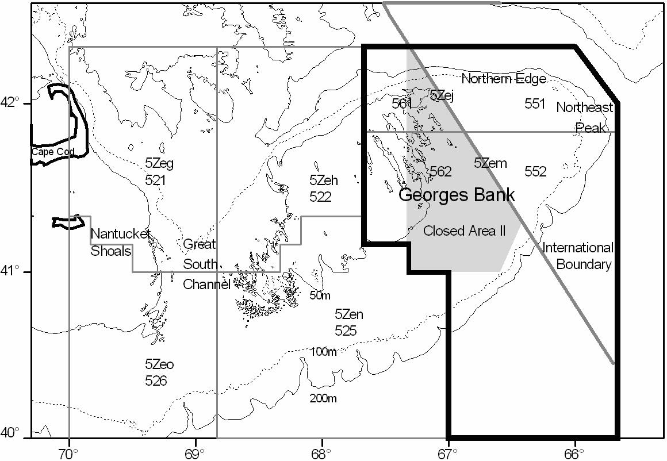
Figure 1. Fisheries statistical areas (Canada and USA) in NAFO Subdivision 5Ze. The Eastern Georges Bank Atlantic Cod management unit is outlined by a heavy black line.

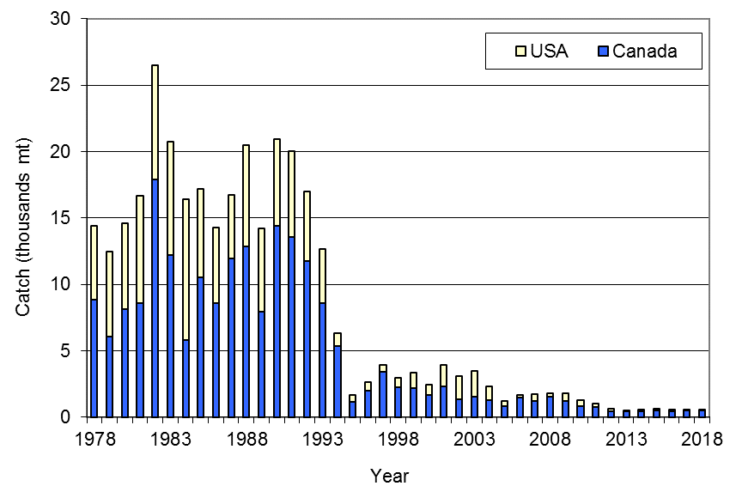
Figure 2. Catches of Eastern Georges Bank Cod, 1978 to 2018.
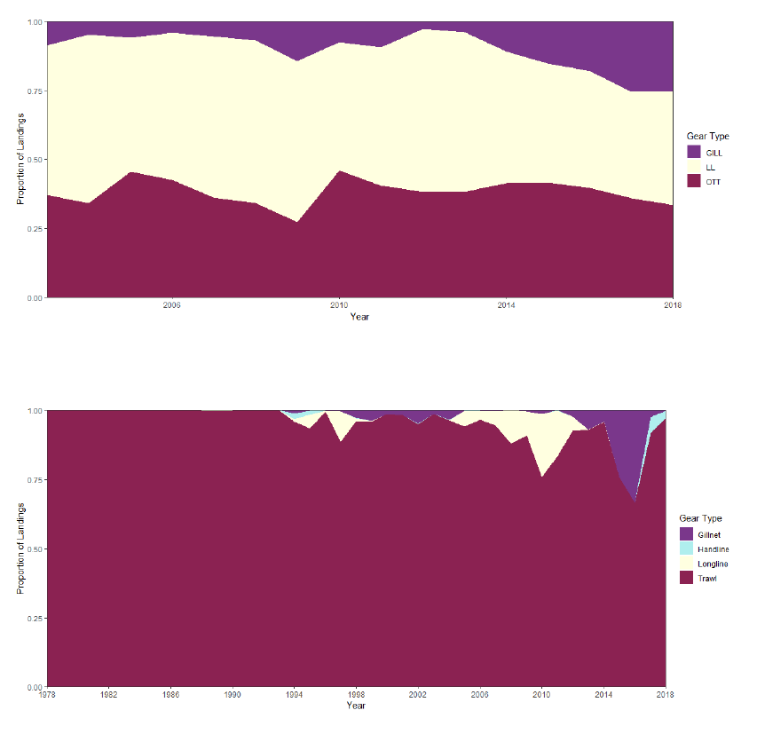
Figure 3. Canadian (upper) and US (lower) proportional landings of Cod by gear from Eastern Georges Bank for 1978 to 2018.
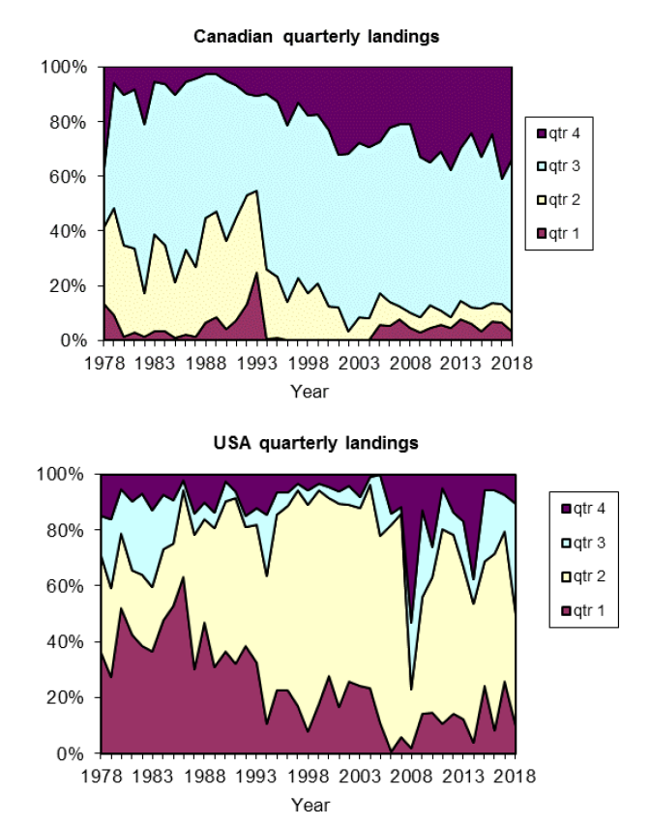
Figure 4. Proportion of Canadian (upper) and USA (lower) quarterly landings of Cod from Eastern Georges Bank, 1978 to 2018.
catch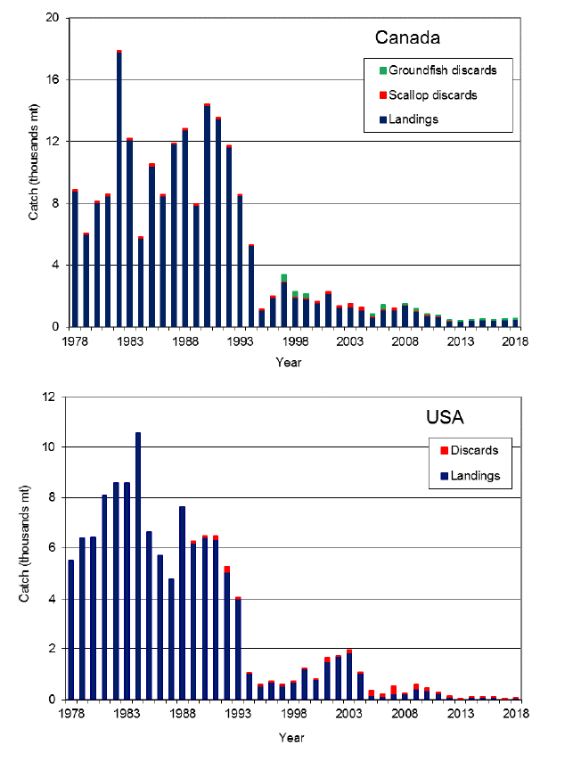
Figure 5. Canadian (upper) and USA (lower) landings and discards of Eastern Georges Bank Cod, 1978 to 2018.
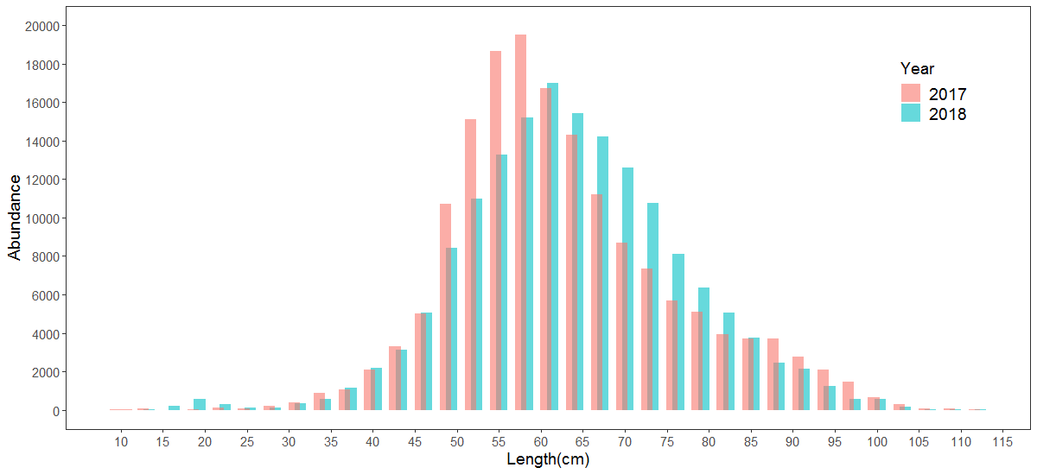
Figure 6. Length frequency of Cod catch (landings and discards) from the 2017 and 2018 Canadian fisheries on Eastern Georges Bank.
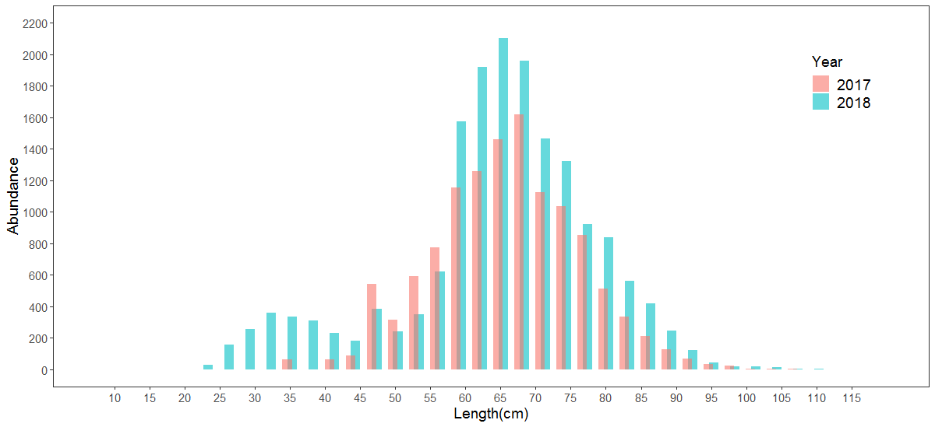
Figure 7. Length frequency of Cod catch (landings and discards) from the 2017 and 2018 USA fisheries on Eastern Georges Bank.
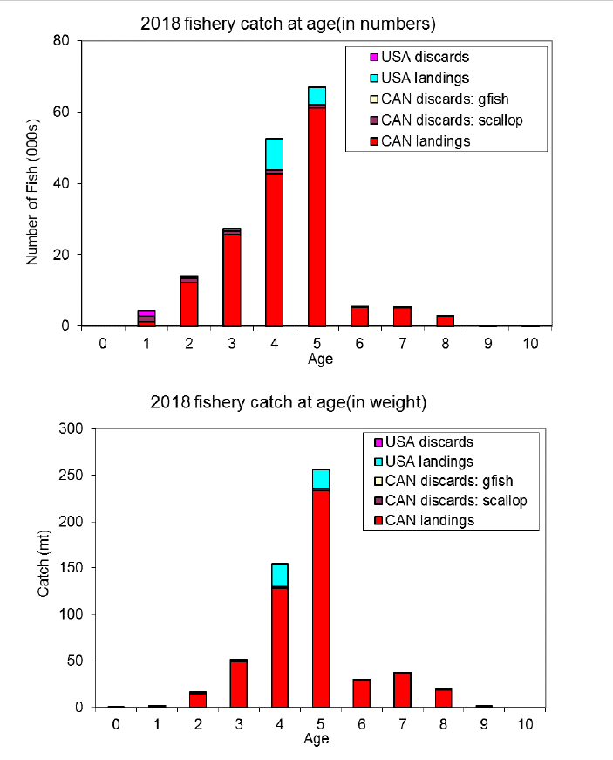
Figure 8. Catch at age in numbers (top) and weight (bottom) for landings and discards of Cod from the 2018 Eastern Georges Bank fisheries.
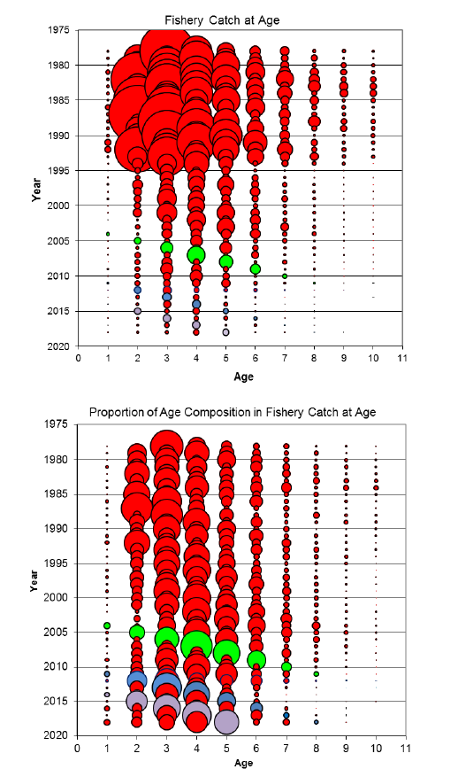
Figure 9. Total catch at age (numbers) of Cod (top) and proportion of catch at age (bottom) from Eastern Georges Bank for 1978 to 2018. The bubble area is proportional to the magnitude. The green denotes the 2003 year class, the blue denotes the 2010 year class and the purple denotes the 2013 year class.
Figure 10. Stratification used for the NMFS surveys. The Eastern Georges Bank management unit is indicated by shading.
Figure 11. Stratification used for the DFO survey. The Eastern Georges Bank management unit is indicated by shading.
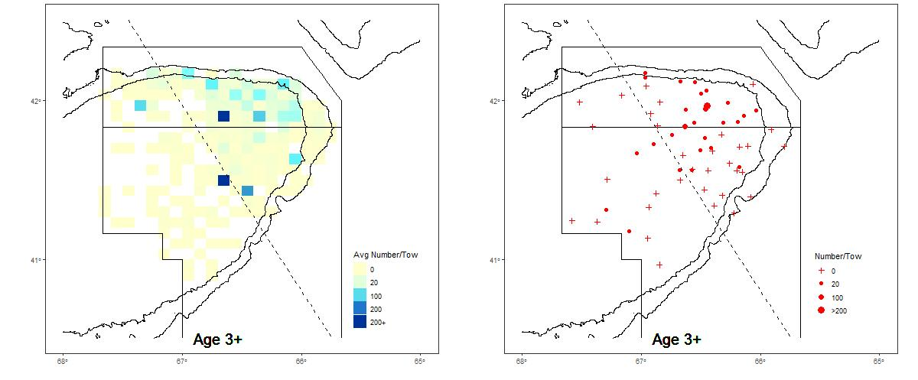
Figure 12. Spatial distribution of age 3+ Cod on Eastern Georges Bank from the DFO survey for 2019 (right) compared to the average for 2009 to 2018 (left).
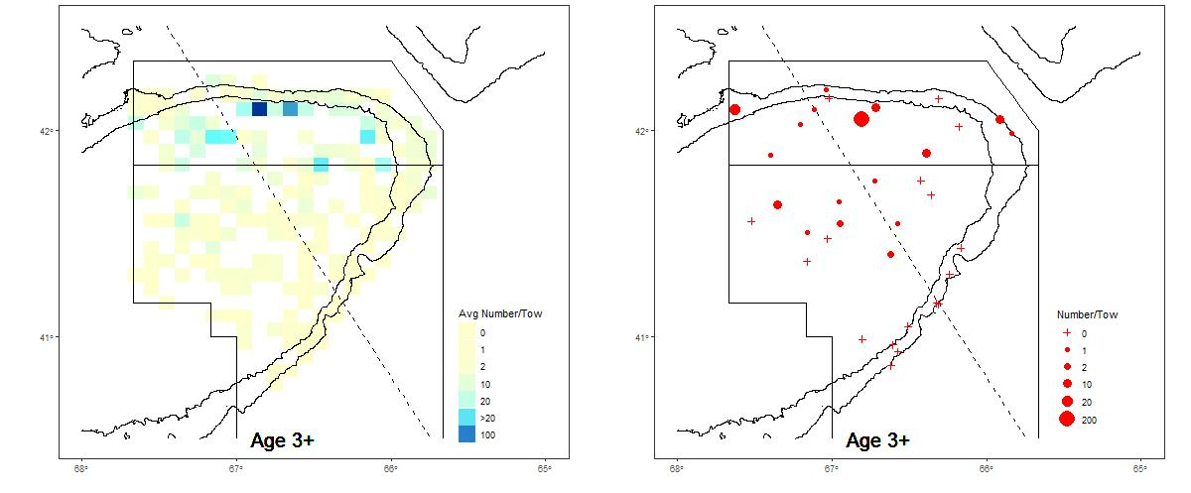
Figure 13. Spatial distribution of age 3+ Cod on Eastern Georges Bank from the NMFS spring survey for 2019 (right panel) compared to the average age 3+ Cod for 2008–2018 (left panel).

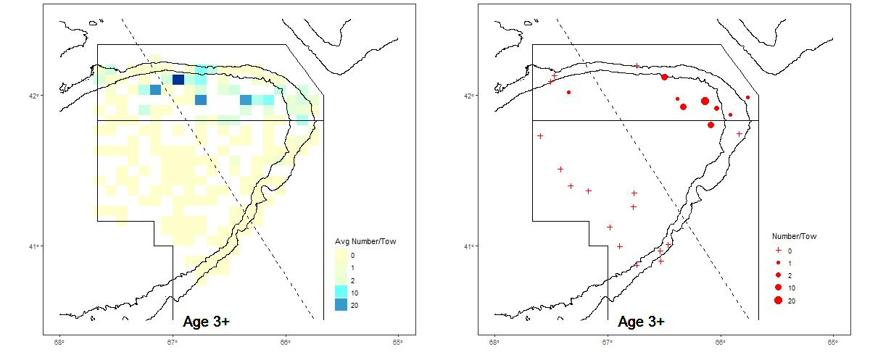
Figure 14. Spatial distribution of age 3+ Cod on Eastern Georges Bank from the NMFS fall survey for 2018 (right) compared to the average for 2009–2017 (left).
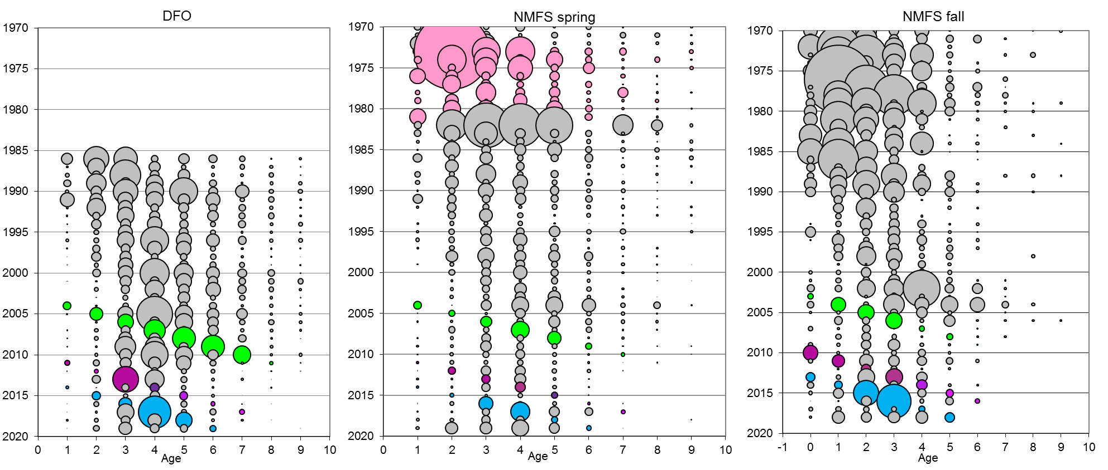
Figure 15. Survey abundance at age (numbers) of Eastern Georges Bank Cod. The bubble area is proportional to magnitude within each survey. Conversion factors to account for changes in door type, net and survey vessel were applied to the NMFS surveys. The NMFS spring survey was conducted using a modified Yankee 41 during 1978 to 1981 (pink bubbles). The 2003 year class is identified with green bubbles, the purple bubbles show the 2010 year class and the blue show the 2013 year class.

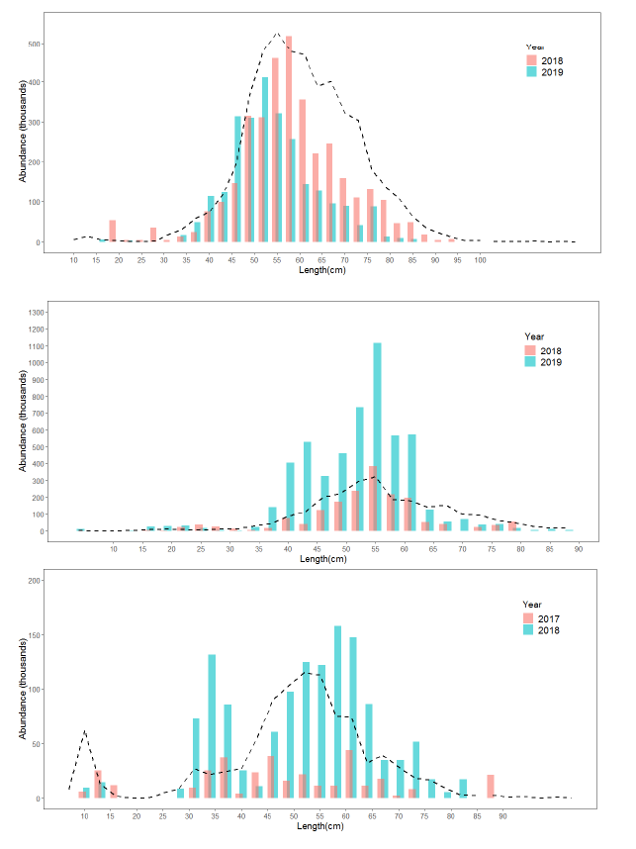
Figure 16. Length frequency distribution of the DFO Spring (top), NMFS Spring (middle) and NMFS fall (bottom) surveys. Bars represent the most recent two years and the dashed line shows the average distribution from the previous ten years (2008–2018 for spring and 2007–2017 for fall).
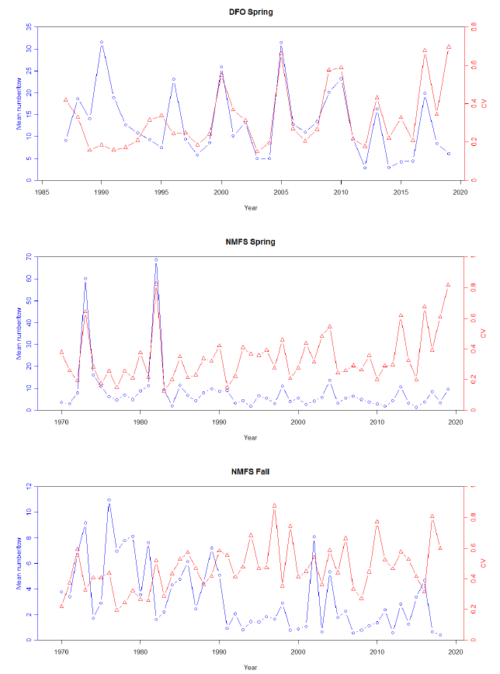
Figure 17. Stratified mean number per tow (blue) and coefficient of variation (CV; red) for DFO (top), NMFS spring (middle) and NMFS fall (bottom) survey catch of Eastern Georges Bank Cod.
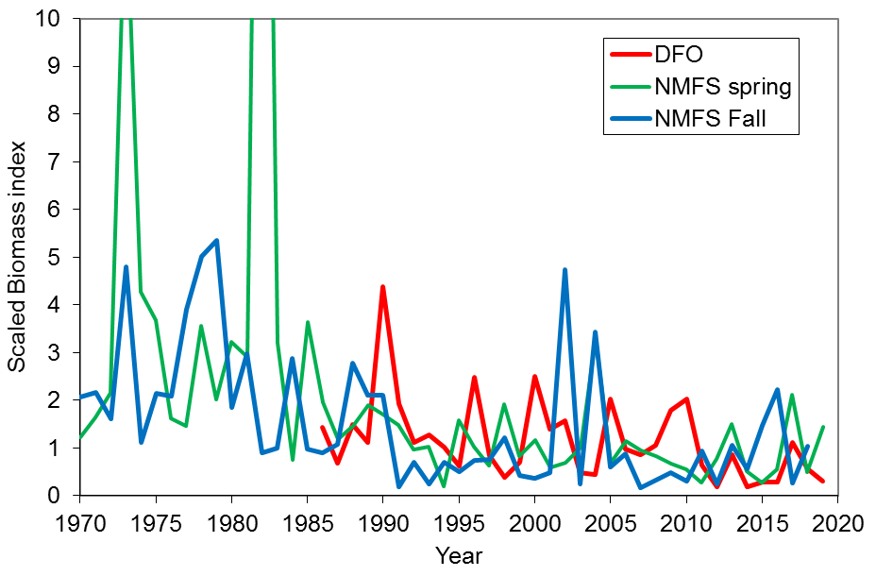
Figure 18. Survey biomass indices (ages 1+) for Eastern Georges Bank Cod from the DFO spring, NMFS spring and NMFS fall surveys, scaled to their respective time series means from 1996 to 2018 for NMFS Fall and 1996 to 2019 for DFO and NMFS spring surveys.
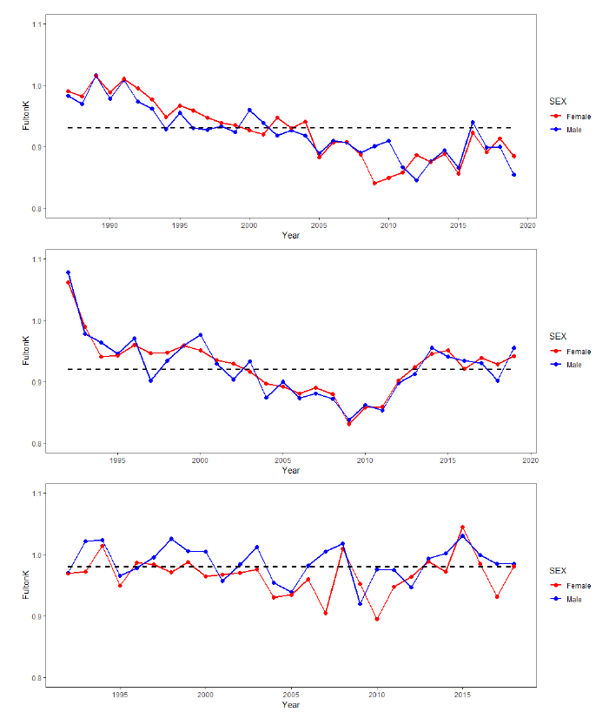
Figure 19. Fish condition (Fulton’s K) of post-spawning Cod for Eastern Georges Bank from DFO spring (top), NMFS Spring (middle) and NMFS Fall (bottom). The dashed lines shows the time series mean.

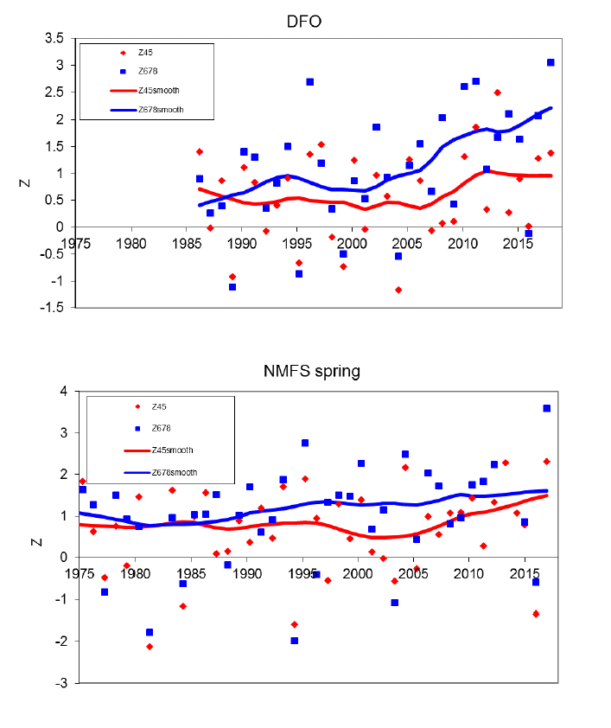Figure 20. Total mortality (Z) calculated using the DFO and NMFS spring surveys data for Eastern Georges Bank Cod.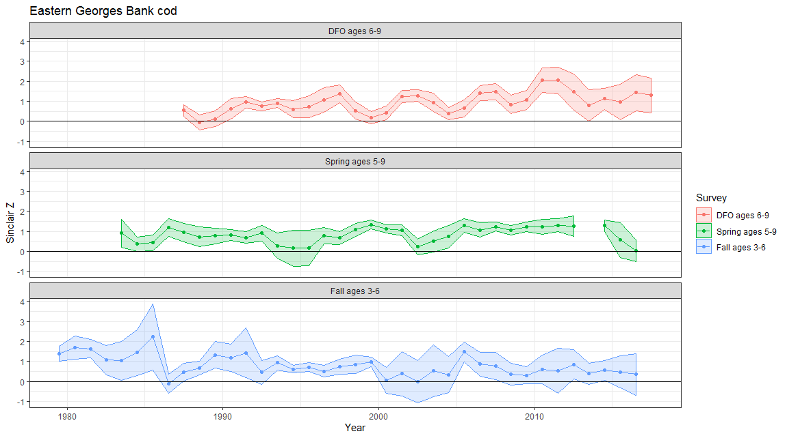
Figure 20. Empirical estimate of total mortality for the DFO (ages 6–9), NMFS spring (ages 5–9) and NMFS fall (ages 3–6) surveys.
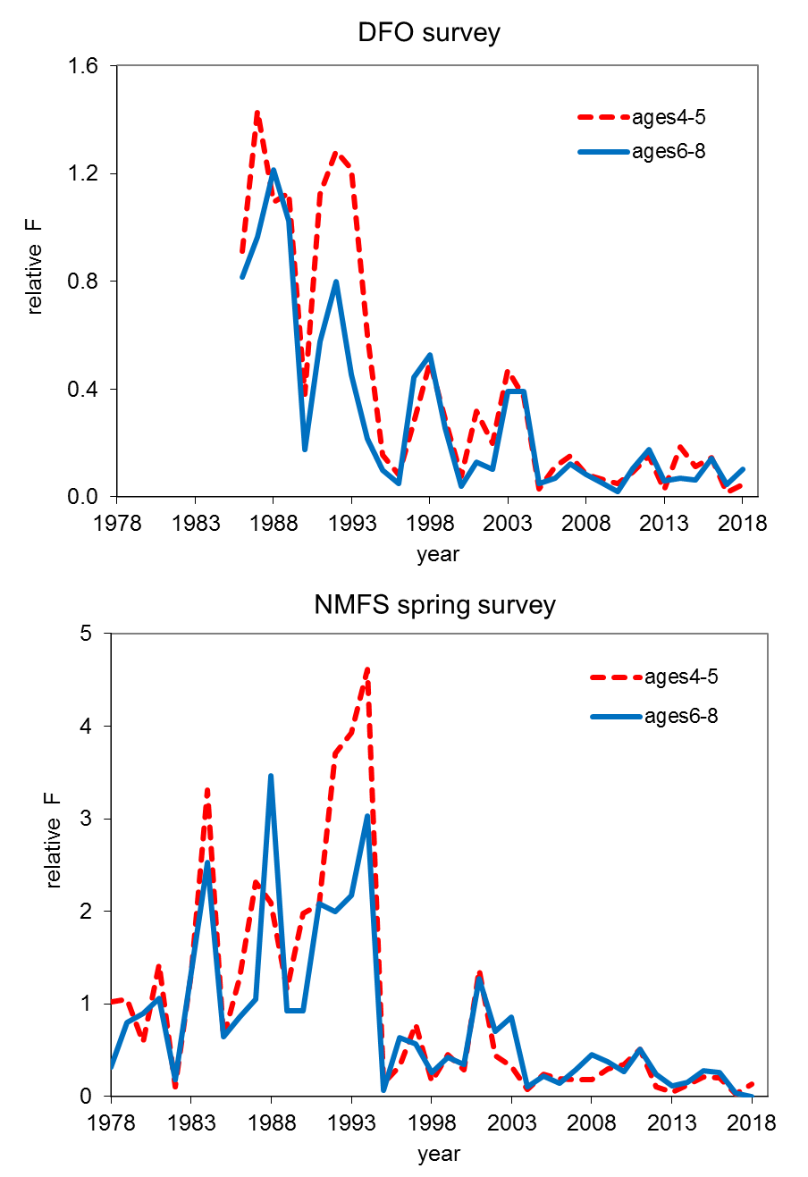
Figure 21. Relative F for Eastern Georges Bank Cod DFO spring survey (top) and NMFS spring survey (bottom).

Discards for the Mobile Fleet were calculated to be 0. Discards for the Fixed Gear fleet were not calculated due to low observer coverage.
Age and length data supplemented with ages from statistical areas 522 and 525.
Age and length data supplemented with ages from statistical area 522. ³ Survey ALK used to supplement quarter 1 age and length data for scallop discards only.

