Assessment of Haddock on Eastern Georges Bank for 2017
M.A. Barrett¹, E.N. Brooks², and Y. Wang¹
¹Fisheries and Oceans Canada
531 Brandy Cove Road
St. Andrews, New Brunswick E5B 2L9
Canada
²NOAA/NMFS Northeast Fisheries Science Center
166 Water Street
Woods Hole, MA 02543
USA

Table of Contents
ABSTRACT iv
INTRODUCTION 1
Fishery 1
Commercial Catches 1
Canadian 1
USA 2
Size and Age Composition 4
Ageing Precision and Accuracy 4
Canadian 4
USA 5
Combined Canada/USA Catch at Age 5
ABUNDANCE INDICES 6
Research Surveys 6
HARVEST STRATEGY 7
ESTIMATION OF STOCK PARAMETERS 7
Calibration of Virtual Population Analysis (VPA) 7
Retrospective Analysis 8
STATE OF RESOURCE 8
PRODUCTIVITY 9
OUTLOOK 11
Standard Projections 11
Sensitivity Projections 12
Management Advice 12
SPECIAL CONSIDERATIONS 13
ACKNOWLEDGEMENTS 14
REFERENCES CITED 14
Tables 16
Figures 47
Appendices 76

ABSTRACT
The total catch of eastern Georges Bank (EGB) Haddock in 2016 was 12,409 mt of the 37,000 mt combined Canada/United States of America (USA) quota. The 2016 Canadian catch decreased from 14,648 mt in 2015 to 11,943 mt, while the USA catch in 2016 was 466 mt, a decrease from the 2015 catch of 1,921 mt. Haddock discards from the Canadian scallop fishery and the USA groundfish fishery were estimated at 8 and 125 mt, respectively.
The 2017 beginning of year adult population biomass (ages 3+) is estimated at 274,482 mt. A preliminary estimate for the 2016 year class is 111 million fish at age 1. The current estimate of the 2013 year class is 885 million fish, which is the highest in the time series (1931–1955 and 1969–2016). The exceptional 2003 and 2010 year classes, estimated at 196 million and 243 million age 1 fish, respectively, are the second and third largest. Except for the strong 2000 and 2011 year classes and the exceptional 2003, 2010, 2013, and 2016 year classes, recruitment has fluctuated between 1.8–27.1 million since 1990. Fully recruited fishing mortality increased to levels above F_{ref} = 0.26 from 2010–2014 before dropping below F_{ref} in 2015. In 2016, F was estimated at 0.10. Positive signs of productivity include expanded age structure, broad spatial distribution, large biomass, and three exceptional year classes and three strong year classes since 2000. On the negative side, condition has decreased substantially and size at age has declined.
Assuming a 2017 catch equal to the 50,000 mt total quota and F = 0.26 (F_{ref}) in 2018 and 2019, a combined Canada/USA catch of 86,000 mt in 2018 results in a neutral risk (50%) that the 2018 fishing mortality rate would exceed F_{ref} = 0.26. The 2010 year class at age 8 is expected to contribute 11% of the catch biomass and the 2013 year class at age 5 is expected to contribute the highest percentage at 86%. Adult biomass is projected to be 243,000 mt, at the beginning of 2019 at the F_{ref} catch level.
A combined Canada/USA catch of 53,000 mt in 2019 results in a neutral risk (50%) that the 2019 fishing mortality rate would exceed F_{ref} = 0.26. The 2010 year class at age 9 is expected to contribute 5% of the catch biomass and the 2013 year class at age 6 is expected to contribute 86%. Adult biomass is projected to be 196,000 mt at the beginning of 2020 at the F_{ref} catch level.
Retrospective analyses indicated that the benchmark model has a tendency to underestimate F and overestimate biomass and age 1 recruitment when additional years of data are added. To account for the retrospective bias, a sensitivity forecast using the rho adjusted 2017 population numbers (ages 0–9+) for deterministic projections and risk assessments was conducted to beginning year 2020. Assuming a 2017 catch equal to the 50,000 mt total quota and F = 0.26 (F_{ref}) in 2018 and 2019, a combined Canada/USA catch of 44,000 mt in 2018 results in a neutral risk (50%) that the 2018 fishing mortality rate would exceed F_{ref} = 0.26. A combined Canada/USA catch of 27,500 mt in 2019 results in a neutral risk (50%) that the 2019 fishing mortality rate would exceed F_{ref} = 0.26.
The F_{ref} catches from the sensitivity projections are considerably lower than the catches from standard projections, but they do take into account the consistent retrospective pattern which has occurred over the past four years in this assessment.

INTRODUCTION
For the purpose of developing a sharing proposal and consistent management by Canada and the United States of America (USA), an agreement was reached that the transboundary management unit for Haddock would be limited to the eastern portion of Georges Bank (EGB; DFO statistical unit areas j and m in North Atlantic Fisheries Organization (NAFO) Subdivision 5Ze; USA statistical areas 551, 552, 561 and 562 in NAFO Subdivision 5Ze; Figure 1; DFO 2002). This assessment applies the approach used by Van Eeckhaute and Brooks (2014) to Canadian and USA fisheries information updated to 2016. Results from the Fisheries and Oceans Canada (DFO) survey, updated to 2017, the USA National Marine Fisheries Service (NMFS) spring survey, updated to 2017, and the NMFS autumn survey, updated to 2016, were also incorporated. The NMFS surveys since 2009, which use a new vessel (National Oceanic Atmospheric Administration [NOAA] ship Henry B. Bigelow), a new net and protocols, were made equivalent to surveys undertaken by the former NOAA ship Albatross IV by applying length-based conversion factors (Brooks et al. 2010).

Fishery

Commercial Catches
Haddock on Georges Bank have supported a commercial fishery since the early 1920s (Schuck 1951; Clark et al. 1982). Catches from EGB during the 1930s to 1950s ranged between 17,000–41,000 mt (Figure 2). Records of catches by unit area for 1956 to 1968 are not available; however, based on records for NAFO Subdivision 5Ze, catches from EGB probably attained record high levels of about 60,000 mt during the early 1960s. Catches during the late 1970s and early 1980s reached a maximum of 23,344 mt and were associated with good recruitment (Table 1; Figure 3). Substantial quantities of small fish were discarded in those years (Overholtz et al. 1983). Catches subsequently declined, fluctuating around 5,000 mt during the mid to late 1980s. Under restrictive management measures (Table 2), combined Canada/USA catches declined from 6,504 mt in 1991 to a low of 2,150 mt in 1995, varied between 3,000–4,000 mt until 1999, and increased to 15,257 mt in 2005. Catches varied between 12,510 mt and 19,855 mt from 2006 to 2011, decreased to 5,066 mt in 2013 then increased to 14,243 and 16,148 mt in 2014 and 2015 respectively. In 2016, the total catch decreased to 12,409 mt and represented 34% of the combined 37,000 mt quota. Canada caught 55% of its 21,830 mt allocation while the USA caught 3% of its 15,170 mt allocation.

Canadian
Some elements of the management measures used on EGB are described in Table 2. Quotas are the principal means used to regulate the Canadian groundfish fisheries on Georges Bank. Quota regulation requires effective monitoring of fishery catch. Weights of all Canadian landings since 1992 have been monitored at dockside. Canadian catches since 1995 have usually been below the quota due to closure of some fleet sectors when the cod quotas were reached. In 2016, at-sea observer coverage represented 79.5% of Otter Trawl Boittom (OTB) and 23% of longline landings, which amounted to an overall observed level of 76% of Haddock landings for the Canadian fishery. For OTB, coverage was 100% from June to August and 50% from September to December.
Between 1994 and 2004, the Canadian fishery for groundfish on EGB was closed from 1 January to 30 May. In 2005, increasing Haddock abundance led to permission to conduct an exploratory Canadian groundfish fishery in January and February that has continued since that time. Observer coverage for the winter fishery remains high (i.e., 80% in 2016). So as not to adversely affect the rebuilding of cod on EGB, the winter fishery was closed February 7th in 2016 based on determinations of active cod spawning in the previous year (i.e., when 30% of cod were in “spawning” or “post-spawning” stages based on analysis of maturity data collected by observers).
Following several studies that compared cod end mesh size and retention of Haddock in 2014, for 2015 and 2016 the Canadian fleet has been required to fish with a 125 mm (minimum) square or 145 mm diamond mesh size.

Canadian Landings
Canadian landings decreased from 14,631 mt in 2015 to 11,935 mt in 2016. In recent years, the Canadian fishery has been conducted primarily by small otter trawlers (i.e., Tonnage Classes [TC] 1–3, < 150 mt) followed by longline, with minimal landings by gillnet (Table 3). The percentage of landings taken by longline has steadily declined since 1992, whereas the small otter trawl share has increased (Figure 4). Over the past 10 years, small otter trawlers have taken an average of about 90% of the catch and longline vessels about 10%. There has been a declining trend in longline catches since 2012, with the 2016 catch representing only 1% of total landings, which is attributed to the difficulties in avoiding cod bycatch. Large otter trawlers (TC 4+) contributed 40–80% of total landings in the 1970s but there are few left in the fishery at present (their contribution is currently 0%). In 2016, the highest landings occurred in July with highest percentage of total Canadian landings occurring in quarter 3 (41%) (Table 4; Figure 5). The 2016 January/February winter fishery landed 2,883 mt of Haddock, accounting for 24% of total Canadian landings.

Canadian Discards
Before 1996, Canadian landings included Haddock catches reported by the scallop fishery. Landings of Haddock by the scallop fleet were low (Table 3) with a maximum of 38 mt reported in 1987. Since 1996, the scallop fishery has been prohibited from landing Haddock, so this species is discarded. Haddock discards from the scallop fleet have ranged between 8 and 186 mt since 1969 (Table 1). A 3-month moving window was used to calculate the discard rate and included December of the previous year for the January discard rate and January of the following year for the December rate (Van Eeckhaute et al. 2011). Discards from 2005 onward have been recalculated to reflect a change in the effort measure used (i.e., from freezer trawler hours to hours x meters; Sameoto et al. 2013). The effect on Haddock discards was minimal. In 2016, there were 23 observed scallop trips available for calculating discards, which were estimated at 8 mt, lower than the 17 mt reported in 2015 (Table 5).
Compliance with mandatory retention is thought to be high since 1992, so Haddock discards in the groundfish fishery are considered to be negligible. The mandatory use of separator panels for bottom trawls was implemented in 1999 to help reduce the bycatch of cod. Currently, all vessels in the fleet are using separator panels.

USA
Management measures for the USA fishery have been primarily effort based since 1994; however, in 2004, quota management was introduced to regulate the USA groundfish fishery for EGB Haddock (Table 2). From 2008 to 2010, the USA portion of the EGB management area was closed to vessels fishing with trawl gear from May 1 to July 31. From 2011 onwards, the regulation only applies to the common pool, which is a miniscule fraction of USA boats that fish on EGB (the common pool, received 0.62%, 0.28%, and 0.32% of the EGB quota in 2011, 2012, and 2013, respectively).
The minimum size for landed Haddock had been reduced to 18 inches (45.7 cm) in October 2007 but reverted back to 19 inches (48.2 cm) in August 2008. On May 1, 2009, the minimum size was again reduced to 18 inches through a NMFS interim action. This minimum size limit was retained in Amendment 16, which went into effect on May 1, 2010. On September 15, 2008, the Ruhle trawl (previously called the Eliminator Trawl) was authorized for use in the USA portion of EGB management area. The Ruhle trawl is intended to reduce by-catch of cod. Also, beginning on May 1, 2010, many participants in the multispecies groundfish fishery organized into sectors, with each unique sector receiving a portion of the overall quota known as an Annual Catch Entitlement (ACE). Those vessels not joining a sector remained in the common pool, which received a portion of the overall quota. A discard provision went into effect on May 1, 2010 requiring that all legal sized fish be retained by vessels in a sector. On May 11, 2011, the Closed Area II Special Access Permit (SAP) was modified to allow targeting of Haddock from August 1 to January 31. Also, on September 14, 2011, the Haddock catch cap regulation for the herring midwater trawl fishery increased to 1% of the Georges Bank Annual Biological Catch (ABC). Beginning July 1, 2013, the minimum size was reduced from 18 inches to 16 inches (40.64 cm).

USA Landings
USA landings of EGB Haddock in 2016 were derived from mandatory fishing Vessel Trip Reports (VTRs) and dealer reports. Statistical methodology was applied to allocate unknown landings to statistical area from 1994 to 2016 (Wigley et al. 2008a; Palmer 2008). Some of the landings for trawl gear that were reported in 2008 to 2010, during the months when EGB was closed to trawl gear, come from the allocation algorithm that assigns a statistical area when area is missing or there are inconsistencies in reported areas on logbooks. Trawl landings that were allocated to EGB during May to July for 2008–2010 comprised 3% to 5% of total annual USA landings.
USA calendar year landings (Table 1) of EGB Haddock decreased from 1,506 mt in 2015 to 341 mt in 2016. The 2016 USA landings peaked in quarter 2 (55%), primarily due to high landings in June, which represented 27% of total annual landings (Table 6). As in other years, otter trawl gear accounted for nearly all of USA landings (339 mt; Table 7), 84% of which was landed by tonnage class 4 vessels.
For USA fishing year May 1, 2016, to April 30, 2017, the USA catch quota for sectors was 15,063 mt of which only 2.9% was realized in landings (3.7% of quota, including discards). The catch quota for the common pool was 157.3 mt, none of which was caught. In recent years, landings have been constrained in part by the low cod quota, the closed area, as well as the delayed opening of the EGB area to trawlers until August 1, in effect from 2008 to 2010 for all USA trawl gear and, since 2011, for the common pool only. The use of the Ruhle and Separator trawls may have reduced interactions with cod.

USA Discards
Discards were estimated from the ratio of discarded Haddock to kept of all species, a new methodology that was first applied for the 2009 EGB Haddock assessment. This ratio is calculated by year-quarter (or other suitable time step)-gear-mesh and prorated to the total landings of all species in the same time-gear category to obtain total discards (mt) (Wigley et al. 2008b). Where time steps within the year are sparse, imputation is carried out.
Total discards in 2016 were 125 mt, a decrease from 415 mt in 2015 (Table 1). Discards were similar during the first and second half of the year in 2015, but in 2016 were greater in the second half (66%). Discards from the otter trawl fishery accounted for 99% and 95% of the USA Haddock discards in 2015 and 2016, respectively. Large mesh otter trawl discards were 6.7% and 52.1%, while separator trawl discards accounted for 44% and 17.7%, and small mesh otter trawl discards reflected 49% and 24.9% of total discards in 2015 and 2016, respectively. Minor amounts of discards were estimated for gillnets (0.2, 4 mt), scallop dredge (0.8, 0.3 mt), midwater trawl (0, 2.3 mt), and lobster pots (0.7, 0 mt) in 2015 and 2016.

Size and Age Composition

Ageing Precision and Accuracy
D. Knox provided ages for the 2016 Canadian fishery and 2017 DFO survey, and S.J. Sutherland provided ages for the 2016 US fishery and the NMFS 2016 autumn and 2017 spring surveys. Age testing was conducted between the DFO reader and the NMFS reader, and intra-reader testing was conducted at both labs (Table 8; Results of all QA/QC Exercises for Haddock). The NMFS reader also completed a test against the Haddock reference collection that resulted in 98% agreement. Inter-lab agreement ranged from 85% to 98%. No bias was detected for the exchange. Intra-reader agreement on non-reference collection samples for the NMFS reader ranged between 95% and 100%. For the DFO reader, intra-reader agreement ranged between 93% and 98%. Age determinations at both labs were considered to be reliable for characterizing catch at age.

Canadian
The size and age composition of Haddock in the 2016 Canadian groundfish fishery was determined using port and at-sea samples from all principal gears with 734,835 length measurements and 1,313 ages available to characterize the catch (Table 9). For trips that were sampled by both at-sea observers and port samples, the length frequencies from the two sources were combined with appropriate weighting from each source to ensure that samples were used in a consistent manner. Gillnet landings were low and no length samples were available; these landings were added in at the quarter level. Landings were applied to length samples combined by gear-month, then combined to calendar quarters before applying quarterly age length keys. Canadian fishery weights were derived from fishery lengths using a length-weight relationship derived from commercial fishery samples (round weight [kg] = 0.0000158 x length [cm]^{2.91612}; Waiwood and Neilson 1985).
The size composition of Haddock discards in the 2016 Canadian scallop fishery was characterized by quarter using length samples obtained from 23 observed scallop trips, which comprised 5% of the total trips (23 of 435). Discards at age for 2005–2012 were updated to reflect changes in estimated amounts due to a change in the effort measure used and changes made to the observer data (Sameoto et al. 2013). DFO survey ages (n = 125) for sets located in the Canadian portion of 5Zjm in 2016 were combined with port sample ages and applied to first quarter landings and discard length compositions. Fishery age samples for quarters 2, 3, and 4 were applied to the corresponding length compositions for both the groundfish fishery and discards (Table 9).
Otter trawl contributed most to the 2016 catch at size (99% by number), followed by longline (<‍ 1%) and dredge discards (< 1%) (Figure 6). Haddock captured by longline had the highest average size, followed by otter trawl and dredge (average fork length: Longline—48.5 cm; OTB—46.5 cm; Dredge—26.5 cm). For both otter trawl and longline, over 50% of the catch was dominated by age 6 (2010 year class) and over 20% by age 3 (2013 year class), while dredge catches consisted of 42% at age 3 (2013 year class) and 5% at age 6 (2010 year class). Over 49% of dredge catches consisted of Catch At Age (CAA) 2 or less. Overall, the 2016 Canadian CAA was dominated by age 6 (2010 yc), then ages 3 (2013 yc), 5 (2011 yc), and 4 (2012 yc) representing 51%, 30%, 7%, and 6% of the total catch. The 9+ age group represented 3% of quarter 1 Canadian landings but less than 1% in all remaining quarters (Table 10). The 2010 (age 6) and 2013 (age 3) year classes were predominant in all four quarters, representing 83% of catches.

USA
USA landings of EGB Haddock are sorted into “large”, “scrod”, and “snapper” market categories at sea and are sampled in port for lengths and ages (Table 11). In 2016, landings of large Haddock totaled 20 mt, scrod Haddock totaled 257 mt, and snapper totaled 52 mt. Length sampling for USA EGB landings in 2016 was available for all market categories except for the “large” category in quarter 3. Length and age samples were pooled to estimate CAA by half year rather than by quarter, and they were augmented with length and age samples from US statistical areas 522 and 525. After augmenting samples, there was a total of 3,977 lengths and 1,879 ages for calculating the 2016 USA commercial fishery CAA. USA fishery weights were derived from fishery lengths using a length-weight relationship for each half year. For quarters 1 and 2, that equation is (round weight [kg] = 6.07E-06*length [cm]^{3.10782}); for quarters 3 and 4, that equation is (round weight [kg] = 7.12E-06*length [cm]^{3.08054}).
USA fishermen are required to discard Haddock under the legal size limit (18 inches/45.7 cm from January–June 2013, then 16 inches since July 2013). A new regulation for the 2010 fishing year required vessels participating in a sector to retain all legal sized Haddock. USA discards at age of EGB Haddock for calendar year 2016 were estimated by half year from at-sea observer data. In calendar year 2016, the number of observed trips from the at-sea monitoring program was 60, a decrease from the previous year when there were 141. There were 429 trips to EGB for all groundfish gear types; however, the fraction of trips sampled varied by gear: 30% of standard otter trawl trips, 100% of separator trawl trips, 37.5% of mid-water trawl trips, 11% of scallop trips, 7% for gillnet, 0% for lobster pot trips (0 out of 0 trips), and 0% for long-line trips (0 out of 0 trips).
As 85% of the discarding was due to the otter trawl fleet, there were few length samples from remaining gears (scallop dredge, gillnet, and lobster pot). Therefore, length samples were combined across gears. The resulting combined length frequencies by half year were converted to discarded number at age by applying the age-length keys from the NMFS spring bottom trawl survey (1270 ages) to quarters 1 and 2 and from the autumn bottom trawl survey (957 ages) to quarters 3 and 4.
USA landings in 2016 had a modal size of 35 cm (Figure 7; upper panel). There were several modal sizes for discards depending on gear type. Haddock discards from otter trawl with a separator panel peaked at 34 cm, while without the panel they peaked at 30 and 32 cm. Scallop dredge discards had a modal size of 38 cm, while discards from mid-water trawl peaked at 32 cm. The 2010 year-class (age 6) represented 30% of the CAA as landings, while the 2013 year class (age 3) represented 42% of the CAA as discards (Figure 7; lower panel). Landings of the 9+ age group (mostly the 2003 year class at age 13) represented < 1% of the CAA (Table‍ 10).

Combined Canada/USA Catch at Age
The 2016 Canadian and USA landings and discards-at-age estimates (Table 1) were summed to obtain the combined annual catch at age and appended to the 1969 to 2015 catch at age data (Table 12; Figure 8). The catch at age tracks strong year classes well (i.e., 2000, 2003, and 2010) and showed an expansion in age structure in the mid-2000s with the contribution of the strong 2000 and 2003 year classes. The 2016 fishery was dominated by the 2010 year class (age 6), which represented 44% of the total catch by number (49% by weight), followed by the 2013 (age 3) year class at 35% by number and 22% by weight. Catches of older fish (7–9+) in 2016 were low but have increased compared to recent years. In comparison to the observed 2016 catch, the age composition of the catch projections made in 2015 and 2016 for the 2016 catch predicted higher percentages in number and weight for the 2013 year class but were lower than observed for the 2010 year class (Figure 9).
There has been a declining trend in the combined Canada/USA commercial fishery Weight At Age (WAA) and Length At Age (LAA) since 2000 (Figure 10). Noteworthy is that the 2016 average fishery WAA, (Table 13) and LAA, (Table 14) are currently at or near the lowest values in the CAA time series (1969-2016). The average weight of age 4 Haddock in 2000 was 1.9 kg, with an average length of 55 cm. In 2016, the average weight and length of an age 4 Haddock was 0.97 kg and 43 cm.

ABUNDANCE INDICES

Research Surveys
Surveys of Georges Bank have been conducted by DFO each year (February/March) since 1986, by NMFS each autumn (October/November) since 1963, and by NMFS and each spring (April) since 1968. All surveys use a stratified random design (Figures 11 and 12). The CCGS Alfred Needler is the standard vessel used for the DFO Georges Bank survey, but, when unavailable, the CCGS Wilfred Templeman, a sister ship to the Needler, was used in 1993, 2004, 2007, and 2008. In 2016 and 2017, the CCGS Teleost was used in the DFO Georges Bank survey. No conversion factors are available for the Templeman or Teleost; however, these vessels are considered to be similar in fishing strength to the Needler. For the NMFS surveys, two vessels have been employed from 1963 to 2008, and there was a change in the trawl door type in 1985. Vessel and door type conversion factors, derived experimentally from comparative fishing, have been applied to the survey results to make the series consistent (Forrester et al. 1997). Additionally, two different trawl nets have been used on the NMFS spring survey, a modified Yankee 41 during 1973–81 and a Yankee 36 in other years, but no conversion factors are available for Haddock, so the indices are treated as separate series.
Since spring 2009, the NMFS surveys have been conducted with the NOAA FSV Henry B. Bigelow using a new net (4-seam, 3-bridle) and revised protocols. Length based conversion factors have been calculated and were applied by dividing Bigelow catches at length by the length-specific conversion value to make the Bigelow survey catches equivalent to the FRV Albatross IV catches for both spring and fall surveys (Brooks et al. 2010).
The spatial distributions of catches by age group (1, 2, and 3+ for spring and 0, 1 and 2+ for autumn) for the 2016 NMFS fall survey, and the 2017 DFO winter and NMFS spring surveys are shown in comparison to the average distribution over the previous 10-years (Figures 13–15). During the fall 2016, ages 0 and 1 were generally spread throughout the 5Zjm area similar to the 10 year average. While age 2 Haddock generally occur on the northern half of the bank, they were also caught along the southern edge in 2016. In March (2017 DFO survey), age 1 and 2 Haddock were distributed throughout the 5Zjm management unit, with higher catches in southern areas similar to the 10-year average, while ages 3+ occurred mostly in Canadian waters along the northern part of the bank similar to the 10-year average. More were caught in US waters compared to previous years. In April-May (2017 NMFS spring survey), age 1–3+ fish occurred throughout the stock area, generally similar to the 10-year average.
Scaled total biomass indices (with various conversion factors applied to NMFS surveys for doors, vessels and nets) show that the three surveys are consistent and track each other well (Figure 16). Some year effects are evident, but all three surveys show low biomass from the early 1980s to mid-1990s, followed by a steady increase to 2007, a decline to 2010–2011, an increase from 2012–2015 (2012–2016 for DFO survey), and a decrease for the most recent survey for both the DFO and NMFS fall surveys. The 2016 DFO survey index was the highest value for the time series (1986–2016) but decreased by 48% in 2017. The NMFS fall survey index was highest in 2015 but decreased by 53% in 2016, while the 2017 NMFS spring values increased by 16% from 2016 to 2017.
Age-specific total abundance indices for the three bottom trawl surveys track strong year classes (i.e., 2000, 2003 and 2010) quite well (Figure 17). The 2017 indices of abundance for the 2013 year class (age 4) from the DFO and NMFS spring surveys were at the highest levels observed for age 4 Haddock over the time series for the DFO survey (Table 15) and the second highest for the NMFS spring survey (Table 16). The index of abundance for the NMFS fall survey also peaked in 2016 for the 2013 year class (Age 3; Table 17). The next highest index value was for the 2016 year class at age 0 in the 2016 NMFS fall survey, and age 1 in the DFO and NMFS spring surveys.
Weights at age from the DFO survey are used as beginning of year population weights and are calculated using the method described in Gavaris and Van Eeckhaute (1998) in which weights observed from the survey are weighted by population numbers at length and age. Similar to the commercial fishery, the DFO survey WAA and LAA exhibit a declining trend from 2000 to present, especially for ages 3 and older (Figure 18; Tables 18 and 19).

HARVEST STRATEGY
The Transboundary Management Guidance Committee (TMGC) has adopted a strategy to maintain a low to neutral risk of exceeding the fishing mortality limit reference, F_{ref} = 0.26 (TMGC‍ 2003). When stock conditions are poor, fishing mortality (F) rates should be further reduced to promote rebuilding. The TMGC agreed to a common F strategy at its December 2002 TMGC meeting. The F references used by both countries for “healthy” or “rebuilt” stocks were virtually identical, i.e., 0.25 for Canada and 0.26 for the USA (TMGC Meeting Summary, October 2, 2003).
The current fishing mortality reference (F_{ref}) of 0.26 for EGB Haddock was calculated from per-analysis and by coincidence F_{0.1} = F_{40%}= 0.26. Since 2003, both survey and fishery have shown substantial fish growth changes. Together with continued changes in fishery management measures in both countries, there was some concern if the F_{ref} = 0.26 is still reflective of the current fishery (Appendix A).

ESTIMATION OF STOCK PARAMETERS

Calibration of Virtual Population Analysis (VPA)
Calibrated Virtual Population Analysis (VPA) was used to estimate stock parameters. The adaptive framework, ADAPT (Gavaris 1988), was used to calibrate the VPA with the research survey data. Details of the model formulations and model assumptions can be found in the 1998 benchmark assessment (Gavaris and Van Eeckhaute 1998). Data and model changes to the EGB Haddock assessment framework from 1998 to 2017 are summarized in Appendix B.
The VPA was based on an annual catch at age, C_{a,t} for ages a = 0, 1, 2…8, 9+, and time t = 1969, 1970…2016, where t represents the beginning of the time interval during which the catch was taken. Catch discards were included in the catch at age. The population was calculated to the beginning of 2017. The VPA was calibrated to bottom trawl survey abundance indices, I_{s,a,t} for
s = DFO, ages a = 1, 2, 3…8, time t = 1986.17, 1987.17… 2016.17, 2017.00
s = NMFS spring (Yankee 36), ages a = 1, 2, 3…8, time t = 1969.28…1972.28 and 1982.28… 2016.28, 2017.00
s = NMFS spring (Yankee 41), ages a = 1, 2, 3…8, time t = 1973.28, 1974.28…1981.28
s = NMFS autumn, ages a = 0, 1, 2…5, time t = 1969.79, 1970.79… 2016.79.
Since the population is calculated to beginning year 2017, the NMFS and DFO spring surveys in 2017 were designated as occurring at time 2017.00.
Statistical properties of estimators were determined using conditional non-parametric bootstrapping of model residuals (Efron and Tibshirani 1993, Gavaris and Van Eeckhaute 1998). Population abundance estimates at ages 1 and 8 exhibit a large relative error of 59% and 68%, and a large relative bias of 12% and 15%, respectively. The relative error for other ages was between 22% and 37% with a relative bias for ages 2 to 7 between 1% and 6% (Table 20). While trends in the three surveys are generally consistent, the survey indices exhibit high variability, which is reflected in the magnitude and direction (i.e., positive or negative) of residual values (Figure 19). Some year and cohort effects are present throughout the time series. Noteworthy is that residuals were mostly negative for the 2017 DFO and 2017 NMFS spring surveys (i.e., model predicts higher abundance than surveys). There was also a tendency for age 0 residuals from NMFS fall surveys to be positive for the past several years but smaller or negative for age 1 during the same period. This may contribute to the restospective pattern observed in this assessment over the past two years.

Retrospective Analysis
A retrospective analysis was conducted for 2017–2010 to detect any trends to consistently overestimate or underestimate age 3–8 biomass, age 5–8 fishing mortality, and age 1 recruitment relative to the terminal year estimates (Figure 20). Over the past four years, the addition of an extra year of data has caused a bias to appear between the present assessment results and previous assessments. Retrospective analysis shows lower biomass, higher F, and lower recruitment for several years of the analysis, while previous assessments remain consistent. A retrospective adjustment (denoted rho adjustment) based on the observed retrospective bias was applied to the terminal year estimates for comparisons of status determination following the methodology in Legault et al. (2010). Due to the recent increase in the retrospective pattern and the potential impact on assessment advice, a sensitivity projection was conducted using rho-adjusted age-specific stock abundance for 2017. Information on the relative change in age 3–8 biomass, age 5–8 F, and age 1 recruits (Figure 21) was used to calculate a rho adjustment (Table 21) that was then applied to the terminal year estimates for comparisons of status determination. For the sensitivity projection, the age 3–8 biomass of 0.564 was used to rho adjust age-specific stock abundance (for all ages) at the start of 2017 which in turn was used to calculate age 3+ biomass at the beginning of 2017. When the rho adjusted estimates for biomass and fishing mortality were plotted against the unadjusted values, they were found to be well outside the 80% and 95% confidence intervals for the unadjusted estimates (Table 22; Figure 22).

STATE OF RESOURCE
Evaluation of the state of the resource was based on results from the VPA for the years 1969 to 2017. For each cohort, the terminal population abundance estimates from ADAPT were adjusted for bias estimated from the bootstrap, and they were used to construct the history of stock status (Tables 23–24). This approach for bias adjustment was considered preferable to using potentially biased point estimates of stock parameters (O'Boyle 1998). The WAA from the DFO survey (Table 18) were used to estimate beginning of year population biomass (Table 25). The adult (ages 3–8) population biomass trend generally reflects the q-adjusted survey biomass trends for the DFO and NMFs spring surveys (ages 3–8) but was lower than indicated for the NMFS fall survey (ages 2–7) (Figure 23).
Adult biomass increased during the late 1970s and early 1980s to 38,000 mt in 1981 (Table 25; Figure 24). The increase was due to recruitment of the strong 1975 and 1978 year classes, which were both estimated to be above 50 million age 1 fish. However, adult biomass declined rapidly in the early 1980s, as these two cohorts were fished intensively at ages 2 and 3, and subsequent recruitment was poor. Improved recruitment in the 1990s and the strong 2000 year class (69 million at age 1), lower exploitation, and reduced capture of small fish in the fisheries allowed the biomass to increase from near a historical low of 10,200 mt in 1993 to 71,000 mt in 2003. Adult biomass decreased to 48,000 mt in 2005 but subsequently increased to 93,000 mt in 2009, higher than the 1931–1955 maximum adult biomass of about 90,000 mt. The near tripling of the biomass from 2005 to 2009 was due to the exceptional 2003 year class, estimated at 195 million age 1 fish. The biomass decreased after the 2009 high and, in 2012, the adult biomass was 24,000 mt, but it increased in 2013 when the 2010 year class joined the age 3+ group, to 85,000 mt, and again in 2014 to 105,000 mt. After a slight decline in 2015 to 95,000 mt, adult biomass increased to 293,000 mt in 2016 The current estimate for 2017 is 274,482 mt (80% confidence interval: 208,936-359,157 mt; Figure 25).
Recruitment has fluctuated between 1.8 and 26.1 million age 1 fish since 1990 except for the strong year classes that typically exceed 100 million age 1 fish. The current estimate of the 2013 year class is 885 million fish, which is the highest in the time series (1931–1955 and 1969–2 016). The 2010 year class is the second highest in the series at 243 million fish.
Since 2003, the age at full recruitment to the fishery has been 5 (rather than age 4, as in previous years) due to a decline in size at age (Table 14). Fully recruited fishing mortality (population weighted average of fully recruited ages) is presented for ages 4–8 for pre-2003 and ages 5–8 for 2003 onwards (Table 24; Figure 26). Fully recruited fishing mortality fluctuated between 0.26 and 0.47 during the 1980s. After reaching a high of 0.55 in 1993, it decreased to well below F_{ref} in 1995, stayed below until 2003, fluctuated around 0.35 during 2004 to 2006, then declined to 0.15 in 2008. Fishing mortality increased to levels above F_{ref} from 2010–2014 before dropping below F_{ref} in 2015. In 2016, F was estimated at 0.102 (80% confidence interval: 0.08–0.14; Figure 25), well below F_{ref}.
Consistent with the increase in age at full recruitment into the fishery, the partial recruitment (PR) at age for EGB Haddock is normalized to ages 4–8 population weighted F for 1969 to 2002 and to ages 5–8 population weighted F from 2003 onwards (Table 26; Figure 27). Average PR estimates are less variable when weighted by population numbers and are considered more appropriate than the unweighted average. The 10-year average PR values for 2007–2016 were used for projections of stock abundance in 2018 and 2019 (Table 27; Figure 27), except for the 2013 year class where the PR values reflect the 2010 year class.

PRODUCTIVITY
Recruitment, spatial distribution, age structure, and growth generally reflect changes in the productive potential. Recruitment, while highly variable, has generally been higher when adult biomass has been above 40,000 mt (Figure 28). Since 1969, only the 1975, 1978, 2000, 2003, 2010, 2011, 2013, and 2015 year classes have been above the average abundance of 38.9 million age 1 fish for year classes observed during the period 1931–1955 and 1969–2016. The very high 3+ biomass (generally greater than about 80,000 mt) observed since 2006 has produced two exceptional year classes but has also produced eight below-average year classes (Figure 28).
The spatial distribution patterns observed during the most recent bottom trawl surveys were similar to the average patterns over the previous ten years for the spring surveys. Consistent with the pattern observed for previous exceptional year classes, the 2013 year class was widely distributed throughout the survey area, especially during the NMFS spring and fall surveys (Figures 13–15). Age structure as reflected in the commercial fishery and RV survey catch at age composition (i.e., Figures 8 and 17) indicate higher abundance of older fish (ages 5+) since the mid-2000s.
An analysis of condition factor (Fulton’s K; weight/length³) was conducted using available individual length and weight data from the DFO (1987–2017), NMFS spring (1992–2017) and NMFS fall (1992–2016) surveys for Haddock 30-70 cm fork length (FL) (i.e., where there was no change in condition at size) (Figure 29). The DFO survey data indicates that there has been a general decline in Fulton’s K over time, with the 2017 value being the lowest in the series, the impact of the delayed DFO survey in 2017 is unknown due to lack of samples at this time of the year in the past. Since 2004, Fulton’s K has generally been at or below the long-term average (1987–2017) for most years except 2009. The NMFS spring survey data also shows a decline in condition, with Fulton’s K falling below the series mean since 2000, with a decreasing trend since 2013. Fulton’s K values from NMFS fall survey data are more variable but appear to have declined since 2003, with most values falling below the long term average since then, with the exception of 2008, 2013, 2014, and 2015. Since this is a time of year when Haddock would be feeding, it appears that in some years since 2003 they did not gain enough weight to bring the condition factor back to a level above average. Given the size of the exceptional 2003, 2010, and 2013 year classes, there may also be density-dependent effects which could be limiting the growth of several cohorts since 2003. The overall pattern is consistent with declining trends in WAA and LAA for Haddock, and is similar to trends in condition observed in EGB cod (Wang and O’Brien 2013) and Georges Bank yellowtail flounder (Legault et al. 2013).
Both fishery and survey average lengths and WAA have declined considerably since 2000 (Figures 10 and 18) with some values currently at or near the lowest levels for the commercial fishery (Tables 13–14) and DFO survey (Tables 18–19) time series. The DFO survey mean LAA for selected cohorts indicate that maximum size has decreased compared to the 1987 year class and that the recent strong 2013 year class have average lengths at ages 3 and 4 that are well below the 2010 year class, values that were previously among the lowest in the time series (Figure 30). Changes in growth in response to changes in stock abundance and episodes of very strong recruitment have been observed throughout the history of this stock. Clark et al. (1982), reporting on Georges Bank Haddock, observed “a decline in mean weight for all age-groups following every period of very strong recruitment” and a rapid increase in growth following the late 1960’s and early 1970’s reduction in stock size. As postulated by Clark et al. (1982), increased or decreased availability of food is probably the greatest determining factor for growth increases and decreases, respectively.
A comparison of total mortality (Z) calculated for ages 3–8 from the DFO survey with VPA estimates of fishing mortality from the current assessment indicates that Z has increased since the early to mid-2000s for ages 3–7, with a decrease in age 8, while F has generally decreased during this time (Figure 31), which would imply some inconsistency between the data and the model assumption of constant natural mortality.
In summary, positive signs of productivity include increased abundance for older ages, broad spatial distribution, and large biomass. This stock has produced three exceptional and three strong year classes in the last 15 years. On the negative side, condition has decreased, growth has declined, recruitment from the very large biomass has been extremely variable, and natural mortality (M) may be increasing on older ages.

OUTLOOK
This outlook is provided in terms of consequences with respect to the harvest reference point for alternative catch quotas in 2018 and 2019. Uncertainty about standing stock generates uncertainty in forecast results, which is expressed here as the risk of exceeding F_{ref} = 0.26. The risk calculations assist in evaluating the consequences of alternative catch quotas by providing a general measure of the uncertainties. However, the risk calculations are dependent on the data and model assumptions and do not include uncertainty due to variations in weight at age, partial recruitment to the fishery, natural mortality, systematic errors in data reporting, or the possibility that the model may not reflect stock dynamics closely enough.
For projections, the most recent 3-year survey (2015–2017) average and the lowest values for the fishery time series (1969–2016) WAA were used for beginning year population (2018–2020) and fishery (2017–2019) WAA, respectively, except as indicated below. The 2017 DFO survey WAA were used for the 2017 population WAA as this is consistent with the assessment results.
An evaluation of the 2016 EGB Haddock Interim Report (Barrett et al. 2017) indicated the importance of addressing the slow growth of strong year classes in the projections. Considering the substantial contribution of the 2013 year class to both biomass and fishery catch in the projections, a linear regression model that describes the relationship between survey weight and age (1 to 4) was estimated for the 2013 year class. The beginning year WAA for 2018 (age 5) and 2019 (age 6) were predicted using this linear regression function for the 2013 year class; these values were lower than minimum values in the time series, which is deemed to be more conservative. To test the robustness of this approach, a similar approach was applied to the strong 2010 year class weight at age data. The predicted weights at ages 5 and 6 of the 2010 year class are similar to the observed values from survey, but overestimated the weight at age 7 as survey growth ceased at this age. Therefore, the weight at age 7 of the 2013 year class in 2020 was assumed to be the same as weight at age 6 in 2019 (Figure 32). For fishery weights at age in the projection, growth rate of the 2010 year class fishery weights at age for ages 4 to 6 was applied to the 2013 year class based on the observed weight at age 3 in the 2016 fishery. For the 2010 year class, minimum values in the time series were used for beginning weights at age. Fishery PR was based on the 2007 to 2016 population weighted average. The PR used for the 2013 year class was from the 2010 year class (Table 27). Ages 5 to 8 were considered fully recruited to the fishery. EGB Haddock are considered 100% mature at ages 3 and older.

Standard Projections
Incorporating the patterns in growth and partial recruitment (Table 27), deterministic projections and risk assessments were conducted to beginning year 2020 (Table 28). Stock size estimates at the beginning of 2017 were used to start the forecasts. Abundance of the 2018, 2019 and 2020 year classes were assumed to be 15.21 million fish at age 1 (the 2007 to 2016 median from the 2016 update results; Barrett et al. 2017). Natural mortality was assumed to be 0.2. Assuming a 2017 catch equal to the 50,000 mt total quota and F = 0.26 (F_{ref}) in 2018 and 2019, a combined Canada/USA catch of 86,000 mt in 2018 results in a neutral risk (50%) that the 2018 fishing mortality rate would exceed F_{ref} = 0.26 (Figure 33). A catch of 71,000 mt in 2018 results in a low risk (25%) that the 2018 fishing mortality rate will exceed F_{ref.} The 2010 year class at age 8 is expected to contribute 11% of the catch biomass and the 2013 year class at age 5 is expected to contribute the highest percentage at 86%. A catch of 17,000 mt in 2018 results in a neutral risk (50%) that the 2018 biomass will not increase by 10%; a catch of 57,000 mt in 2018 results in a neutral risk that biomass will remain the same. Thus, both the low and neutral catch associated with not exceeding F_{ref} will produce a decline in biomass. Adult biomass is projected to be 243,000 mt, at the beginning of 2019 at the F_{ref} catch level.
A combined Canada/USA catch of 53,000 mt in 2019 results in a neutral risk (50%) that the 2019 fishing mortality rate would exceed F_{ref} = 0.26 (Figure 34). A catch of 44,500 mt in 2019 results in a low risk (25%) that the 2019 fishing mortality rate will exceed F_{ref}. The 2010 year class at age 9 is expected to contribute 5% of the catch biomass and the 2013 year class at age 6 is expected to contribute 86%. Even if no catch were taken in 2019, biomass is projected to decline. Adult biomass is projected to be 196,000 mt at the beginning of 2020 at the F_{ref} catch level.

Sensitivity Projections
A sensitivity forecast using the rho adjusted 2017 population numbers (ages 0–9+) for deterministic projections and risk assessments was conducted to beginning year 2020 (Table 29). All other input values for the forecast were the same as in Table 27. Assuming a 2017 catch equal to the 50,000 mt total quota and F = 0.26 (F_{ref}) in 2018 and 2019, a combined Canada/USA catch of 44,000 mt in 2018 results in a neutral risk (50%) that the 2018 fishing mortality rate would exceed F_{ref} (Figure 35). A catch of 35,000 mt in 2018 results in a low risk (25%) that the 2018 fishing mortality rate will exceed F_{ref}. The 2010 year class at age 8 is expected to contribute 9% of the catch biomass, and the 2013 year class at age 5 is expected to contribute 88%. A catch of 11,000 mt in 2018 results in a neutral risk (50%) that the 2018 biomass will not increase by 10%; a catch of 32,000 mt in 2018 results in a neutral risk that biomass will remain the same. Thus, both the low and neutral catch associated with not exceeding F_{ref} in 2018 will produce a decline in biomass. Adult biomass is projected to be 126,000 mt, at the beginning of 2019 at the F_{ref} catch level.
A combined Canada/USA catch of 27,500 mt in 2019 results in a neutral risk (50%) that the 2019 fishing mortality rate would exceed F_{ref} = 0.26 (Figure 36). A catch of 23,000 mt in 2019 results in a low risk (25%) that the 2019 fishing mortality rate will exceed F_{ref}. The 2010 year class at age 9 is expected to contribute 4% of the catch biomass and the 2013 year class at age 6 is expected to contribute 86%. Even if no catch were taken in 2019, biomass is projected to decline. Adult biomass is projected to be 102,000 mt at the beginning of 2020 at the F_{ref} catch level.
The F_{ref} catches from the sensitivity projections are considerably lower than the catches from standard projections, but they do take into account the continuing retrospective pattern that has occurred over the past four years in this assessment.

Management Advice
There are reasons for considering both the standard projection and the sensitivity projection (rho adjusted) for catch advice. Reasons for using the standard projection include the survey biomass being at or near historic highs, recent recruitment (2010 and 2013) estimated to be the highest in the time series, expanded age structure, and success at projecting age composition of the fishery catch. Reasons for using the sensitivity projection include the overestimation of SSB and underestimation of F in the last four assessments, the observation that terminal year biomass is lower than projected even though only about half of the quota was caught, and previous experience with assessments of other fish stocks of not accounting for retrospective bias leading to overfishing and further changes in perception of the stock status. For these reasons, both projections have been provided for consideration by the Transboundary Management Guidance Committee.

SPECIAL CONSIDERATIONS
Catch projections for this stock can be highly influenced by outstanding year classes. There is no direct evidence to indicate that age 9 and older Haddock should be less available to the fishery than age 8 Haddock; however, the domed partial recruitment at age 9 and older that the assessment model produces may be aliasing increased natural mortality, emigration outside of the management area or to areas inaccessible to the fishery. The decision to use the lower PR produced by the model, is also supported by the comparisons of percent predicted versus percent observed age 9+ from several recent assessments.
If the 2017 quota is caught, the projection indicates that the 2017 F will be above F_{ref} , which is due to retrospective pattern and the decreased weight at age of the 2010 year class in the 2017 projection (Table 28, the F on ages 5–8 in 2017 would be 0.318). Moreover, if the rho adjusted projections are more appropriate, then catching the full 2017 quota would result in F > F_{ref} (0.607 for ages 5–8, Table 29).
In 2017, a large proportion of the exceptional 2013 year class will be below the current minimum size regulation used by the US, which could lead to significant discarding. The reduction of the minimum size for the US fishery in July 2013 from 18 inches to 16 inches will help to reduce discarding of Haddock. This is not expected to be an issue in the Canadian fishery due to the different gear types and management measures.
The terminal year rho adjusted SSB and rho adjusted F were well outside of both the 80% and 95% confidence intervals of the point estimates. This result indicates there is substantial unmeasured uncertainty, which has increased since last year’s assessment.
Cod and Haddock are often caught together in groundfish fisheries, although their catchabilities to the fisheries differ and they are not necessarily caught in proportion to their relative abundance. With current fishing practices and catch quotas, the achievement of rebuilding objectives for cod may constrain the harvesting of Haddock. Modifications to fishing gear and practices, with enhanced monitoring, may mitigate these concerns.
The table in Appendix C summarizes the performance of the management system. It reports the TRAC advice, expected beginning of year 3+ biomass in the year following the catch year, the TMGC quota decision, actual catch, and realized stock conditions for this stock. Fishing mortality and trajectory of age 3+ biomass from the assessment following the catch year are compared to results from this assessment. These comparisons were kindly provided in 2011 by Tom Nies (staff member of the New England Fishery Management Council, NEFMC) and updated for this assessment by Jamie Cournane (NEFMC). The largest differences in expected and actual results occurred when projection inputs for partial recruitment and weights at age for large dominant year classes (i.e., 2000 and 2003) were higher than the realized values. When year class specific input values were used, expected and actual results were similar. These results indicate that stock biomass is being adequately estimated by the model for management purposes, but misspecification of partial recruitment and weights at age, especially of very large and influential year classes, can result in higher than expected fishing mortality due to catch advice being set too high.

ACKNOWLEDGEMENTS
K. Underhill and D. Frotten of DFO and at-sea observers from Javitech Ltd. provided samples from the Canadian fishery. D. Knox and S. Sutherland provided ageing information for the DFO and NMFS surveys and Canadian and USA fisheries. V. Noble provided assistance with the production of the document. We also thank NMFS reviewers for their suggestions to improve the document.

REFERENCES CITED
Barrett, M.A., M. Finley, E.N. Brooks, and Y. Wang. 2017. Evaluation of the 2016 Eastern Georges Bank Haddock Interim Report. TRAC Ref. Doc. 2017/05: 21 p.
Brooks, E.N., T.J. Miller, C.M. Legault, L. O’Brien, K.J. Clark, S. Gavaris, and L. Van Eeckhaute. 2010. Determining length-based calibration factors for cod, haddock, and yellowtail flounder. TRAC Ref. Doc. 2010/08: 25 p.
Clark, S.H., W.J. Overholtz, and R.C. Hennemuth. 1982. Review and assessment of the Georges Bank and Gulf of Maine haddock fishery. J. Northw. Atl. Fish. Sci. 3: 1-27.
DFO. 2002. Development of a sharing allocation proposal for transboundary resources of cod, haddock and yellowtail flounder on Georges Bank. DFO Mar. Prov., Reg. Fish. Manag. Rep. 2002/01: 59 p.
Efron, B., and R.J. Tibshirani. 1993. An Introduction to the Bootstrap. Chapman & Hall. New York. 436 p.
Forrester, J.R.S., C.J. Byrne, M.J. Fogarty, M.P. Sissenwine, and E.W. Bowman. 1997. Background papers on USA vessel, trawl, and door conversion studies. SAW/SARC 24 Working Paper Gen 6. Northeast Fish. Sci. Cent., Woods Hole, MA.
Gavaris, S. 1988. An adaptive framework for the estimation of population size. CAFSAC Res. Doc. 88/29: 12 p.
Gavaris, S., and L. Van Eeckhaute. 1998. Assessment of haddock on eastern Georges Bank. DFO CSAS Res. Doc. 98/66: 75 p.
Legault, C.M., L. Alade, and H.H. Stone. 2010. Stock assessment of Georges Bank (5Zjmnh) yellowtail flounder for 2010. Transboundary Resource Assessment Committee. Research Document. 2010/06, 96 p.
Legault, C.M., L. Alade, W.E. Gross, and H.H. Stone. 2013. Stock Assessment of Georges Bank Yellowtail Flounder for 2013. TRAC Ref. Doc. 2013/01; 132 p.
O’Boyle, R.N. (Chair). 1998. Proceedings of the Transboundary Resource Assessment Committee; 20-24 April 1998. CSAS Proc. Ser. 98/10: 49 p.
Overholtz, W.J., S.H. Clark, and D.Y. White. 1983. A review of the status of the Georges Bank and Gulf of Maine haddock stocks for 1983. Woods Hole Lab. Ref. Doc. 83-23, NOAA, NMFS, p. 1-33.
Palmer, M. 2008. A Method to Apportion Landings with Unknown Area, Month and Unspecified Market Categories Among Landings with Similar Region and Fleet Characteristics. Groundfish Assessment Review Meeting (GARM III-Biological Reference Points Meeting). Working Paper 4.4. 9 p.
Sameoto, J., B. Hubley, L. Van Eeckhaute, and A. Reeves. 2013. A Review of the Standarization of Effort for the Calculation of Discards of Atlantic Cod, Haddock and Yellowtail Flounder from the 2005 to 2011 Canadian Scallop Fishery on Georges Bank. TRAC. Ref. Doc. 2013/04; 22 p.
Schuck, H.A. 1951. Studies of Georges Bank haddock, Part I: Landings by pounds, numbers and sizes of fish. Fish. Bull. U.S., 52: 151-176.
TMGC. 2003. Transboundary Management Guidance Committee Guidance Document 2003/1: 7 p.
Van Eeckhaute, L., Y. Wang, J. Sameoto, and A. Glass. 2011. Discards of Atlantic cod, haddock and yellowtail flounder from the 2010 Canadian scallop fishery on Georges Bank. TRAC Ref. Doc. 2011/05 (in prep.). 14 p.
Van Eeckhaute, L., and E.N. Brooks. 2014. Assessment of eastern Georges Bank haddock for 2014. TRAC Ref. Doc 2014/03: 96 p.
Waiwood, K.G., and J.D. Neilson. 1985. The 1985 assessment of 5Ze haddock. CAFSAC Res. Doc. 85/95: 49 p.
Wang, Y., and L. O'Brien. Assessment of Eastern Georges Bank Cod. TRAC Ref. Doc. 2013/02: 99 p.
Wigley S.E., P. Hersey, and J.E. Palmer. 2008a. A Description of the Allocation Procedure Applied to the 1994 to 2007 Commercial Landings Data. US Dept. Commer., Northeast Fish. Sci. Cent. Ref. Doc. 08-18; 61 p.
Wigley, S.E., M.C. Palmer, J. Blaylock, and P.J. Rago. 2008b. A Brief Description of the Discard Estimation for the National By-Catch Report. Northeast Fish. Sci. Cent. Ref. Doc. 08-02; 35‍ p.

Tables
Table 1. Nominal catches (mt) of Haddock from Eastern Georges Bank (EGB) during 1969–2016. For “Other” it was assumed that 40% of the total 5Z catch was in EGB. USA landings and 1989 to 2007 USA discards were revised (Van Eeckhaute et al. 2009). Canadian discards are from the scallop fishery and USA discards are from the groundfish fishery. Dashes (-) indicate data are not available.
 | Landings |  |  | Discards |  | Totals |  |  | Quotas
Year | Canada | USA | Other | Canada | USA | Canada | USA | Catch | Canadian | USA²
1969 | 3941 | 6624 | 695 | 123 | - | 4064 | 6624 | 11382 | - | -
1970 | 1970 | 3154 | 357 | 116 | - | 2086 | 3154 | 5597 | - | -
1971 | 1610 | 3533 | 770 | 111 | - | 1721 | 3533 | 6024 | - | -
1972 | 609 | 1551 | 502 | 133 | - | 742 | 1551 | 2795 | - | -
1973 | 1565 | 1397 | 396 | 98 | - | 1663 | 1397 | 3455 | - | -
1974 | 462 | 955 | 573 | 160 | 757 | 622 | 1712 | 2907 | - | -
1975 | 1353 | 1705 | 29 | 186 | - | 1539 | 1705 | 3273 | - | -
1976 | 1355 | 974 | 24 | 160 | - | 1515 | 974 | 2513 | - | -
1977 | 2871 | 2428 | - | 151 | 2966 | 3022 | 5394 | 8416 | - | -
1978 | 9968 | 4725 | - | 177 | 1556 | 10145 | 6281 | 16426 | - | -
1979 | 5080 | 5213 | - | 186 | - | 5266 | 5213 | 10479 | - | -
1980 | 10017 | 5615 | - | 151 | 7561 | 10168 | 13176 | 23344 | - | -
1981 | 5658 | 9081 | - | 177 | - | 5835 | 9081 | 14916 | - | -
1982 | 4872 | 6286 | - | 130 | - | 5002 | 6286 | 11287 | - | -
1983 | 3208 | 4453 | - | 119 | - | 3327 | 4453 | 7780 | - | -
1984 | 1463 | 5121 | - | 124 | - | 1587 | 5121 | 6708 | - | -
1985 | 3484 | 1684 | - | 186 | - | 3670 | 1684 | 5354 | - | -
1986 | 3415 | 2201 | - | 92 | - | 3507 | 2201 | 5708 | - | -
1987 | 4703 | 1418 | - | 138 | - | 4841 | 1418 | 6259 | - | -
1988 | 4046¹ | 1694 | - | 151 | - | 4197 | 1694 | 5891 | - | -
1989 | 3060 | 785 | - | 138 | 137 | 3198 | 922 | 4121 | - | -
1990 | 3340 | 1189 | - | 128 | 76 | 3468 | 1265 | 4732 | - | -
1991 | 5456 | 931 | - | 117 | 0 | 5573 | 931 | 6504 | - | -
1992 | 4058 | 1629 | - | 130 | 9 | 4188 | 1638 | 5826 | 5000 | -
1993 | 3727 | 424 | - | 114 | 106 | 3841 | 530 | 4371 | 5000 | -
1994 | 2411 | 24 | - | 114 | 1279 | 2525 | 1302 | 3827 | 3000 | -
1995 | 2065 | 15 | - | 69 | 0 | 2134 | 16 | 2150 | 2500 | -
1996 | 3663 | 26 | - | 52 | 5 | 3715 | 31 | 3746 | 4500 | -
1997 | 2749 | 55 | - | 60 | 1 | 2809 | 56 | 2865 | 3200 | -
1998 | 3371 | 271 | - | 102 | 0 | 3473 | 271 | 3744 | 3900 | -
1999 | 3681 | 359 | - | 49 | 5 | 3729 | 364 | 4093 | 3900 | -
2000 | 5402 | 340 | - | 29 | 3 | 5431 | 343 | 5774 | 5400 | -
2001 | 6774 | 762 | - | 39 | 22 | 6813 | 784 | 7597 | 6989 | -
2002 | 6488 | 1090 | - | 29 | 16 | 6517 | 1106 | 7623 | 6740 | -
2003 | 6775 | 1677 | - | 98 | 96 | 6874 | 1772 | 8646 | 6933 | -
2004 | 9745 | 1847 | - | 93 | 235 | 9838 | 2081 | 11919 | 9900 | 5100
2005 | 14484 | 649 | - | 49 | 76 | 14533 | 724 | 15257 | 15410 | 7590
2006 | 11984 | 313 | - | 58 | 275 | 12043 | 588 | 12630 | 14520 | 7480
2007 | 11890 | 256³ | - | 58 | 306³ | 11948 | 562 | 12510 | 12730 | 6270
2008 | 14781 | 1138³ | - | 33 | 52³ | 14814 | 1190 | 16003 | 14950 | 8050
2009 | 17595 | 2152³ | - | 53 | 55³ | 17648 | 2208 | 19855 | 18900 | 11100
2010 | 16578 | 2167 | - | 15 | 34 | 16593 | 2201 | 18794 | 17612 | 11988
2011 | 11232 | 1322 | - | 16 | 87 | 11248 | 1409 | 12656 | 12540 | 9460
2012 | 5034 | 443 | - | 30 | 126 | 5064 | 569 | 5633 | 9120 | 6880
2013 | 4621 | 344 | - | 10 | 91 | 4631 | 435 | 5066 | 6448 | 3952
2014 | 12936 | 1182 | - | 17 | 108 | 12953 | 1290 | 14243 | 16470 | 10530
2015 | 14631 | 1506 | - | 17 | 415 | 14648 | 1921 | 16148 | 19200 | 17800
2016 | 11935 | 341 | - | 8 | 125 | 11943 | 466 | 12409 | 21830 | 15170
¹ 1895 mt excluded because of suspected area misreporting.
²The USA quota pertains to the USA fishing year of May 1 to April 30, while the USA catches reported in this table pertain to the calendar year.
³USA landings and discards revised in 2011.
Table 2. Regulatory measures implemented for the 5Z and eastern Georges Bank (EGB) fishery management units by the United States (USA) and Canada, respectively, from 1977, when jurisdiction was extended to 200 miles for coastal states, to the present. Dashes (-) indicate data are not available.
Year | USA | Canada
1977–82 | Mesh size of 5 1/8” (140 mm), seasonal spawning closures, quotas and trip limits. | -
1982–85 | All catch controls eliminated, retained closed area and mesh size regulations, implemented minimum landings size (43 cm). | First 5Ze assessment in 1983.
Oct.1984 | Implementation of the ‘Hague’ line, the boundary between Canada and the USA.
1985 | 5 ½” mesh size, Areas 1 and 2 closed February-May. | -
1989 | - | Combined Cod-Haddock-Pollock quota for 4X-5Zc.
1990 | - | EGB adopted as management unit.  For mobile gear (MG) < 65 ft. – trip limits with a 30% by-catch of Haddock to a maximum of 8 trips of 35,000 lbs per trip between June 1 and Oct. 31 and minimum square mesh size 130 mm.  Fixed gear required to use large hooks until June.
1991 | Established overfishing definitions for Haddock. | MG < 65 ft similar to 1990 but diamond mesh size increased to minimum 145 mm.
1992 | - | Introduction of Individual Transferable Quotas (ITQ) and dockside monitoring. Total allowable catch (TAC) = 5000 mt.
1993 | Area 2 closure in effect from Jan 1-June30. | Otter trawl (OT) fishery permitted to operate in Jan. and Feb.  Increase in use of square mesh, minimum 130 mm. TAC = 5000 mt.
1994 | Jan.: Expanded Area 2 closure to include June and increased extent of area.  Area 1 closure not in effect.  500 lb trip limit.  Catch data obtained from mandatory log books combined with dealer reports (replaces interview system).  May: 6” mesh restriction.  Dec.: Area 1,2 closed year-round. | Spawning closure extended to Jan. 1 to May 31.  Fixed gear vessels must choose between 5Z or 4X for the period of June to September.  Small fish protocol.  Increased at sea monitoring.  OT > 65 could not begin fishing until July 1.  Predominantly square mesh, minimum 130 mm by end of year.  TAC = 3000 mt.
1995 | - | All OT vessels using square mesh, mimimum 130 mm.  Fixed gear vessels with a history since 1990 of 25t or more for 3 years of cod, Haddock, pollock, hake or cusk combined can participate in 5Z fishery.  ITQ vessels require at least 2t of cod and 8t of Haddock quota to fish Georges. TAC = 2500 mt.  Restrictions on catching of cod and Haddock under 43 cm (small fish protocol).
1996 | July: Additional Days-at-Sea restrictions, trip limit raised to 1000 lbs. | Fixed gear history requirement dropped. TAC = 4500 mt.
1997 | May: Additional scheduled Days-at-sea restrictions.  September: Trip limit raised to 1000 lbs/day, maximum of 10,000 lbs/trip. | All OT vessels using square mesh, mimimum 130 mm.  Vessels over 65 ft operated on enterprise allocations, otter trawlers under 65 ft on individual quotas, fixed gear vessels 45-65 ft on self-administered individual quotas and fixed gear vessels under 45 ft on community quotas administered by local boards. TAC = 3,200 mt.
1998 | Sept. 1: Trip limit raised to 3000 lbs/day, maximum of 30,000 lbs/trip. | All OT vessels using square mesh, mimimum 130 mm.  Fixed gear vessels 45-65 ft operated on individual quotas. TAC = 3,900 mt.
1999 | May 1: Trip limit 2,000 lbs/day, max. 20,000 lbs/trip.  Square mesh size increased to 6.5” (diamond is 6”).  June 15: Scallop exemption fishery in Closed Area II.  Nov. 5: Trip limit 5,000 lbs/day, max. 50,000 lbs/trip. | All OT vessels using square mesh, mimimum 130 mm.  TAC = 3,900 mt; mandatory cod separator panel when no observer on board.
2000 | October: Daily trip limit suspended to April 2001 but retained max. trip limit of 50,000 lbs/trip. | All OT vessels using square mesh, mimimum 130 mm.  TAC = 5,400 mt.
2001–2002 | Day and trip limit adjustments. Daily trip limit suspended July 5, 2002. | All OT vessels using square mesh, mimimum 130 mm.  TAC=6,989 and 6,740 mt for 2001 and 2002 respectively.
2002–2003 | 30,000–50,000 lb/trip limit.  Trip limit suspended in Oct. 2003. | All OT vessels using square mesh, mimimum 130 mm.  TAC = 6,933 mt for 2003.
Canada – USA Resource Sharing Agreement on Georges Bank
2004 | May 1, day and trip limits removed. Quota management introduced. (Used primarily effort based management from 1994 to 2003.) TAC¹=5,100 mt. Oct. 1: unit areas 561 and 562 closed to groundfish vessels. Nov. 19: Special Access Program (SAP) for Haddock opened. Dec. 31: Haddock SAP closed. | All OT vessels using square mesh, mimimum 130 mm.  TAC = 9,900 mt.
2005 | TAC¹ = 7,590 mt. Jan. 14: separator trawl required. Fishery was closed in August when cod by-catch quota reached. | All OT vessels using square mesh, mimimum 130 mm.  TAC = 15,410 mt; exploratory winter fishery Jan. to Feb. 18, 2005.
2006 | TAC¹ = 7,480 mt; EGB area closed to USA fishery in first half of year when USA cod quota nearly reached. | All OT vessels using square mesh, mimimum 130 mm.  TAC = 14,520 mt; exploratory winter fishery Jan. to Feb. 6, 2006.
2007 | TAC¹ = 6,270 mt. June 20: EGB area closed to USA fishery due to USA cod catch nearing quota. August 9: Minimum Haddock size reduced to 18 inches; October 20: EGB area opened to USA fishery. | All OT vessels using square mesh, mimimum 130 mm.  TAC = 12,730 mt; exploratory winter fishery Jan. to Feb. 15, 2007
2008 | TAC¹ = 8,050 mt. Minimum size reverts back to 19 inches in August. Prohibitions on yellowtail flounder fishing Jan 24 to April 30. Trawl fishery opening delayed until Aug. 1. Ruhle trawl (type of separator trawl) approved for use beginning Sept 15. Restrictions on cod catches. | All OT vessels using square mesh, mimimum 130 mm.  TAC = 14,950 mt; winter fishery Jan. 1 to Feb. 8, 2008.
2009 | TAC¹ = 11,100 mt.  May 1: Interim action by NMFS set the minimum size at 18 inches.  Trawl fishery opening delayed until Aug. 1. | All OT vessels using square mesh, mimimum 130 mm.  TAC = 18,900 mt; winter fishery Jan. 1 to Feb. 7, 2009. Industry test fishery/survey in deep water in February to assess spawning condition of Haddock in deep water. Test fishery terminated after 2 trips.
2010 | TAC¹ = 11,988 mt  May 1, 2010: Sector Management with Annual Catch Entitlements (ACEs) and accountability measures implemented (Amendment 16). Minimum Haddock size limit of 18 inches retained in Amendment 16, effective May 1. All legal size fish must be retained by sector vessels. Trawl fishery opening delayed until Aug. 1. | All OT vessels using square mesh, mimimum 130 mm.  TAC = 17,612 mt; winter fishery Jan. 1 to Feb. 7, 2010.
2011 | TAC¹ = 9,460 mt  Common pool fishery (very small percentage of quota) closed May 1 to July 31.  On May 11 the Closed Area II Special Access Permit (SAP) modified to allow targeting of Haddock from Aug. 1 to Jan 31.  On Sept. 14 Haddock catch cap regulation for herring midwater trawl fishery increased to 1% of the Georges Bank Annual Biological Catch (ABC). | All OT vessels using square mesh, mimimum 130 mm.  TAC = 12,540 mt; winter fishery Jan. 1 to Feb. 6, 2011.
2012 | TAC¹ = 6,880 mt  Common pool fishery (very small percentage of quota) closed May 1 to July 31. | All OT vessels using square mesh, minimum 130 mm.  TAC = 9,120 mt; winter fishery Jan. 1 to Feb. 4, 2012.
2013 | TAC¹ = 3,952 mt  July: Minimum size reduced from 18” to 16”.  Common pool fishery (very small percentage of quota) closed May 1 to July 31. | TAC = 6,448 mt; winter fishery Jan. 1 to Feb. 4, 2013.  All OT vessels using square mesh, minimum 130 mm.
2014 | TAC¹ = 10,530 mt  Common pool fishery (very small percentage of quota) closed May 1 to July 31. | TAC = 16,470 mt; winter fishery Jan. 1 to Feb. 3, 2014.  Experimental use of 145 mm diamond mesh in winter fishery. Starting in June, 145 mm diamond use continued and experimental use of 125 mm square.  Continued use of 130 mm square.
2015 | TAC¹ = 17,800 mt  Common pool fishery (very small percentage of quota) closed May 1 to July 31.  No trip allocated to CAII Yellowtail Flounder/Haddock SAP for FY 2015 for the purposes of targeting yellowtail flounder. Vessels may fish in the SAP to catch Haddock when using a Haddock separator trawl, a Ruhle trawl, or hook gear. Vessels may not fish in the SAP using flounder nets. The SAP closes on 1/31/2016.  Eastern US/CA area opens on May 1 for sectors vessels fishing with trawl gear; common pool vessel can fish in area starting on May 1, must use a Haddock separator trawl, a Ruhle trawl, or a flounder trawl in the area | TAC = 19,200 mt; winter fishery Jan. 1 to Feb. 1, 2015.  All OT vessels using minimum of 125 mm square or 145 mm diamond (only for winter fishery) mesh size with a mandatory horizontal separator panel.  Small fish protocol not enforced for the winter fishery. Small fish protocol enforced using a minimum size of 38 cm for all other months.  Observer coverage for fixed gear will be 100% for June 1–July 14 and 50% for July 15–Aug 31.  Observer coverage for mobile gear will be 100% for the winter fishery, 100% for June and July, 50% for August and 33% for September to December.
2016 | TAC¹ = 15,170 mt  Common pool fishery (very small percentage of quota) closed May 1 to July 31.  Beginning October 27, 2016, the separator panel in a Haddock separator trawl will be required to be a contrasting color to the portions of the net that it separates in order to make the panel highly visible  Starting on May 1, 2016, common pool vessels using trawl gear may fish in the Eastern U.S/Canada Area.  Common pool vessels must use a Haddock separator trawl, a Ruhle trawl, or a flounder trawl in this area. | TAC = 21,830 mt; winter fishery Jan. 1 to Feb. 7, 2016.  All OT vessels using square mesh, minimum of 125 mm square with a mandatory horizontal separator panel.  Small fish protocol enforced using a minimum size of 38 cm for Haddock.  Observer coverage for fixed gear will be 100% for June 1–July14 and 50% for July 15–Aug 31.  Observer coverage for mobile gear will be 80% for the winter fishery, 100% from June-August and 50% for September to December.
¹For fishing year from May 1 to April 30
Table 3. Canadian landings (mt) of Haddock from Eastern Georges Bank during 1969–2016 by gear category and tonnage class (TC).
 |  | Stern Trawl
Year | Side trawl | TC1-3 | TC4+ | Longline | Scallop Dredge | Misc² | Total
1969 | 777 | 1 | 3127 | 23 | 15 | 0 | 3943
1970 | 575 | 2 | 1312 | 78 | 2 | 1 | 1970
1971 | 501 | 0 | 955 | 151 | 3 | 0 | 1610
1972 | 148 | 1 | 262 | 195 | 1 | 2 | 609
1973 | 633 | 0 | 826 | 105 | 0 | 1 | 1565
1974 | 27 | 6 | 340 | 88 | 1 | 0 | 462
1975 | 222 | 1 | 1023 | 107 | 0 | 0 | 1353
1976 | 217 | 3 | 964 | 156 | 0 | 15 | 1355
1977 | 370 | 335 | 2043 | 94 | 1 | 28 | 2871
1978 | 2456 | 1049 | 5990 | 169 | 17 | 287 | 9968
1979 | 1622 | 994 | 2191 | 271 | 2 | 0 | 5080
1980 | 1444 | 713 | 7204 | 587 | 4 | 65 | 10017
1981 | 478 | 1078 | 3081 | 1019 | 1 | 1 | 5658
1982 | 115 | 517 | 3528 | 712 | 0 | 0 | 4872
1983 | 106 | 1046 | 1237 | 815 | 1 | 3 | 3208
1984 | 5 | 450 | 170 | 835 | 2 | 1 | 1463
1985 | 72 | 2242 | 503 | 626 | 2 | 39 | 3484
1986 | 51 | 2207 | 527 | 594 | 4 | 32 | 3415
1987 | 48 | 2231 | 1290 | 1046 | 38 | 50 | 4703
1988¹ | 72 | 2599 | 584 | 695 | 16 | 80 | 4046
1989 | 0 | 1064 | 912 | 977 | 12 | 95 | 3060
1990 | 0 | 1824 | 587 | 853 | 7 | 69 | 3340
1991 | 0 | 3258 | 770 | 1309 | 8 | 111 | 5456
1992 | 0 | 1882 | 701 | 1384 | 4 | 87 | 4058
1993 | 0 | 1723 | 766 | 1143 | 2 | 93 | 3727
1994 | 0 | 1406 | 191 | 714 | 9 | 91 | 2411
1995 | 0 | 1419 | 228 | 390 | 7 | 21 | 2065
1996 | 1 | 2253 | 436 | 947 | 0 | 26 | 3663
1997 | 0 | 1804 | 187 | 722 | 0 | 36 | 2749
1998 | 0 | 2253 | 169 | 921 | 0 | 28 | 3371
1999 | 0 | 2442 | 319 | 887 | 0 | 32 | 3680
2000 | 0 | 3670 | 476 | 1186 | 0 | 70 | 5402
2001 | 0 | 4355 | 757 | 1633 | 0 | 29 | 6774
2002 | 0 | 4298 | 657 | 1521 | 0 | 12 | 6488
2003 | 0 | 4985 | 0 | 1776 | 0 | 14 | 6775
2004 | 0 | 7676 | 67 | 2000 | 0 | 1 | 9745
2005 | 0 | 11789 | 326 | 2368 | 0 | 1 | 14484
2006 | 0 | 9487 | 601 | 1896 | 0 | 1 | 11984
2007 | 0 | 9875 | 159 | 1854 | 0 | 1 | 11890
2008 | 0 | 12615 | 0 | 2164 | 0 | 2 | 14781
2009 | 0 | 15380 | 27 | 2185 | 0 | 3 | 17595
2010 | 0 | 13439 | 661 | 2476 | 0 | 2 | 16578
2011 | 0 | 9552 | 113 | 1566 | 0 | 1 | 11232
2012 | 0 | 4172 | 29 | 832 | 0 | 1 | 5034
2013 | 0 | 4307 | 42 | 272 | 0 | 1 | 4621
2014 | 0 | 12628 | 79 | 228 | 0 | 1 | 12936
2015 | 0 | 13981 | 367 | 282 | 0 | 1 | 14631
2016 | 0 | 11838 | 0 | 96 | 0 | 1 | 11935
¹Catches in 1988 of 26 t, 776 t, 1091 t and 2 t for side otter trawlers and stern otter trawlers tonnage classes 2, 3 and 5 respectively were excluded because of suspected area misreporting.
²Miscellaneous gears include gillnet, handline and other unknown gears.
Table 4. Monthly landings (mt) of Haddock by Canada from Eastern Georges Bank during 1969–2016.
Year | Jan | Feb | Mar | Apr | May | Jun | Jul | Aug | Sep | Oct | Nov | Dec | Total
1969 | 105 | 74 | 6 | 291 | 588 | 691 | 559 | 580 | 551 | 360 | 102 | 34 | 3941
1970 | 2 | 105 | 0 | 1 | 574 | 345 | 103 | 456 | 242 | 103 | 26 | 12 | 1970
1971 | 0 | 9 | 1 | 0 | 400 | 132 | 283 | 278 | 97 | 246 | 141 | 21 | 1610
1972 | 0 | 119 | 2 | 0 | 2 | 111 | 84 | 116 | 98 | 68 | 7 | 2 | 609
1973 | 4 | 10 | 0 | 0 | 0 | 184 | 198 | 572 | 339 | 232 | 22 | 4 | 1565
1974 | 19 | 0 | 1 | 0 | 0 | 58 | 63 | 53 | 96 | 61 | 92 | 19 | 462
1975 | 4 | 14 | 0 | 0 | 0 | 166 | 256 | 482 | 100 | 166 | 118 | 45 | 1353
1976 | 0 | 7 | 62 | 68 | 60 | 587 | 152 | 190 | 186 | 26 | 9 | 7 | 1355
1977 | 102 | 177 | 7 | 0 | 23 | 519 | 1059 | 835 | 13 | 59 | 56 | 22 | 2871
1978 | 104 | 932 | 44 | 22 | 21 | 319 | 405 | 85 | 642 | 5433 | 1962 | 0 | 9968
1979 | 123 | 898 | 400 | 175 | 69 | 1393 | 885 | 396 | 406 | 261 | 53 | 22 | 5080
1980 | 38 | 134 | 14 | 29 | 223 | 2956 | 2300 | 965 | 1411 | 1668 | 104 | 176 | 10017
1981 | 38 | 481 | 568 | 4 | 254 | 1357 | 1241 | 726 | 292 | 82 | 378 | 239 | 5658
1982 | 129 | 309 | 1 | 11 | 46 | 1060 | 769 | 682 | 585 | 837 | 398 | 44 | 4872
1983 | 32 | 67 | 29 | 47 | 60 | 1288 | 387 | 483 | 526 | 195 | 88 | 6 | 3208
1984 | 3 | 5 | 81 | 88 | 73 | 433 | 219 | 254 | 211 | 71 | 25 | 0 | 1463
1985 | 1 | 11 | 33 | 99 | 26 | 354 | 392 | 1103 | 718 | 594 | 61 | 93 | 3484
1986 | 11 | 28 | 79 | 99 | 40 | 1339 | 1059 | 369 | 233 | 139 | 12 | 8 | 3415
1987 | 24 | 26 | 138 | 70 | 12 | 1762 | 1383 | 665 | 405 | 107 | 97 | 14 | 4703
1988¹ | 39 | 123 | 67 | 79 | 15 | 1816 | 1360 | 315 | 130 | 65 | 13 | 24 | 4046
1989 | 33 | 94 | 48 | 7 | 20 | 1398 | 356 | 566 | 141 | 272 | 108 | 18 | 3060
1990 | 35 | 14 | 50 | 0 | 7 | 1178 | 668 | 678 | 469 | 199 | 18 | 22 | 3340
1991 | 144 | 166 | 49 | 26 | 21 | 1938 | 1004 | 705 | 566 | 576 | 123 | 137 | 5456
1992 | 118 | 205 | 97 | 152 | 36 | 1381 | 619 | 414 | 398 | 401 | 209 | 28 | 4058
1993 | 468 | 690 | 96 | 78 | 25 | 723 | 505 | 329 | 202 | 198 | 230 | 183 | 3727
1994 | 3 | 3 | 1 | 2 | 0 | 398 | 693 | 373 | 375 | 220 | 211 | 133 | 2411
1995 | 5 | 1 | 1 | 1 | 0 | 762 | 327 | 290 | 281 | 109 | 197 | 93 | 2065
1996 | 0 | 0 | 0 | 0 | 0 | 1067 | 672 | 706 | 359 | 278 | 191 | 391 | 3663
1997 | 0 | 0 | 0 | 0 | 0 | 328 | 751 | 772 | 426 | 190 | 116 | 166 | 2749
1998 | 0 | 0 | 0 | 0 | 0 | 687 | 420 | 580 | 707 | 542 | 164 | 271 | 3371
1999 | 37 | 0 | 0 | 0 | 0 | 898 | 975 | 562 | 573 | 295 | 269 | 70 | 3681
2000 | 1 | 0 | 0 | 0 | 0 | 1368 | 1175 | 1026 | 848 | 658 | 175 | 150 | 5402
2001 | 0 | 0 | 0 | 0 | 0 | 971 | 1335 | 930 | 1267 | 1075 | 647 | 548 | 6774
2002 | 0 | 0 | 0 | 0 | 0 | 572 | 1703 | 983 | 1364 | 820 | 593 | 452 | 6488
2003 | 0 | 0 | 0 | 0 | 0 | 840 | 1767 | 1290 | 930 | 952 | 676 | 320 | 6775
2004 | 0 | 0 | 0 | 0 | 0 | 1547 | 2268 | 2109 | 1753 | 1275 | 556 | 236 | 9745
2005 | 1025 | 1182 | 0 | 0 | 13 | 1423 | 3004 | 3820 | 2199 | 1198 | 357 | 266 | 14484
2006 | 1176 | 381 | 0 | 0 | 0 | 1093 | 2433 | 2668 | 2211 | 1149 | 558 | 316 | 11984
2007 | 1100 | 454 | 0 | 0 | 0 | 1432 | 3034 | 2510 | 1916 | 991 | 231 | 222 | 11890
2008 | 1867 | 1604 | 0 | 0 | 0 | 1640 | 2539 | 2446 | 2382 | 1314 | 645 | 343 | 14781
2009 | 2977 | 947 | 0 | 0 | 0 | 2217 | 1996 | 2889 | 2479 | 2191 | 1239 | 659 | 17595
2010 | 2391 | 574 | 0 | 0 | 0 | 1861 | 2893 | 3809 | 2257 | 1572 | 692 | 530 | 16578
2011 | 1954 | 466 | 0 | 0 | 0 | 941 | 2074 | 2554 | 1751 | 931 | 299 | 262 | 11232
2012 | 692 | 634 | 0 | 0 | 0 | 583 | 949 | 1077 | 490 | 419 | 61 | 128 | 5034
2013 | 843 | 185 | 0 | 0 | 0 | 193 | 50 | 350 | 939 | 1004 | 488 | 569 | 4621
2014 | 1555 | 578 | 0 | 0 | 0 | 1250 | 1640 | 1820 | 1814 | 1741 | 1060 | 1477 | 12936
2015 | 1731 | 346 | 0 | 0 | 0 | 1417 | 2267 | 2762 | 2018 | 1764 | 1349 | 976 | 14631
2016 | 1816 | 1067 | 0 | 0 | 0 | 806 | 1913 | 1904 | 1111 | 1906 | 590 | 821 | 11935
¹ Catches in 1988 of 3t, 1846t and 46t for Jan., Feb., and Mar., respectively for otter trawlers were excluded because of suspected area misreporting.
Table 5. Haddock discards from the Canadian scallop fishery on Georges Bank for 2016 calculated using a 3-month moving window to estimate discard rates. The discard rates for January and December are calculated by including observed trips from Dec. 2015 and Jan. 2017, respectively. Effort hours are in hours x meters.
Year | Month | Prorated  Discards | Observed  Effort  (hrs x m) | Discard Rate (kg/hr x m) | Fleet  Effort  (hrs x m) | Discards (mt) | Cumulative Annual Discards  (mt)
2016 | Jan | 0 | 0 | 0.113 | 4352 | 0.491 | 0.491
2016 | Feb | 836 | 7403 | 0.096 | 11853 | 1.142 | 1.633
2016 | Mar | 70 | 1998 | 0.084 | 18743 | 1.566 | 3.199
2016 | Apr | 4 | 1486 | 0.017 | 22048 | 0.385 | 3.585
2016 | May | 64 | 4378 | 0.018 | 28366 | 0.506 | 4.091
2016 | Jun | 100 | 3516 | 0.036 | 22954 | 0.831 | 4.922
2016 | Jul | 258 | 3757 | 0.053 | 17435 | 0.918 | 5.841
2016 | Aug | 254 | 4354 | 0.062 | 11297 | 0.701 | 6.541
2016 | Sep | 95 | 1673 | 0.067 | 10235 | 0.690 | 7.232
2016 | Oct | 327 | 3996 | 0.070 | 7410 | 0.521 | 7.752
2016 | Nov | 37 | 872 | 0.074 | 5528 | 0.408 | 8.160
2016 | Dec | 224 | 3105 | 0.066 | 3105 | 0.204 | 8.364
Table 6. Monthly landings (mt) of Haddock by the United States from Eastern Georges Bank during 1969–2016. An allocation algorithm was applied to landings from 1994 to 2016 to determine area fished (Wigley et al. 2008a).
Year | Jan | Feb |  |  | Mar | Apr | May |  | Jun | Jul |  | Aug | Sep | Oct |  | Nov | Dec | Total
1969 | 525 | 559 |  |  | 976 | 1826 | 670 |  | 810 | 204 |  | 219 | 249 | 226 |  | 203 | 157 | 6624
1970 | 169 | 219 |  |  | 242 | 375 | 608 |  | 374 | 324 |  | 333 | 179 | 219 |  | 61 | 50 | 3154
1971 | 155 | 361 |  |  | 436 | 483 | 668 |  | 503 | 338 |  | 152 | 147 | 165 |  | 58 | 68 | 3533
1972 | 150 | 196 |  |  | 91 | 90 | 239 |  | 261 | 97 |  | 164 | 84 | 63 |  | 52 | 64 | 1551
1973 | 90 | 111 |  |  | 77 | 85 | 139 |  | 365 | 217 |  | 196 | 37 | 3 |  | 22 | 55 | 1397
1974 | 135 | 70 |  |  | 47 | 70 | 122 |  | 160 | 165 |  | 43 | 27 | 6 |  | 19 | 91 | 955
1975 | 152 | 123 |  |  | 32 | 116 | 388 |  | 489 | 138 |  | 95 | 57 | 24 |  | 52 | 39 | 1705
1976 | 116 | 147 |  |  | 84 | 106 | 323 |  | 162 | 7 |  | 6 | 5 | 2 |  | 3 | 13 | 974
1977 | 75 | 211 |  |  | 121 | 154 | 374 |  | 372 | 434 |  | 191 | 73 | 52 |  | 146 | 226 | 2428
1978 | 336 | 437 |  |  | 263 | 584 | 752 |  | 750 | 467 |  | 221 | 245 | 426 |  | 194 | 49 | 4725
1979 | 274 | 329 |  |  | 352 | 548 | 766 |  | 816 | 588 |  | 659 | 224 | 202 |  | 282 | 172 | 5213
1980 | 632 | 1063 |  |  | 742 | 784 | 711 |  | 461 | 324 |  | 254 | 221 | 91 |  | 110 | 222 | 5615
1981 | 551 | 1852 |  |  | 634 | 628 | 882 |  | 1327 | 1233 |  | 873 | 321 | 284 |  | 242 | 255 | 9081
1982 | 425 | 755 |  |  | 502 | 348 | 719 |  | 1805 | 757 |  | 145 | 201 | 216 |  | 276 | 138 | 6286
1983 | 492 | 931 |  |  | 272 | 181 | 310 |  | 1145 | 231 |  | 178 | 187 | 110 |  | 227 | 190 | 4453
1984 | 540 | 961 |  |  | 366 | 281 | 627 |  | 1047 | 370 |  | 303 | 250 | 196 |  | 92 | 89 | 5121
1985 | 165 | 190 |  |  | 254 | 300 | 352 |  | 206 | 60 |  | 47 | 1 | 24 |  | 41 | 43 | 1683
1986 | 184 | 396 |  |  | 334 | 479 | 496 |  | 221 | 31 |  | 6 | 12 | 6 |  | 6 | 29 | 2201
1987 | 225 | 52 |  |  | 43 | 307 | 233 |  | 342 | 67 |  | 30 | 24 | 4 |  | 23 | 68 | 1418
1988 | 196 | 152 |  |  | 207 | 245 | 366 |  | 316 | 30 |  | 19 | 6 | 1 |  | 45 | 110 | 1694
1989 | 114 | 56 |  |  | 47 | 164 | 161 |  | 145 | 15 |  | 8 | 1 | 5 |  | 25 | 46 | 785
1990 | 148 | 21 |  |  | 155 | 274 | 214 |  | 306 | 23 |  | 3 | 5 | 5 |  | 16 | 19 | 1189
1991 | 105 | 28 |  |  | 76 | 133 | 89 |  | 434 | 1 |  | 20 | 6 | 0 |  | 19 | 19 | 931
1992 | 253 | 81 |  |  | 51 | 149 | 353 |  | 669 | 20 |  | 20 | 17 | 3 |  | 2 | 12 | 1629
1993 | 15 | 12 |  |  | 16 | 55 | 88 |  | 209 | 6 |  | 3 | 3 | 7 |  | 2 | 8 | 424
1994 | 0 | 1 |  |  | 1 | 3 | 1 |  | 1 | 12 |  | 1 | 0 | 1 |  | 1 | 2 | 24
1995 | 1 | 1 |  |  | 3 | 4 | 2 |  | 3 | 1 |  | 0 | 0 | 0 |  | 1 | 0 | 15
1996 | 2 | 1 |  |  | 2 | 3 | 7 |  | 3 | 3 |  | 2 | 1 | 1 |  | 1 | 1 | 26
1997 | 5 | 4 |  |  | 3 | 4 | 11 |  | 6 | 2 |  | 1 | 9 | 4 |  | 2 | 6 | 55
1998 | 5 | 19 |  |  | 23 | 29 | 31 |  | 50 | 21 |  | 17 | 39 | 22 |  | 1 | 15 | 271
1999 | 35 | 15 |  |  | 30 | 52 | 71 |  | 62 | 23 |  | 18 | 28 | 0 |  | 0 | 22 | 359
2000 | 6 | 13 |  |  | 89 | 48 | 42 |  | 22 | 21 |  | 15 | 24 | 2 |  | 17 | 42 | 340
2001 | 42 | 9 |  |  | 228 | 146 | 81 |  | 97 | 51 |  | 12 | 8 | 38 |  | 21 | 31 | 762
2002 | 92 | 105 |  |  | 91 | 150 | 272 |  | 175 | 66 |  | 46 | 17 | 42 |  | 11 | 24 | 1090
2003 | 94 | 24 |  |  | 86 | 506 | 310 |  | 319 | 57 |  | 17 | 4 | 51 |  | 40 | 169 | 1677
2004 | 97 | 21 |  | 174 |  | 725 | 101 |  | 349 | 256 |  | 26 | 57 | 5 |  | 5 | 31 | 1847
2005¹ | 2 |  | 0 | 45 |  | 34 |  | 210 | 158 | 103 | 93 |  | 0 | 0 | 1 |  | 2 | 649
2006¹ | 1 |  | 0 | 0 |  | 23 |  | 192 | 87 | 0 | 7 |  | 0 | 0 | 1 |  | 3 | 313
2007¹ | 1 |  | 0 | 5 |  | 71 |  | 43 | 60 | 3 | 0 |  | 0 | 25 | 47 |  | 0 | 256
2008¹ | 0 |  | 0 | 6 |  | 26 |  | 31 | 80 | 47 | 92 |  | 65 | 153 | 98 |  | 539 | 1138
2009 | 13 |  | 4 | 41 |  | 677 |  | 30 | 109 | 38 | 458 |  | 140 | 31 | 195 |  | 418 | 2152
2010 | 130 |  | 13 | 281 |  | 503 |  | 100 | 76 | 16 | 367 |  | 193 | 118 | 224 |  | 147 | 2167
2011 | 75 |  | 70 | 110 |  | 341 |  | 165 | 150 | 76 | 123 |  | 40 | 34 | 43 |  | 93 | 1322
2012 | 50 |  | 10 | 30 |  | 112 |  | 113 | 48 | 17 | 4 |  | 20 | 18 | 5 |  | 17 | 443
2013 | 23 |  | 4 | 9 |  | 28 |  | 11 | 9 | 29 | 40 |  | 29 | 34 | 43 |  | 84 | 344
2014 | 21 |  | 25 | 169 |  | 104 |  | 110 | 300 | 20 | 28 |  | 70 | 59 | 66 |  | 208 | 1182
2015 | 105 |  | 91 | 366 |  | 92 |  | 115 | 147 | 273 | 114 |  | 98 | 17 | 14 |  | 74 | 1506
2016 | 28 |  | 37 | 18 |  | 59 |  | 37 | 90 | 32 | 10 |  | 14 | 4 | 4 |  | 7 | 340
¹Restrictions placed on USA fishery in Eastern Georges Bank due to bycatch limitations.
Table 7. United States landings (mt) of Haddock from Eastern Georges Bank during 1969–2016 by gear category and tonnage class. An allocation algorithm was applied to landings from 1994 to 2016 to determine area fished (Wigley et al. 2008a).
Year | Otter Trawl |  | Other | Total
Year | 3 | 4 | Other | Total
1969 | 3013 | 3610 | 0 | 6624
1970 | 1602 | 1551 | 0 | 3154
1971 | 1760 | 1768 | 0 | 3533
1972 | 861 | 690 | 0 | 1551
1973 | 638 | 759 | 0 | 1397
1974 | 443 | 512 | 0 | 955
1975 | 1025 | 679 | 0 | 1705
1976 | 671 | 303 | 0 | 974
1977 | 1724 | 703 | 0 | 2428
1978 | 3140 | 1582 | 3 | 4725
1979 | 3285 | 1927 | 1 | 5213
1980 | 2654 | 2955 | 4 | 5615
1981 | 3601 | 5433 | 15 | 9081
1982 | 2589 | 3660 | 37 | 6286
1983 | 1162 | 3276 | 15 | 4453
1984 | 1855 | 3261 | 5 | 5121
1985 | 857 | 823 | 4 | 1683
1986 | 993 | 1207 | 1 | 2201
1987 | 766 | 651 | 1 | 1418
1988 | 920 | 768 | 6 | 1694
1989 | 359 | 419 | 6 | 785
1990 | 488 | 697 | 4 | 1189
1991 | 404 | 527 | 0 | 931
1992 | 650 | 979 | 0 | 1629
1993 | 153 | 272 | 0 | 424
1994 | 13 | 11 | 0 | 24
1995 | 4 | 11 | 0 | 15
1996 | 12 | 14 | 0 | 26
1997 | 39 | 15 | 1 | 55
1998 | 123 | 147 | 1 | 271
1999 | 126 | 229 | 4 | 359
2000 | 107 | 233 | 0 | 340
2001 | 248 | 513 | 1 | 762
2002 | 462 | 626 | 2 | 1090
2003 | 798 | 879 | 0 | 1677
2004 | 676 | 1169 | 2 | 1847
2005 | 255 | 359 | 35 | 649
2006 | 159 | 110 | 44 | 313
2007 | 139 | 101 | 16 | 256
2008 | 284 | 745 | 108 | 1138
2009 | 632 | 1395 | 125 | 2152
2010 | 472 | 1532 | 162 | 2167
2011 | 314 | 954 | 53 | 1322
2012 | 88 | 350 | 5 | 443
2013 | 50 | 281 | 13 | 344
2014 | 278 | 908 | 1 | 1182
2015 | 277 | 1229 | 0.2 | 1507
2016 | 54 | 285 | 0.7 | 341
Table 8. Inter- and intra-reader testing for Georges Bank Haddock ageing for the 2016 Canadian and USA fisheries and 2016/2017 DFO/NMFS surveys. (SJS = S. Sutherland (National Marine Fisheries Service, NMFS) and DK = D. Knox (Canadian Department of Fisheries and Oceans, DFO), CV = coefficient of variation).
Sample Source | Test Type | Date Completed | Age Reader | Sample Size | CV (%) | Agreement (%)
DFO/NMFS Exchange:
2016 Can. Commercial (Q1,2,3,4) | Exchange | Spring 2017 | SJS vs DK | 148 | 0.19 | 98.0
2017 DFO Survey | Exchange | Spring 2017 | SJS vs DK | 72 | 3.09 | 84.7
2016 NMFS Autumn Survey | Exchange | Spring 2017 | SJS vs DK | 154 | 2.42 | 89.0
2016 US Commercial (Q1–2) | Exchange | Spring 2017 | SJS vs DK | 117 | 1.53 | 90.6
2016 US Commercial (Q1–2) and Fall 2016 survey | Exchange | Spring 2017 | SJS vs DK | 271 | 2.03 | 89.7
NMFS testing:
2017 NMFS Spring Survey | Precision | June 2017 | SJS | 95 | 0.00 | 100.0
2016 NMFS Autumn Survey | Precision | Feb 2017 | SJS | 100 | 1.11 | 97.0
2016 US Commercial (Q4) | Precision | Apr 2017 | SJS | 100 | 0.40 | 97.0
2016 US Commercial (Q2 and Q3) | Precision | Mar 2017 | SJS | 100 | 0.00 | 100.0
2016 US Commercial (Q1) | Precision | Oct 2016 | SJS | 100 | 0.51 | 95.0
Haddock Reference Collection | Accuracy | Apr 2017 | SJS | 56 | 0.36 | 98.2
DFO testing:
2016 Canadian Commercial (Q4) | Precision | Feb 2017 | DK | 106 | 1.85 | 93.4
2016 Canadian Commercial (Q3) | Precision | Jan 2017 | DK | 97 | 0.50 | 97.9
2016 Canadian Commercial (Q2) | Precision | Jan 2017 | DK | 105 | 0.25 | 98.1
2016 Canadian Commercial (Q1) | Precision | Jan 2017 | DK | 98 | 0.69 | 95.9
Table 9. Haddock age and length samples for landings from the Canadian groundfish fishery and for discards from the scallop dredge fishery in 2016 from Eastern Georges Bank. (OTB = Otter Trawl Bottom, LL = Long Line, GN = Gill Net, DR = Scallop Dredge). A dash (-) indicates no available data.
Qtr. | Gear | Month | Landings  (kg) | Length Frequency Samples |  |  |  | Ages³
 |  |  |  | At Sea |  | Port |  | Ages³
 |  |  |  | Trips | Measured | Samples | Measured | Ages³
1 | OTB | Jan | 1,816,427 | 52 | 57,835 | 8 | 1,872 | DFO Survey = 125  Port = 278  At Sea = 0  Total = 403⁴
1 | OTB | Feb | 1,066,883 | 17 | 14,606 | 6 | 1,395 | DFO Survey = 125  Port = 278  At Sea = 0  Total = 403⁴
1 | DR¹ |  | 3,199 | 6 | 640 | - | - | DFO Survey = 125  Port = 278  At Sea = 0  Total = 403⁴
2 | OTB | June | 803,678 | 51 | 95,934 | 12 | 2,777 | Port = 337  At Sea = 0  Total = 337⁵
2 | GN² | June | 234 | - | - | - | - | Port = 337  At Sea = 0  Total = 337⁵
2 | LL | June | 2,196 | 1 | 605 | 1 | 231 | Port = 337  At Sea = 0  Total = 337⁵
2 | DR¹ |  | 1,723 | 6 | 62 | - | - | Port = 337  At Sea = 0  Total = 337⁵
3 | OTB | July | 1,888,636 | 89 | 165,047 | 13 | 2,774 | Port = 298  At Sea = 4  Total = 302⁶
3 | OTB | Aug | 1,872,945 | 88 | 155,909 | 14 | 3,270 | Port = 298  At Sea = 4  Total = 302⁶
3 | OTB | Sept | 1,088,732 | 26 | 114,033 | 14 | 3,243 | Port = 298  At Sea = 4  Total = 302⁶
3 | LL | July | 23,954 | 4 | 2,183 | 2 | 466 | Port = 298  At Sea = 4  Total = 302⁶
3 | LL | Aug | 30,657 | 8 | 1,382 | 2 | 438 | Port = 298  At Sea = 4  Total = 302⁶
3 | LL | Sept | 22,001 | 1 | 400 | 1 | 236 | Port = 298  At Sea = 4  Total = 302⁶
3 | GN² | July | 335 | - | - | - | - | Port = 298  At Sea = 4  Total = 302⁶
3 | GN² | Aug | 278 | - | - | - | - | Port = 298  At Sea = 4  Total = 302⁶
3 | GN² | Sept | 20 | - | - | - | - | Port = 298  At Sea = 4  Total = 302⁶
3 | DR¹ |  | 2,309 | 7 | 374 | - | - | Port = 298  At Sea = 4  Total = 302⁶
4 | OTB | Oct | 1,899,483 | 35 | 50,301 | 15 | 3,498 | Port = 271  At Sea = 0  Total = 271⁷
4 | OTB | Nov | 580,410 | 26 | 24,017 | 5 | 1,157 | Port = 271  At Sea = 0  Total = 271⁷
4 | OTB | Dec | 821,053 | 12 | 28,062 | 4 | 930 | Port = 271  At Sea = 0  Total = 271⁷
4 | LL | Oct | 6,938 | - | - | - | - | Port = 271  At Sea = 0  Total = 271⁷
4 | LL | Nov | 9,794 | 1 | 349 | 1 | 230 | Port = 271  At Sea = 0  Total = 271⁷
4 | DR¹ |  | 1,133 | 5 | 579 | - | - | Port = 271  At Sea = 0  Total = 271⁷
Totals |  |  | 11,943,018 | 435 | 712,318 | 98 | 22,517 | 1,313
¹Scallop fishery samples were combined by quarter.
²Gillnet added in at quarter level.
³When otoliths were not available for a length grouping, ages were inferred.
⁴Ages for 16 length groupings were inferred and are not included in the total.
⁵Ages for 16 length groupings were inferred and are not included in the total.
⁶Ages for 22 length groupings were inferred and are not included in the total.
⁷Ages for 29 length groupings were inferred and are not included in the total.

Table 10. Components of the 2016 catch at age in numbers of Haddock from Eastern Georges Bank by nation and quarter (Q) or half year (H) for landings and discards.
 | Age Group
 | 0 | 1 | 2 | 3 | 4 | 5 | 6 | 7 | 8 | 9+ | Total
Canadian Landings
2016 Q1 | 0 | 0 | 447 | 193583 | 254370 | 132037 | 1361855 | 285883 | 7696 | 71753 | 2307624
2016 Q2 | 0 | 1 | 1 | 165888 | 27630 | 38979 | 456291 | 14228 | 0 | 6772 | 709790
2016 Q3 | 1 | 156 | 79443 | 1834514 | 138706 | 389969 | 2139962 | 15484 | 0 | 11171 | 4609406
2016 Q4 | 11 | 1697 | 18134 | 1593224 | 87436 | 273367 | 1284663 | 19429 | 1515 | 4854 | 3284332
Year total | 12 | 1855 | 98026 | 3787208 | 508142 | 834352 | 5242771 | 335025 | 9211 | 94550 | 10911153
United States Landings¹
2016 H1
2016 H2
Year total | 0 | 0 | 199 | 68513 | 45579 | 31979 | 184311 | 2133 | 143 | 1899 | 334755
Canadian Discards
2016 Q1 | 1175 | 2132 | 2625 | 2904 | 744 | 75 | 461 | 64 | 5 | 24 | 10209
2016 Q2 | 279 | 699 | 420 | 1891 | 76 | 48 | 401 | 5 | 0 | 0 | 3819
2016 Q3 | 881 | 786 | 1275 | 3160 | 29 | 41 | 154 | 0 | 0 | 0 | 6326
2016 Q4 | 433 | 470 | 333 | 1574 | 9 | 11 | 93 | 0 | 0 | 0 | 2923
Year total | 2768 | 4088 | 4652 | 9530 | 857 | 175 | 1108 | 69 | 5 | 24 | 23277
United States Discards¹
2016 H1 | 0 | 457 | 2336 | 104085 | 1623 | 385 | 2962 | 0 | 0 | 253 | 112101
2016 H2 | 0 | 1340 | 2718 | 151348 | 1874 | 943 | 7984 | 0 | 0 | 0 | 166207
Year total | 0 | 1797 | 5055 | 255433 | 3497 | 1328 | 10946 | 0 | 0 | 253 | 278308
Total Catch
2016 | 2780 | 7741 | 107932 | 4120683 | 558075 | 867834 | 5439136 | 337226 | 9359 | 96726 | 11547494
¹United States landings and discards at age were calculated by half year, however, landings and discards occurred in other quarters.

Table 11. United States landings and discards of Eastern Georges Bank Haddock in 2016 by quarter and market category and National Marine Fisheries Service sampling for lengths and ages. Note that summaries by market category are not possible for discards as the fish are discarded at sea and are not given a market category. Numbers in parentheses are additional lengths and ages from US commercial statistical areas 522 and 525 used to augment samples from statistical areas 561 and 562. A dash (-) indicates no available data.
Market Category | Large | Scrod | Snapper | Unclassified | Total
Landings (mt)
Quarter 1 | 9 | 67 | 2 | 4 | 83
Quarter 2 | 7 | 139 | 38 | 3 | 186
Quarter 3 | 3 | 41 | 11 | 2 | 57
Quarter 4 | 1 | 10 | 1 | 2 | 15
Total | 20 | 257 | 52 | 11 | 340
Number Lengths measured
Quarter 1 | 375 | 503 | 331 | - | 1209
Quarter 2 | 896 | 710 | 456 | - | 2062
Quarter 3 | - | 50 | 102 | - | 152
Quarter 4 | 201 | 203 | 150 | - | 554
Total | 1472 | 1466 | 1039 | 0 | 3977
Number aged
Quarter 1 | 208 | 238 | 153 | - | 599
Quarter 2 | 489 | 284 | 171 | - | 944
Quarter 3 | - | 23 | 49 | - | 72
Quarter 4 | 94 | 99 | 71 | - | 264
Total | 791 | 644 | 444 | 0 | 1879
Discards (mt)
Quarter 1 | N/A | N/A | - | N/A | -
Quarter 2 | N/A | N/A | - | N/A | 39
Quarter 3 | N/A | N/A | - | N/A | -
Quarter 4 | N/A | N/A | - | N/A | 69
Total | N/A | N/A | - | N/A | 108
Table 12. Total annual commercial catch at age numbers (000’s) of Haddock from Eastern Georges Bank during 1969–2016. Estimates of discards are included.
Year | Age Group
Year | 0 | 1 | 2 | 3 | 4 | 5 | 6 | 7 | 8 | 9+ | 0+
1969 | 6 | 0 | 18 | 1451 | 262 | 334 | 2909 | 831 | 91 | 283 | 6184
1970 | 0 | 66 | 84 | 7 | 351 | 151 | 130 | 1153 | 372 | 193 | 2508
1971 | 43 | 0 | 1201 | 251 | 31 | 252 | 159 | 161 | 774 | 412 | 3284
1972 | 118 | 346 | 1 | 390 | 72 | 21 | 94 | 39 | 16 | 451 | 1547
1973 | 7 | 1119 | 1758 | 6 | 364 | 38 | 10 | 39 | 8 | 169 | 3517
1974 | 9 | 37 | 2257 | 276 | 0 | 32 | 3 | 0 | 29 | 63 | 2706
1975 | 553 | 18 | 279 | 1504 | 216 | 5 | 36 | 2 | 2 | 31 | 2645
1976 | 1 | 402 | 157 | 173 | 834 | 135 | 0 | 19 | 0 | 18 | 1739
1977 | 0 | 1 | 8028 | 66 | 182 | 307 | 164 | 0 | 15 | 15 | 8778
1978 | 110 | 6 | 291 | 9956 | 164 | 173 | 306 | 80 | 10 | 9 | 11105
1979 | 12 | 212 | 17 | 208 | 4307 | 364 | 201 | 217 | 43 | 14 | 5597
1980 | 31 | 32 | 17701 | 343 | 302 | 2425 | 193 | 130 | 52 | 12 | 21220
1981 | 6 | 55 | 693 | 6773 | 400 | 497 | 1243 | 119 | 33 | 7 | 9826
1982 | 1 | 2 | 731 | 1057 | 2848 | 205 | 379 | 730 | 62 | 65 | 6080
1983 | 75 | 11 | 149 | 663 | 554 | 1653 | 208 | 104 | 409 | 35 | 3860
1984 | 1 | 72 | 100 | 259 | 350 | 270 | 1131 | 186 | 166 | 318 | 2854
1985 | 353 | 9 | 2147 | 386 | 182 | 199 | 128 | 381 | 53 | 117 | 3954
1986 | 0 | 89 | 39 | 2586 | 175 | 143 | 124 | 119 | 174 | 42 | 3492
1987 | 19 | 0 | 2081 | 131 | 1536 | 100 | 58 | 83 | 70 | 111 | 4190
1988 | 1 | 53 | 53 | 2199 | 124 | 894 | 111 | 39 | 46 | 100 | 3619
1989 | 8 | 2 | 1274 | 86 | 776 | 143 | 347 | 34 | 23 | 47 | 2740
1990 | 18 | 31 | 8 | 1346 | 133 | 770 | 73 | 168 | 43 | 43 | 2633
1991 | 35 | 22 | 466 | 91 | 2076 | 89 | 391 | 72 | 146 | 61 | 3450
1992 | 151 | 49 | 249 | 324 | 129 | 1466 | 90 | 320 | 26 | 91 | 2895
1993 | 4 | 80 | 283 | 357 | 291 | 91 | 667 | 41 | 157 | 76 | 2049
1994 | 13 | 36 | 423 | 870 | 186 | 73 | 101 | 190 | 89 | 48 | 2028
1995 | 4 | 8 | 79 | 534 | 414 | 53 | 25 | 3 | 52 | 16 | 1188
1996 | 6 | 4 | 32 | 489 | 864 | 419 | 60 | 18 | 3 | 72 | 1967
1997 | 1 | 29 | 94 | 73 | 535 | 484 | 195 | 13 | 8 | 34 | 1466
1998 | 19 | 18 | 195 | 292 | 260 | 541 | 448 | 114 | 12 | 35 | 1932
1999 | 2 | 27 | 44 | 752 | 319 | 249 | 347 | 256 | 99 | 25 | 2119
2000 | 1 | 6 | 320 | 449 | 1268 | 264 | 213 | 217 | 186 | 67 | 2991
2001 | 0 | 22 | 65 | 1733 | 533 | 847 | 263 | 204 | 232 | 204 | 4105
2002 | 0 | 1 | 333 | 218 | 1891 | 379 | 671 | 115 | 110 | 289 | 4008
2003 | 486 | 7 | 10 | 1831 | 288 | 1487 | 426 | 479 | 110 | 234 | 5358
2004 | 4 | 332 | 26 | 75 | 3646 | 605 | 1498 | 519 | 421 | 263 | 7388
2005 | 0 | 14 | 241 | 29 | 224 | 6891 | 526 | 823 | 128 | 157 | 9034
2006 | 1 | 20 | 16 | 2515 | 44 | 289 | 4544 | 234 | 551 | 154 | 8367
2007 | 0 | 2 | 39 | 181 | 7345 | 148 | 168 | 1431 | 136 | 187 | 9637
2008 | 0 | 4 | 30 | 273 | 268 | 9721 | 102 | 85 | 708 | 95 | 11288
2009 | 3 | 17 | 125 | 192 | 741 | 261 | 11222 | 73 | 58 | 379 | 13074
2010 | 15 | 31 | 56 | 391 | 314 | 844 | 382 | 9849 | 50 | 210 | 12142
2011 | 1 | 243 | 107 | 181 | 515 | 228 | 676 | 108 | 6233 | 75 | 8366
2012 | 3 | 75 | 638 | 174 | 126 | 351 | 174 | 379 | 138 | 2055 | 4112
2013 | 162 | 24 | 197 | 3458 | 233 | 108 | 233 | 72 | 106 | 613 | 5206
2014 | 5 | 939 | 340 | 1096 | 12514 | 468 | 95 | 71 | 60 | 255 | 15843
2015 | 8 | 27 | 2311 | 809 | 2658 | 10129 | 191 | 51 | 23 | 202 | 33018
2016 | 3 | 8 | 176 | 4098 | 544 | 1020 | 5257 | 335 | 9 | 431 | 24196
Table 13. Average weight at age (kg) of Haddock from the combined Canadian and USA commercial groundfish fishery landings on Eastern Georges Bank during 1969–2016. For 1969–1973 only, USA fishery sampling for lengths and ages was available; for 1974–1984, a mix of USA and Canadian samples were used. For missing age 1 weights (bold), an average of 0.600 kg was used. Missing weights for older Haddock were extrapolated within year class.
Year | Age Group
Year | 1 | 2 | 3 | 4 | 5 | 6 | 7 | 8 | 9+
1969 | 0.600 | 0.763 | 1.282 | 1.531 | 1.649 | 1.836 | 2.298 | 2.879 | 3.354
1970 | 0.721 | 1.067 | 0.812 | 1.653 | 1.886 | 2.124 | 2.199 | 2.841 | 3.150
1971 | 0.600 | 0.928 | 1.059 | 1.272 | 2.011 | 2.255 | 2.262 | 2.613 | 3.047
1972 | 0.759 | 0.983 | 1.562 | 1.750 | 2.147 | 2.505 | 2.411 | 2.514 | 2.989
1973 | 0.683 | 1.002 | 1.367 | 1.804 | 2.202 | 1.631 | 2.885 | 3.295 | 3.192
1974 | 0.600 | 1.052 | 1.491 | 1.683 | 2.017 | 3.760 | 2.583 | 3.145 | 3.735
1975 | 0.600 | 0.877 | 1.557 | 2.085 | 1.999 | 2.429 | 4.107 | 3.534 | 3.429
1976 | 0.610 | 0.984 | 1.292 | 1.853 | 2.417 | 2.247 | 2.774 | 4.484 | 3.807
1977 | 0.600 | 0.970 | 1.442 | 1.810 | 2.336 | 2.807 | 2.494 | 3.094 | 4.150
1978 | 0.619 | 1.158 | 1.432 | 2.067 | 2.602 | 2.926 | 2.971 | 2.741 | 4.334
1979 | 0.600 | 0.966 | 1.288 | 1.823 | 2.214 | 2.791 | 3.214 | 3.206 | 4.041
1980 | 0.405 | 0.889 | 1.035 | 1.703 | 2.094 | 2.606 | 3.535 | 3.584 | 3.109
1981 | 0.600 | 0.888 | 1.270 | 1.650 | 2.310 | 2.627 | 3.545 | 4.086 | 4.455
1982 | 0.600 | 0.964 | 1.370 | 1.787 | 2.332 | 2.550 | 2.957 | 3.528 | 3.426
1983 | 0.600 | 1.028 | 1.327 | 1.755 | 2.132 | 2.475 | 2.895 | 3.125 | 4.010
1984 | 0.600 | 0.872 | 1.338 | 1.798 | 2.151 | 2.577 | 2.842 | 3.119 | 3.411
1985 | 0.600 | 0.950 | 1.230 | 1.915 | 2.227 | 2.702 | 2.872 | 3.180 | 3.696
1986 | 0.452 | 0.981 | 1.352 | 1.866 | 2.367 | 2.712 | 2.969 | 3.570 | 3.908
1987 | 0.600 | 0.833 | 1.431 | 1.984 | 2.148 | 2.594 | 2.953 | 3.646 | 3.880
1988 | 0.421 | 0.974 | 1.305 | 1.708 | 2.042 | 2.350 | 3.011 | 3.305 | 3.693
1989 | 0.600 | 0.868 | 1.450 | 1.777 | 2.183 | 2.522 | 3.012 | 3.411 | 3.751
1990 | 0.639 | 0.999 | 1.419 | 1.787 | 2.141 | 2.509 | 2.807 | 3.002 | 3.668
1991 | 0.581 | 1.197 | 1.241 | 1.802 | 2.086 | 2.597 | 2.913 | 3.010 | 3.362
1992 | 0.538 | 1.163 | 1.622 | 1.654 | 2.171 | 2.491 | 2.988 | 3.388 | 3.524
1993 | 0.659 | 1.160 | 1.724 | 2.181 | 2.047 | 2.623 | 2.386 | 3.112 | 3.486
1994 | 0.405 | 1.141 | 1.669 | 2.244 | 2.662 | 2.454 | 2.837 | 3.253 | 3.449
1995 | 0.797 | 1.055 | 1.511 | 2.032 | 2.549 | 2.762 | 2.978 | 3.012 | 3.535
1996 | 0.576 | 1.026 | 1.441 | 1.796 | 2.296 | 2.490 | 3.331 | 2.220 | 3.620
1997 | 0.685 | 1.216 | 1.336 | 1.747 | 2.121 | 2.476 | 3.034 | 3.367 | 3.927
1998 | 0.568 | 1.131 | 1.573 | 1.697 | 1.983 | 2.312 | 2.864 | 3.395 | 3.657
1999 | 0.678 | 1.094 | 1.568 | 1.907 | 1.893 | 2.216 | 2.577 | 2.816 | 3.743
2000 | 0.664 | 1.104 | 1.470 | 1.917 | 2.242 | 2.132 | 2.518 | 2.829 | 3.170
2001 | 0.394 | 1.102 | 1.461 | 1.742 | 2.100 | 2.364 | 2.187 | 2.554 | 3.114
2002 | 0.405 | 1.010 | 1.400 | 1.739 | 1.905 | 2.352 | 2.742 | 2.550 | 2.895
2003 | 0.475 | 0.758 | 1.377 | 1.577 | 1.845 | 1.913 | 2.389 | 2.859 | 2.909
2004 | 0.482 | 0.589 | 1.100 | 1.502 | 1.610 | 1.872 | 1.993 | 2.307 | 2.558
2005 | 0.454 | 0.697 | 0.988 | 1.429 | 1.678 | 1.842 | 2.005 | 2.055 | 2.419
2006 | 0.335 | 0.514 | 0.977 | 0.977 | 1.598 | 1.776 | 1.861 | 2.021 | 2.216
2007 | 0.464 | 0.584 | 0.990 | 1.187 | 1.385 | 1.658 | 1.833 | 1.671 | 2.122
2008 | 0.458 | 0.791 | 1.003 | 1.230 | 1.390 | 1.610 | 1.572 | 1.912 | 2.434
2009 | 0.551 | 0.864 | 0.987 | 1.255 | 1.422 | 1.531 | 1.740 | 2.245 | 2.248
2010 | 0.436 | 0.739 | 1.063 | 1.231 | 1.338 | 1.503 | 1.594 | 1.728 | 2.220
2011 | 0.346 | 1.027 | 1.024 | 1.217 | 1.319 | 1.360 | 1.556 | 1.630 | 2.125
2012 | 0.256 | 0.646 | 1.027 | 1.222 | 1.310 | 1.437 | 1.477 | 1.559 | 1.705
2013 | 0.323 | 0.660 | 0.848 | 1.205 | 1.254 | 1.301 | 1.469 | 1.547 | 1.692
2014 | 0.272 | 0.546 | 0.760 | 0.942 | 1.165 | 1.267 | 1.514 | 1.443 | 1.692
2015 | 0.159 | 0.493 | 0.728 | 1.037 | 1.128 | 1.210 | 1.440 | 1.847 | 1.789
2016 | 0.307 | 0.734 | 0.745 | 0.969 | 1.195 | 1.262 | 1.472 | 1.957 | 1.627
Low | 0.159 | 0.493 | 0.728 | 0.942 | 1.128 | 1.210 | 1.440 | 1.443 | 1.627
High | 0.797 | 1.216 | 1.724 | 2.244 | 2.662 | 3.760 | 4.107 | 4.086 | 4.455
Median | 0.475 | 0.966 | 1.331 | 1.742 | 2.066 | 2.364 | 2.758 | 2.758 | 3.386
Average | 0.502 | 0.916 | 1.265 | 1.634 | 1.944 | 2.215 | 2.517 | 2.760 | 3.156
2014-16 Avg | 0.284 | 0.591 | 0.744 | 0.982 | 1.162 | 1.246 | 1.476 | 1.749 | 1.703
Table 14. Average lengths at age (cm) of Haddock from the combined Canadian and USA commercial groundfish fishery landings on Eastern Georges Bank during 1969–2016. Highlighted cells follow the large year classes. A dash (-) indicates no available data.
Year | Age Group
Year | 0 | 1 | 2 | 3 | 4 | 5 | 6 | 7 | 8 | 9+
1969 | - |  | 42.5 | 50.2 | 53.4 | 54.9 | 56.6 | 61.2 | 66.7 | 70.6
1970 | - | 40.1 | 47.0 | 43.4 | 54.9 | 57.4 | 60.0 | 60.4 | 66.4 | 68.6
1971 | - | - | 44.7 | 46.6 | 50.0 | 58.4 | 61.3 | 61.9 | 64.2 | 68.1
1972 | - | 40.6 |  | 53.3 | 55.4 | 59.4 | 63.3 | 63.5 | 62.0 | 67.3
1973 | - | 39.2 | 45.2 | 52.5 | 55.4 | 60.3 | 54.7 | 65.8 | 69.2 | 69.0
1974 | - | - | 45.6 | 52.1 | - | 59.6 | 72.5 | - | 69.2 | 73.3
1975 | - | - | 42.5 | 52.8 | 59.7 | 59.8 | 63.7 | 75.8 | 72.7 | 71.7
1976 | - | 37.4 | 44.6 | 49.5 | 57.1 | 62.3 | - | 65.8 | - | 72.6
1977 | - | - | 44.1 | 51.2 | 55.9 | 61.1 | 65.4 | - | 68.8 | 76.7
1978 | - | 37.6 | 46.4 | 50.5 | 57.3 | 63.5 | 65.8 | 65.9 | 66.1 | 76.1
1979 | - | - | 44.3 | 49.0 | 55.3 | 59.3 | 64.7 | 68.4 | 67.8 | 74.0
1980 | - | 32.5 | 42.5 | 44.9 | 54.3 | 58.6 | 63.1 | 71.6 | 71.0 | 67.0
1981 | - | - | 42.9 | 48.8 | 53.2 | 60.4 | 63.4 | 70.7 | 75.5 | 76.3
1982 | - | - | 44.4 | 50.1 | 55.1 | 60.6 | 63.1 | 66.3 | 71.5 | 70.9
1983 | - | - | 45.0 | 49.2 | 54.4 | 58.8 | 62.0 | 65.4 | 67.6 | 73.4
1984 | - | - | 44.1 | 50.5 | 55.8 | 59.8 | 63.6 | 66.5 | 68.2 | 70.3
1985 | - | - | 43.3 | 47.5 | 55.8 | 59.2 | 63.6 | 65.9 | 67.9 | 70.8
1986 | - | 33.7 | 43.8 | 49.6 | 55.1 | 60.1 | 63.7 | 66.3 | 70.8 | 72.0
1987 | - |  | 41.4 | 50.3 | 56.5 | 58.0 | 62.2 | 66.3 | 71.3 | 71.9
1988 | - | 32.8 | 43.7 | 48.6 | 53.7 | 58.0 | 60.6 | 67.1 | 68.5 | 69.3
1989 | - |  | 41.9 | 50.0 | 54.1 | 59.2 | 61.9 | 66.6 | 70.3 | 70.0
1990 | - | 37.9 | 44.2 | 50.0 | 55.4 | 58.2 | 63.4 | 63.7 | 64.9 | 69.4
1991 | - | 36.2 | 47.0 | 48.3 | 54.2 | 58.3 | 62.2 | 66.7 | 64.9 | 66.6
1992 | - | 35.7 | 46.4 | 52.7 | 53.9 | 58.2 | 63.2 | 65.5 | 71.6 | 67.8
1993 | - | 38.3 | 46.4 | 53.3 | 58.0 | 57.0 | 61.7 | 62.4 | 65.2 | 67.9
1994 | - | 32.5 | 46.1 | 52.6 | 58.1 | 61.6 | 59.7 | 62.9 | 65.6 | 67.4
1995 | - | 40.2 | 45.0 | 50.9 | 56.3 | 60.8 | 62.5 | 64.1 | 64.2 | 67.9
1996 | - | 36.4 | 44.6 | 50.0 | 53.9 | 58.6 | 60.1 | 66.7 | 58.1 | 68.4
1997 | - | 38.7 | 47.2 | 48.8 | 53.4 | 57.0 | 60.2 | 64.4 | 66.9 | 70.5
1998 | - | 36.5 | 46.1 | 51.6 | 52.8 | 55.7 | 58.7 | 63.3 | 67.2 | 68.8
1999 | - | 38.7 | 45.6 | 51.5 | 55.1 | 54.9 | 57.9 | 61.0 | 63.0 | 69.3
2000 | - | 38.5 | 45.7 | 50.4 | 55.2 | 58.3 | 57.1 | 60.4 | 62.9 | 65.3
2001 | - | 32.1 | 45.5 | 50.4 | 53.5 | 56.9 | 59.2 | 57.6 | 60.3 | 64.5
2002 | - | 32.5 | 44.3 | 49.6 | 53.5 | 55.2 | 59.2 | 62.6 | 60.7 | 63.5
2003 | - | 34.2 | 40.2 | 49.3 | 51.8 | 54.7 | 55.3 | 59.7 | 63.8 | 64.0
2004 | - | 34.5 | 36.9 | 45.6 | 50.8 | 52.3 | 54.7 | 55.9 | 58.3 | 60.1
2005 | - | 33.7 | 38.8 | 44.1 | 49.9 | 52.8 | 54.5 | 56.1 | 56.5 | 59.2
2006 | - | 30.4 | 35.2 | 43.7 | 43.9 | 51.9 | 53.8 | 54.7 | 56.1 | 57.8
2007 | - | 34.0 | 36.7 | 43.9 | 46.8 | 49.3 | 52.5 | 54.3 | 52.3 | 57.1
2008 | - | 33.3 | 40.7 | 44.3 | 47.6 | 49.6 | 52.0 | 51.3 | 55.0 | 59.6
2009 | - | 36.0 | 42.0 | 44.4 | 47.9 | 49.7 | 51.4 | 52.9 | 57.7 | 57.8
2010 | - | 33.1 | 39.9 | 45.1 | 47.6 | 49.1 | 50.9 | 52.1 | 53.3 | 58.4
2011 | - | 30.7 | 44.0 | 44.7 | 47.4 | 48.9 | 49.5 | 51.8 | 52.5 | 57.8
2012 | - | 27.7 | 37.9 | 44.8 | 47.4 | 48.6 | 50.2 | 50.7 | 51.5 | 53.2
2013 | 22.8 | 30.0 | 38.2 | 41.8 | 47.2 | 47.8 | 48.4 | 50.5 | 51.4 | 53.0
2014 | 20.5 | 28.1 | 36.1 | 40.3 | 43.3 | 46.7 | 48.1 | 51.2 | 50.3 | 53.3
2015 | - | 23.5 | 34.3 | 39.1 | 44.7 | 45.9 | 46.7 | 49.9 | 54.3 | 53.6
2016 | 22.2 | 29.5 | 39.5 | 39.7 | 43.4 | 47.0 | 47.7 | 50.4 | 55.6 | 53.0
Low |  | 23.5 | 34.3 | 39.1 | 43.3 | 45.9 | 46.7 | 49.9 | 50.3 | 53.0
High |  | 40.6 | 47.2 | 53.3 | 59.7 | 63.5 | 72.5 | 75.8 | 75.5 | 76.7
Median |  | 34.2 | 44.1 | 49.4 | 53.9 | 58.1 | 60.1 | 63.1 | 64.9 | 68.0
Average |  | 34.5 | 42.9 | 48.2 | 52.7 | 56.1 | 58.6 | 61.4 | 63.4 | 66.1
2014-16
Average |  | 27.0 | 36.6 | 39.7 | 43.8 | 46.5 | 47.5 | 50.5 | 53.4 | 53.3

Table 15. Total swept area estimates of abundance at age (numbers in 000’s) of Eastern Georges Bank Haddock from the Canadian Department of Fisheries and Oceans (DFO) surveys during 1986–2017.
Year | Age Group
Year | 1 | 2 | 3 | 4 | 5 | 6 | 7 | 8 | 9+ | Total
1986 | 5057 | 306 | 8176 | 997 | 189 | 348 | 305 | 425 | 401 | 16205
1987 | 46 | 4286 | 929 | 3450 | 653 | 81 | 387 | 135 | 1132 | 11099
1988 | 971 | 49 | 12714 | 257 | 4345 | 274 | 244 | 130 | 686 | 19670
1989 | 48 | 6664 | 991 | 2910 | 245 | 526 | 40 | 34 | 265 | 11724
1990 | 726 | 108 | 12300 | 168 | 4466 | 299 | 1370 | 144 | 389 | 19968
1991 | 383 | 2163 | 134 | 10819 | 114 | 1909 | 117 | 505 | 225 | 16368
1992 | 1914 | 3879 | 1423 | 221 | 4810 | 18 | 1277 | 52 | 656 | 14249
1993 | 3448 | 1759 | 545 | 431 | 34 | 1186 | 19 | 281 | 147 | 7849
1994 | 4197 | 15163 | 5332 | 549 | 314 | 20 | 915 | 18 | 356 | 26864
1995 | 1231 | 3224 | 6236 | 3034 | 720 | 398 | 0 | 729 | 849 | 16422
1996 | 1455 | 2290 | 4784 | 5305 | 3113 | 303 | 274 | 38 | 684 | 18247
1997 | 1033 | 1550 | 1222 | 2742 | 2559 | 1397 | 150 | 65 | 372 | 11090
1998 | 2379 | 10626 | 5348 | 3190 | 5312 | 5028 | 2248 | 348 | 601 | 35080
1999 | 24593 | 4787 | 10067 | 3104 | 1963 | 1880 | 1764 | 448 | 174 | 48780
2000 | 3177 | 15865 | 7679 | 12108 | 2900 | 2074 | 2726 | 1591 | 813 | 48932
2001 | 23026 | 3519 | 14633 | 4255 | 5608 | 1808 | 1426 | 1963 | 2299 | 58536
2002 | 732 | 28174 | 5977 | 12660 | 2981 | 2646 | 648 | 529 | 2423 | 56769
2003 | 1682 | 1503 | 82161 | 5533 | 15105 | 3675 | 2355 | 1106 | 1986 | 115107
2004 | 91843 | 539 | 2682 | 54882 | 5001 | 9695 | 1654 | 954 | 634 | 167883
2005 | 1669 | 20958 | 531 | 1557 | 25559 | 3403 | 4815 | 1087 | 548 | 60125
2006 | 9130 | 5817 | 178604 | 2521 | 2251 | 15695 | 764 | 1633 | 261 | 216675
2007 | 3051 | 9541 | 3289 | 67311 | 984 | 154 | 3584 | 251 | 652 | 88816
2008 | 3832 | 1219 | 4647 | 5025 | 103874 | 1006 | 191 | 8553 | 724 | 129071
2009 | 2001 | 3977 | 2668 | 5989 | 652 | 43838 | 637 | 125 | 1568 | 61456
2010 | 868 | 606 | 3005 | 2335 | 4855 | 1433 | 42302 | 314 | 1071 | 56788
2011 | 209508 | 1892 | 1649 | 3079 | 1329 | 2974 | 741 | 29157 | 535 | 250864
2012 | 20047 | 353084 | 4108 | 746 | 1061 | 410 | 684 | 401 | 4454 | 384995
2013 | 2988 | 33059 | 320949 | 5319 | 786 | 1390 | 588 | 969 | 5442 | 371491
2014 | 474896 | 8419 | 17468 | 51849 | 654 | 88 | 28 | 183 | 548 | 554132
2015 | 6200 | 892569 | 20633 | 8311 | 60473 | 0 | 281 | 53 | 1092 | 989612
2016 | 9685 | 10517 | 544958 | 2169 | 2238 | 30113 | 346 | 0 | 329 | 600364
2017 | 27077 | 13235 | 7231 | 237788 | 2111 | 1295 | 5586 | 26 | 139 | 294488
Table 16. Total swept area estimated abundance at age (numbers in 000’s) of Eastern Georges Bank Haddock from the National Marine Fisheries Service spring surveys during 1968–2017. From 1973–1981, a 41 Yankee trawl was used while a 36 Yankee trawl was used in other years up to and including 2008. Since 2009, a new net, vessel and protocols were used and conversion factors to equate to Albatross IV catches were applied.
Year | Age Group
Year | 1 | 2 | 3 | 4 | 5 | 6 | 7 | 8 | 9+ | Total
1968 | 0 | 3254 | 68 | 679 | 4853 | 2045 | 240 | 123 | 234 | 11496
1969 | 17 | 35 | 614 | 235 | 523 | 3232 | 1220 | 358 | 489 | 6724
1970 | 478 | 190 | 0 | 560 | 998 | 441 | 3165 | 2491 | 769 | 9092
1971 | 0 | 655 | 261 | 0 | 144 | 102 | 58 | 1159 | 271 | 2650
1972 | 2594 | 0 | 771 | 132 | 25 | 47 | 211 | 27 | 1214 | 5020
1973 | 2455 | 5639 | 0 | 1032 | 154 | 0 | 276 | 0 | 1208 | 10763
1974 | 1323 | 20596 | 4084 | 0 | 354 | 0 | 43 | 72 | 322 | 26795
1975 | 528 | 567 | 6016 | 1063 | 0 | 218 | 127 | 45 | 208 | 8773
1976 | 8228 | 402 | 424 | 1127 | 532 | 0 | 0 | 0 | 22 | 10735
1977 | 126 | 26003 | 262 | 912 | 732 | 568 | 0 | 22 | 102 | 28727
1978 | 0 | 743 | 20859 | 641 | 880 | 1163 | 89 | 23 | 116 | 24516
1979 | 10496 | 441 | 1313 | 9764 | 475 | 72 | 445 | 42 | 9 | 23056
1980 | 4355 | 66450 | 1108 | 1086 | 5761 | 613 | 371 | 693 | 360 | 80797
1981 | 3281 | 2823 | 27085 | 2906 | 751 | 2455 | 347 | 56 | 21 | 39725
1982 | 584 | 3703 | 1658 | 7802 | 767 | 455 | 697 | 0 | 0 | 15666
1983 | 238 | 770 | 686 | 359 | 2591 | 30 | 0 | 798 | 58 | 5529
1984 | 1366 | 1414 | 1046 | 910 | 847 | 1189 | 133 | 73 | 490 | 7469
1985 | 40 | 8911 | 1396 | 674 | 1496 | 588 | 1995 | 127 | 483 | 15709
1986 | 3334 | 280 | 3597 | 246 | 210 | 333 | 235 | 560 | 159 | 8953
1987 | 122 | 5480 | 144 | 1394 | 157 | 231 | 116 | 370 | 0 | 8013
1988 | 305 | 61 | 1868 | 235 | 611 | 203 | 218 | 178 | 0 | 3678
1989 | 84 | 6665 | 619 | 1343 | 267 | 791 | 58 | 92 | 47 | 9966
1990 | 1654 | 70 | 10338 | 598 | 1042 | 110 | 182 | 0 | 0 | 13995
1991 | 740 | 2071 | 432 | 3381 | 192 | 203 | 66 | 87 | 25 | 7198
1992 | 529 | 287 | 205 | 158 | 602 | 32 | 46 | 46 | 0 | 1905
1993 | 1870 | 1116 | 197 | 232 | 195 | 717 | 77 | 35 | 43 | 4480
1994 | 1025 | 4272 | 1487 | 269 | 184 | 118 | 278 | 28 | 84 | 7745
1995 | 921 | 2312 | 4184 | 1727 | 265 | 152 | 51 | 272 | 214 | 10099
1996 | 912 | 1365 | 3789 | 3190 | 1905 | 237 | 36 | 0 | 496 | 11931
1997 | 1635 | 1226 | 380 | 595 | 470 | 343 | 24 | 44 | 20 | 4736
1998 | 549 | 6046 | 2005 | 1281 | 1184 | 303 | 58 | 15 | 122 | 11562
1999 | 6286 | 1914 | 3655 | 661 | 1128 | 1062 | 468 | 476 | 46 | 15696
2000 | 2675 | 2131 | 3399 | 1624 | 636 | 564 | 438 | 305 | 165 | 11938
2001 | 10503 | 1186 | 3304 | 1232 | 374 | 294 | 113 | 20 | 20 | 17047
2002 | 231 | 40432 | 10938 | 4044 | 1492 | 473 | 287 | 229 | 236 | 58362
2003 | 125 | 1105 | 16915 | 2245 | 3773 | 476 | 200 | 82 | 286 | 25206
2004 | 195013 | 4724 | 2644 | 45872 | 3544 | 5261 | 960 | 1245 | 842 | 260104
2005 | 540 | 32911 | 257 | 614 | 5818 | 671 | 1196 | 240 | 67 | 42313
2006 | 2961 | 1247 | 48882 | 213 | 949 | 6650 | 325 | 574 | 187 | 61988
2007 | 1468 | 11383 | 2055 | 95882 | 180 | 441 | 2168 | 222 | 312 | 114110
2008 | 3402 | 1671 | 4332 | 240 | 38569 | 836 | 371 | 1739 | 480 | 51639
2009 | 2896 | 2758 | 1589 | 5126 | 801 | 23985 | 563 | 483 | 1259 | 39462
2010 | 481 | 644 | 3326 | 1461 | 3785 | 517 | 20735 | 0 | 600 | 31548
2011 | 16812 | 1319 | 834 | 707 | 551 | 1052 | 303 | 6751 | 155 | 28484
2012 | 19701 | 99410 | 1372 | 362 | 725 | 657 | 908 | 43 | 3532 | 126709
2013 | 2583 | 9575 | 60096 | 1197 | 506 | 411 | 349 | 292 | 1101 | 76111
2014 | 91436 | 4429 | 8306 | 28732 | 291 | 65 | 78 | 49 | 153 | 133540
2015 | 2158 | 203399 | 3264 | 2837 | 16150 | 376 | 0 | 64 | 111 | 228359
2016 | 13974 | 1285 | 86616 | 904 | 912 | 6866 | 29 | 0 | 88 | 110673
2017 | 9948 | 3841 | 925 | 89283 | 705 | 607 | 4233 | 37 | 19 | 109598

Table 17. Total swept area estimated abundance at age (numbers in 000’s) of Eastern Georges Bank Haddock from National Marine Fisheries Service fall surveys during 1963–2016. Since 2009, a new net, vessel and protocols were used and conversion factors to equate to Albatross IV catches were applied.
Year | Age Group
Year | 0 | 1 | 2 | 3 | 4 | 5 | 6 | 7 | 8+ | Total
1963 | 105993 | 40995 | 10314 | 3378 | 5040 | 4136 | 1477 | 451 | 276 | 172061
1964 | 1178 | 123976 | 46705 | 4358 | 807 | 1865 | 477 | 211 | 167 | 179742
1965 | 259 | 1503 | 51338 | 8538 | 479 | 302 | 142 | 148 | 208 | 62918
1966 | 9325 | 751 | 1742 | 20323 | 3631 | 671 | 138 | 133 | 84 | 36798
1967 | 0 | 3998 | 73 | 327 | 1844 | 675 | 141 | 88 | 88 | 7233
1968 | 55 | 113 | 800 | 28 | 37 | 2223 | 547 | 177 | 313 | 4293
1969 | 356 | 0 | 0 | 509 | 62 | 30 | 739 | 453 | 108 | 2257
1970 | 0 | 6400 | 336 | 16 | 415 | 337 | 500 | 902 | 578 | 9483
1971 | 2626 | 0 | 788 | 97 | 0 | 265 | 27 | 73 | 594 | 4471
1972 | 4747 | 2396 | 0 | 232 | 0 | 0 | 53 | 0 | 275 | 7702
1973 | 1223 | 16797 | 1598 | 0 | 168 | 0 | 0 | 8 | 16 | 19809
1974 | 151 | 234 | 961 | 169 | 0 | 6 | 0 | 0 | 70 | 1589
1975 | 30365 | 664 | 192 | 1042 | 239 | 0 | 0 | 0 | 28 | 32530
1976 | 738 | 121717 | 431 | 25 | 484 | 71 | 0 | 17 | 37 | 123521
1977 | 47 | 238 | 26323 | 445 | 125 | 211 | 84 | 4 | 4 | 27480
1978 | 14642 | 547 | 530 | 7706 | 56 | 42 | 94 | 0 | 0 | 23617
1979 | 1598 | 21605 | 14 | 335 | 1489 | 45 | 12 | 0 | 0 | 25098
1980 | 3556 | 2788 | 5829 | 0 | 101 | 1081 | 108 | 25 | 4 | 13492
1981 | 596 | 4617 | 2585 | 2748 | 89 | 136 | 318 | 0 | 15 | 11103
1982 | 62 | 0 | 673 | 465 | 2508 | 153 | 97 | 528 | 42 | 4527
1983 | 3609 | 444 | 236 | 501 | 289 | 402 | 17 | 12 | 86 | 5598
1984 | 45 | 3775 | 856 | 233 | 194 | 45 | 262 | 0 | 41 | 5451
1985 | 12148 | 381 | 1646 | 199 | 70 | 68 | 46 | 30 | 21 | 14611
1986 | 30 | 7471 | 109 | 961 | 52 | 50 | 72 | 24 | 23 | 8793
1987 | 508 | 0 | 843 | 28 | 152 | 38 | 22 | 0 | 0 | 1592
1988 | 122 | 3983 | 184 | 2348 | 155 | 400 | 142 | 140 | 38 | 7513
1989 | 167 | 83 | 2645 | 112 | 509 | 68 | 73 | 0 | 0 | 3656
1990 | 1217 | 1041 | 36 | 1456 | 65 | 196 | 24 | 5 | 0 | 4040
1991 | 705 | 331 | 267 | 52 | 289 | 25 | 10 | 0 | 0 | 1679
1992 | 3484 | 1052 | 172 | 110 | 0 | 95 | 0 | 18 | 18 | 4948
1993 | 687 | 6656 | 3601 | 585 | 0 | 87 | 96 | 30 | 0 | 11742
1994 | 625 | 782 | 927 | 419 | 96 | 32 | 0 | 24 | 0 | 2905
1995 | 892 | 1436 | 5993 | 3683 | 550 | 30 | 0 | 0 | 53 | 12637
1996 | 1742 | 453 | 570 | 2302 | 963 | 167 | 0 | 0 | 0 | 6196
1997 | 217 | 5738 | 3368 | 592 | 690 | 385 | 0 | 0 | 13 | 11004
1998 | 2566 | 2966 | 4214 | 1085 | 705 | 526 | 722 | 0 | 0 | 12784
1999 | 3268 | 1236 | 5364 | 5060 | 837 | 2825 | 148 | 1150 | 991 | 20879
2000 | 1368 | 5284 | 6226 | 3712 | 622 | 229 | 0 | 146 | 97 | 17684
2001 | 659 | 16626 | 1382 | 6939 | 3000 | 1586 | 306 | 127 | 58 | 30684
2002 | 172 | 1864 | 44602 | 6040 | 5120 | 1660 | 863 | 457 | 354 | 61131
2003 | 196182 | 60 | 285 | 3415 | 655 | 739 | 20 | 99 | 158 | 201613
2004 | 2864 | 116289 | 322 | 775 | 17200 | 1034 | 2410 | 416 | 528 | 141837
2005 | 4981 | 3114 | 95159 | 340 | 532 | 3631 | 347 | 242 | 155 | 108502
2006 | 930 | 8752 | 1040 | 65817 | 1083 | 82 | 796 | 0 | 16 | 78517
2007 | 1264 | 1922 | 11764 | 965 | 52456 | 955 | 562 | 244 | 0 | 70132
2008 | 1902 | 1865 | 1162 | 2564 | 477 | 21289 | 0 | 74 | 484 | 29818
2009 | 2010 | 862 | 1352 | 1082 | 2504 | 388 | 20906 | 88 | 237 | 29430
2010 | 172390 | 1154 | 585 | 1069 | 393 | 1166 | 589 | 9909 | 172 | 187428
2011 | 14019 | 106939 | 349 | 225 | 281 | 331 | 650 | 219 | 3673 | 126686
2012 | 3493 | 10311 | 72573 | 237 | 151 | 83 | 102 | 80 | 754 | 87784
2013 | 909714 | 3149 | 6643 | 52237 | 445 | 106 | 21 | 0 | 360 | 972675
2014 | 2039 | 245370 | 1715 | 1306 | 18618 | 419 | 174 | 16 | 8 | 269664
2015 | 42284 | 7314 | 363054 | 1910 | 3623 | 33858 | 67 | 14 | 32 | 452156
2016 | 81298 | 20564 | 2308 | 155369 | 597 | 683 | 6052 | 0 | 44 | 266916

Table 18. Average weight at age (kg) of Eastern Georges Bank Haddock from DFO surveys for 1986–2017. These weights are used to represent beginning of year population weights. Age 9+ weights are population weighted averages. Highlighted cells indicated exceptionally strong year classes.
Year | Age Group
Year | 1 | 2 | 3 | 4 | 5 | 6 | 7 | 8 | 9+
1986 | 0.135 | 0.451 | 0.974 | 1.445 | 3.044 | 2.848 | 3.598 | 3.376 | 3.918
1987 | 0.150 | 0.500 | 0.716 | 1.672 | 2.012 | 2.550 | 3.148 | 3.151 | 3.629
1988 | 0.097 | 0.465 | 0.931 | 1.795 | 1.816 | 1.918 | 2.724 | 3.264 | 3.871
1989 | 0.062 | 0.474 | 0.650 | 1.392 | 1.995 | 2.527 | 2.158 | 2.859 | 3.141
1990 | 0.149 | 0.525 | 0.924 | 1.181 | 1.862 | 2.073 | 2.507 | 2.815 | 3.472
1991 | 0.120 | 0.685 | 0.800 | 1.512 | 1.695 | 2.434 | 2.105 | 3.122 | 3.432
1992 | 0.122 | 0.602 | 1.118 | 1.061 | 2.078 | 2.165 | 2.709 | 2.284 | 3.440
1993 | 0.122 | 0.481 | 1.227 | 1.803 | 1.274 | 2.332 | 2.343 | 2.739 | 3.280
1994 | 0.107 | 0.469 | 1.047 | 1.621 | 1.927 | 2.154 | 3.154 | 2.688 | 3.084
1995 | 0.086 | 0.493 | 0.963 | 1.556 | 2.222 | 2.445 | 2.41 | 2.991 | 3.184
1996 | 0.139 | 0.495 | 0.919 | 1.320 | 1.932 | 2.555 | 2.902 | 2.611 | 3.588
1997 | 0.132 | 0.506 | 0.782 | 1.205 | 1.664 | 2.176 | 2.454 | 2.577 | 3.158
1998 | 0.107 | 0.535 | 1.035 | 1.161 | 1.570 | 1.954 | 2.609 | 3.559 | 3.462
1999 | 0.130 | 0.474 | 0.911 | 1.290 | 1.259 | 1.869 | 2.131 | 2.722 | 2.992
2000 | 0.116 | 0.543 | 0.949 | 1.478 | 1.871 | 1.789 | 2.298 | 2.508 | 2.901
2001 | 0.093 | 0.524 | 1.005 | 1.371 | 1.798 | 2.165 | 2.250 | 2.593 | 2.928
2002 | 0.096 | 0.332 | 0.778 | 1.138 | 1.494 | 1.965 | 2.177 | 2.206 | 2.708
2003 | 0.080 | 0.369 | 0.846 | 1.063 | 1.477 | 1.645 | 2.208 | 2.229 | 2.487
2004 | 0.064 | 0.310 | 0.781 | 1.151 | 1.306 | 1.558 | 1.622 | 1.956 | 2.216
2005 | 0.028 | 0.218 | 0.493 | 0.696 | 1.226 | 1.321 | 1.531 | 1.600 | 2.444
2006 | 0.059 | 0.171 | 0.389 | 0.657 | 0.870 | 1.366 | 1.591 | 1.742 | 2.355
2007 | 0.077 | 0.246 | 0.405 | 0.709 | 0.992 | 1.745 | 1.559 | 1.671 | 1.862
2008 | 0.107 | 0.329 | 0.573 | 0.795 | 0.927 | 1.254 | 1.729 | 1.476 | 1.897
2009 | 0.114 | 0.387 | 0.775 | 0.999 | 0.987 | 1.258 | 1.482 | 2.680 | 2.228
2010 | 0.072 | 0.385 | 0.749 | 0.960 | 1.120 | 1.207 | 1.333 | 1.772 | 2.066
2011 | 0.038 | 0.322 | 0.612 | 0.900 | 0.953 | 1.018 | 1.120 | 1.371 | 1.721
2012 | 0.070 | 0.186 | 0.457 | 0.506 | 0.997 | 1.104 | 1.084 | 1.190 | 1.346
2013 | 0.070 | 0.261 | 0.412 | 0.789 | 1.092 | 0.972 | 1.100 | 1.142 | 1.457
2014 | 0.042 | 0.323 | 0.537 | 0.648 | 0.911 | 1.214 | 1.214 | 0.953 | 1.432
2015 | 0.102 | 0.189 | 0.407 | 0.706 | 0.807 | 1.097 | 1.199 | 1.358 | 1.242
2016 | 0.041 | 0.178 | 0.342 | 0.699 | 1.121 | 1.020 | 1.238 | 1.151 | 2.106
2017 | 0.043 | 0.168 | 0.421 | 0.437 | 0.729 | 0.888 | 0.981 | 1.340 | 1.409
Low | 0.028 | 0.168 | 0.342 | 0.437 | 0.729 | 0.888 | 0.981 | 0.953 | 1.242
High | 0.150 | 0.685 | 1.227 | 1.803 | 3.044 | 2.848 | 3.598 | 3.559 | 3.918
Median | 0.096 | 0.419 | 0.780 | 1.144 | 1.392 | 1.829 | 2.131 | 2.396 | 2.805
Average | 0.093 | 0.394 | 0.748 | 1.116 | 1.470 | 1.768 | 2.008 | 2.240 | 2.639
Avgerage 2015–17 | 0.062 | 0.178 | 0.390 | 0.614 | 0.886 | 1.002 | 1.139 | 1.283 | 1.585
¹The weight midway between the age 6 and 8 weight for that cohort was used as data were not available for this age group.
Table 19. Average lengths at age (cm) of Eastern Georges Bank Haddock from DFO surveys for 1986–2017. Highlighted cells indicated exceptionally strong year classes. A dash (-) indicates no available data.
Year | Age Group
Year | 1 | 2 | 3 | 4 | 5 | 6 | 7 | 8 | 9+
1986 | 22.9 | 36.2 | 45.4 | 51.0 | 63.7 | 61.9 | 67.8 | 66.0 | 70.7
1987 | 24.2 | 36.3 | 39.7 | 53.4 | 57.1 | 61.1 | 65.1 | 65.8 | 69.6
1988 | 22.3 | 36.4 | 45.1 | 55.7 | 55.9 | 58.0 | 62.4 | 65.8 | 71.5
1989 | 19.5 | 35.9 | 39.1 | 50.4 | 56.8 | 61.3 | 58.0 | 64.6 | 66.3
1990 | 24.7 | 35.8 | 44.4 | 48.0 | 55.9 | 58.7 | 61.6 | 63.1 | 67.5
1991 | 23.1 | 40.7 | 42.7 | 51.7 | 52.9 | 60.2 | 58.3 | 65.1 | 67.8
1992 | 23.2 | 39.2 | 47.7 | 46.8 | 57.7 | 62.5 | 63.9 | 60.3 | 68.1
1993 | 23.6 | 36.6 | 49.7 | 55.5 | 50.0 | 60.4 | 59.3 | 63.7 | 67.3
1994 | 22.3 | 35.8 | 45.8 | 53.8 | 57.6 | 58.5 | 65.9 | 66.5 | 65.4
1995 | 20.2 | 36.3 | 45.1 | 52.7 | 59.0 | 62.5 | - | 65.0 | 66.0
1996 | 24.2 | 36.2 | 44.4 | 50.1 | 56.9 | 62.7 | 66.2 | 61.8 | 68.4
1997 | 23.6 | 37.1 | 42.1 | 48.9 | 54.2 | 59.5 | 62.4 | 63.5 | 66.8
1998 | 21.8 | 37.6 | 46.4 | 47.3 | 52.9 | 57.2 | 62.5 | 69.3 | 68.7
1999 | 23.7 | 35.9 | 44.8 | 49.8 | 48.9 | 56.1 | 58.9 | 63.6 | 66.6
2000 | 22.7 | 37.6 | 44.3 | 52.1 | 56.4 | 54.7 | 59.6 | 61.7 | 64.7
2001 | 21.7 | 37.5 | 46.1 | 51.1 | 56.2 | 60.0 | 59.0 | 62.5 | 65.5
2002 | 21.5 | 31.8 | 42.1 | 47.5 | 52.0 | 58.1 | 60.3 | 59.2 | 64.4
2003 | 20.2 | 34.0 | 43.3 | 46.8 | 52.0 | 53.8 | 61.2 | 61.3 | 63.3
2004 | 19.1 | 31.8 | 42.0 | 47.9 | 50.6 | 53.3 | 55.3 | 59.1 | 60.2
2005 | 15.1 | 29.1 | 37.2 | 41.1 | 49.7 | 51.6 | 53.8 | 54.3 | 62.7
2006 | 18.7 | 27.0 | 34.0 | 40.2 | 42.6 | 51.8 | 52.8 | 55.7 | 62.2
2007 | 20.6 | 29.6 | 34.2 | 41.0 | 46.7 | 55.0 | 53.5 | 54.1 | 55.4
2008 | 23.1 | 33.1 | 39.4 | 43.0 | 45.7 | 50.5 | 56.3 | 52.9 | 57.9
2009 | 23.2 | 34.7 | 42.6 | 45.8 | 44.9 | 49.3 | 51.9 | 61.7 | 59.4
2010 | 20.3 | 34.8 | 43.0 | 46.3 | 48.3 | 50.5 | 51.4 | 55.7 | 59.8
2011 | 16.6 | 32.5 | 40.1 | 45.8 | 47.5 | 47.6 | 49.3 | 52.3 | 56.9
2012 | 19.9 | 26.7 | 36.2 | 37.1 | 47.0 | 48.7 | 48.6 | 50.1 | 52.0
2013 | 19.8 | 30.0 | 35.0 | 43.9 | 48.3 | 48.2 | 49.4 | 50.4 | 53.5
2014 | 16.4 | 32.4 | 37.9 | 40.5 | 46.8 | 49.2 | 50.5 | 47.8 | 54.0
2015 | 21.8 | 27.2 | 35.1 | 42.8 | 44.5 | - | 51.6 | 52.5 | 51.5
2016 | 17.2 | 27.3 | 33.1 | 43.1 | 48.8 | 47.4 | 51.8 | - | 59.1
2017 | 17.5 | 26.2 | 35.9 | 36.3 | 43.8 | 47.2 | 48.1 | 54.5 | 54.6
Low | 15.1 | 26.2 | 33.1 | 36.3 | 42.6 | 47.2 | 48.1 | 47.8 | 51.5
High | 24.7 | 40.7 | 49.7 | 55.7 | 63.7 | 62.7 | 67.8 | 69.3 | 71.5
Median | 21.8 | 35.3 | 42.4 | 47.4 | 51.3 | 56.1 | 58.3 | 61.7 | 64.6
Average | 21.1 | 33.7 | 41.4 | 47.1 | 51.6 | 55.4 | 57.3 | 59.7 | 62.7
Average 2015–2017 | 18.9 | 26.9 | 34.7 | 40.7 | 45.7 | 47.3 | 50.5 | 53.5 | 55.1

Table 20. Statistical properties of estimates of population abundance (numbers in 000’s) at beginning of year 2017 and survey calibration constants (unitless, survey:population) for Eastern Georges Bank Haddock obtained from a bootstrap with 1000 replications.
Age | Estimate | Standard Error | Relative Error | Bias | Relative Bias
Population Abundance (000’s)
1 | 127118 | 74386 | 0.585 | 15541 | 0.122
2 | 39877 | 14744 | 0.370 | 2301 | 0.058
3 | 7208 | 2309 | 0.320 | 297 | 0.041
4 | 493733 | 131302 | 0.266 | 14059 | 0.028
5 | 3255 | 953 | 0.293 | 131 | 0.040
6 | 4152 | 1281 | 0.309 | 164 | 0.039
7 | 51978 | 11294 | 0.217 | 481 | 0.009
8 | 53 | 36 | 0.681 | 8 | 0.148
Survey Calibration Constants
DFO Survey, 1986–2017
1 | 0.326 | 0.053 | 0.164 | 0.005 | 1.569
2 | 0.590 | 0.093 | 0.157 | 0.001 | 0.002
3 | 1.062 | 0.162 | 0.153 | 0.014 | 0.013
4 | 0.966 | 0.153 | 0.158 | 0.011 | 0.011
5 | 0.975 | 0.154 | 0.158 | 0.018 | 0.019
6 | 0.837 | 0.132 | 0.158 | 0.012 | 0.014
7 | 0.900 | 0.148 | 0.165 | 0.012 | 0.013
8 | 0.923 | 0.155 | 0.168 | 0.004 | 0.004
NMFS Spring Survey, Yankee 36,1969–72/1982–2017
1 | 0.168 | 0.024 | 0.140 | 0.001 | 0.005
2 | 0.374 | 0.054 | 0.144 | 0.005 | 0.014
3 | 0.473 | 0.067 | 0.142 | 0.001 | 0.003
4 | 0.432 | 0.062 | 0.144 | 0.001 | 0.002
5 | 0.482 | 0.069 | 0.144 | 0.004 | 0.009
6 | 0.430 | 0.061 | 0.141 | 0.003 | 0.007
7 | 0.423 | 0.063 | 0.149 | 0.002 | 0.006
8 | 0.451 | 0.066 | 0.147 | 0.006 | 0.014
NMFS Spring Survey, Yankee 41, 1973–81
1 | 0.228 | 0.074 | 0.327 | 0.011 | 0.051
2 | 0.534 | 0.155 | 0.290 | 0.008 | 0.014
3 | 0.652 | 0.211 | 0.323 | 0.031 | 0.048
4 | 0.806 | 0.276 | 0.343 | 0.047 | 0.058
5 | 0.895 | 0.299 | 0.334 | 0.051 | 0.057
6 | 0.811 | 0.289 | 0.356 | 0.043 | 0.053
7 | 1.488 | 0.517 | 0.347 | 0.069 | 0.046
8 | 0.724 | 0.259 | 0.358 | 0.052 | 0.072
NMFS Fall Survey, 1969–2016
0 | 0.186 | 0.024 | 0.129 | 0.002 | 0.010
1 | 0.364 | 0.049 | 0.135 | 0.003 | 0.007
2 | 0.283 | 0.037 | 0.131 | 0.003 | 0.011
3 | 0.263 | 0.035 | 0.133 | 0.002 | 0.009
4 | 0.226 | 0.030 | 0.135 | 0.001 | 0.006
5 | 0.194 | 0.026 | 0.136 | 0.003 | 0.013

Table 21. Calculation of Mohn’s rho and percent adjustment for retrospective analysis. F is fishing mortality.
Peel | Age 1 Recruits | Age 3–8 Biomass | Age 5–8 F
1 | 0.65 | 0.18 | -0.075
2 | 0.24 | 0.21 | -0.415
3 | 0.78 | 0.48 | -0.543
4 | 0.51 | 0.86 | -0.632
5 | 3.34 | 1.33 | -0.640
6 | 0.83 | 1.38 | -0.537
7 | 0.26 | 0.96 | -0.425
Mohn's Rho | 0.95 | 0.77 | -0.467
% Adjustment | 0.514 | 0.564 | 1.876
calculated as 1/(1+ rho value)
Table 22. Estimated and rho adjusted values for fishing mortality for ages 5 to 8 (F₅₋₈) and 3+ biomass (B₃₊), and confidence intervals (CI) for the original estimated values of F₅₋₈ and B₃₊. (Note: The % rho adjustment value of 0.564 for age 3–8 biomass was used to adjust the age 3+ biomass estimate at the beginning of 2017).
Parameter | Original Estimate | Rho Adjusted Estimate | 80% CI | 95% CI
B₃₊ (mt) | 274,482 | 154,808 | 208,936 to 359,157 | 182,168 to 406,040
F₅₋₈ | 0.10 | 0.19 | 0.08 to 0.14 | 0.08 to 0.16
Table 23. Beginning of year population abundance (numbers in 000’s) for Eastern Georges Bank Haddock during 1969–2017 from a virtual population analysis using the bootstrap bias adjusted population abundance at the beginning of 2017. Highlighted cells follow recent large year classes, 2000, 2003, 2010 and 2013.
Year | Age Group
Year | 1 | 2 | 3 | 4 | 5 | 6 | 7 | 8 | 9+ | 1+ |  | 2+ | 3+
1969 | 804 | 193 | 3639 | 872 | 911 | 7650 | 2497 | 250 | 776 | 17592 |  | 16789 | 16596
1970 | 3593 | 658 | 141 | 1681 | 479 | 447 | 3659 | 1299 | 506 | 12463 |  | 8870 | 8212
1971 | 235 | 2881 | 463 | 109 | 1061 | 256 | 249 | 1961 | 971 | 8187 |  | 7952 | 5071
1972 | 5303 | 192 | 1285 | 155 | 62 | 642 | 69 | 61 | 1340 | 9109 |  | 3806 | 3614
1973 | 11637 | 4029 | 157 | 702 | 63 | 32 | 441 | 21 | 728 | 17811 |  | 6174 | 2144
1974 | 3081 | 8519 | 1728 | 123 | 251 | 18 | 17 | 327 | 454 | 14517 |  | 11436 | 2917
1975 | 3448 | 2489 | 4947 | 1166 | 100 | 176 | 12 | 14 | 557 | 12910 |  | 9462 | 6973
1976 | 54073 | 2807 | 1787 | 2701 | 761 | 78 | 112 | 8 | 437 | 62764 |  | 8691 | 5884
1977 | 6038 | 43909 | 2157 | 1307 | 1463 | 501 | 64 | 74 | 348 | 55860 |  | 49823 | 5914
1978 | 4057 | 4942 | 28724 | 1706 | 906 | 922 | 263 | 52 | 319 | 41892 |  | 37835 | 32893
1979 | 52342 | 3316 | 3783 | 14594 | 1249 | 587 | 480 | 144 | 287 | 76782 |  | 24440 | 21124
1980 | 6237 | 42662 | 2699 | 2910 | 8083 | 695 | 300 | 199 | 301 | 64087 |  | 57850 | 15188
1981 | 4615 | 5077 | 19098 | 1901 | 2110 | 4442 | 396 | 130 | 352 | 38121 |  | 33506 | 28428
1982 | 2095 | 3729 | 3533 | 9567 | 1197 | 1281 | 2521 | 217 | 358 | 24498 |  | 22403 | 18674
1983 | 2551 | 1714 | 2396 | 1943 | 5278 | 795 | 708 | 1409 | 356 | 17150 |  | 14599 | 12885
1984 | 16093 | 2079 | 1268 | 1367 | 1094 | 2838 | 465 | 486 | 1046 | 26736 |  | 10642 | 8563
1985 | 1638 | 13111 | 1612 | 805 | 804 | 652 | 1311 | 214 | 821 | 20969 |  | 19330 | 6220
1986 | 13896 | 1333 | 8802 | 973 | 496 | 480 | 419 | 731 | 694 | 27824 |  | 13928 | 12595
1987 | 2177 | 11297 | 1056 | 4885 | 639 | 278 | 281 | 237 | 972 | 21822 |  | 19645 | 8348
1988 | 16013 | 1782 | 7376 | 746 | 2622 | 433 | 176 | 156 | 827 | 30132 |  | 14118 | 12336
1989 | 1020 | 13063 | 1412 | 4066 | 500 | 1345 | 255 | 109 | 673 | 22442 |  | 21422 | 8359
1990 | 2374 | 833 | 9547 | 1078 | 2630 | 280 | 790 | 178 | 577 | 18287 |  | 15913 | 15080
1991 | 2054 | 1916 | 675 | 6604 | 763 | 1462 | 164 | 495 | 541 | 14674 |  | 12620 | 10704
1992 | 8009 | 1662 | 1150 | 470 | 3545 | 544 | 846 | 70 | 663 | 16959 |  | 8949 | 7287
1993 | 11961 | 6513 | 1136 | 651 | 270 | 1591 | 365 | 406 | 494 | 23386 |  | 11425 | 4912
1994 | 11198 | 9721 | 5077 | 610 | 273 | 139 | 706 | 261 | 527 | 28512 |  | 17314 | 7593
1995 | 5578 | 9136 | 7577 | 3374 | 333 | 157 | 25 | 407 | 523 | 27110 |  | 21532 | 12397
1996 | 5500 | 4560 | 7408 | 5722 | 2389 | 225 | 106 | 18 | 700 | 26629 |  | 21128 | 16569
1997 | 16291 | 4500 | 3704 | 5624 | 3907 | 1579 | 130 | 71 | 520 | 36326 |  | 20035 | 15535
1998 | 7969 | 13312 | 3599 | 2967 | 4122 | 2762 | 1117 | 95 | 446 | 36390 |  | 28420 | 15108
1999 | 26061 | 6508 | 10723 | 2684 | 2194 | 2887 | 1858 | 812 | 401 | 54129 |  | 28068 | 21560
2000 | 8095 | 21312 | 5289 | 8101 | 1910 | 1572 | 2052 | 1291 | 881 | 50503 |  | 42409 | 21096
2001 | 69585 | 6622 | 17160 | 3925 | 5491 | 1326 | 1096 | 1484 | 1550 | 108239 |  | 38654 | 32032
2002 | 3296 | 56951 | 5362 | 12487 | 2734 | 3732 | 849 | 713 | 2091 | 88217 |  | 84921 | 27970
2003 | 1847 | 2698 | 46327 | 4194 | 8520 | 1896 | 2452 | 592 | 1936 | 70463 |  | 68616 | 65918
2004 | 195642 | 1506 | 2200 | 36277 | 3174 | 5637 | 1169 | 1577 | 1760 | 248942 |  | 53299 | 51793
2005 | 4669 | 159878 | 1210 | 1733 | 26414 | 2054 | 3270 | 494 | 2116 | 201839 |  | 197170 | 37292
2006 | 8991 | 3811 | 130679 | 965 | 1217 | 15436 | 1209 | 1938 | 1880 | 166125 |  | 157134 | 153324
2007 | 3102 | 7343 | 3106 | 104720 | 750 | 737 | 8560 | 779 | 2492 | 131589 |  | 128487 | 121144
2008 | 4518 | 2538 | 5977 | 2379 | 79111 | 481 | 452 | 5720 | 2388 | 103564 |  | 99046 | 96508
2009 | 1783 | 3695 | 2051 | 4648 | 1706 | 56011 | 302 | 293 | 5914 | 76402 |  | 74619 | 70924
2010 | 4015 | 1444 | 2912 | 1505 | 3138 | 1161 | 35763 | 181 | 4687 | 54807 |  | 50792 | 49348
2011 | 243473 | 3259 | 1132 | 2032 | 950 | 1811 | 609 | 20436 | 3752 | 277453 |  | 33980 | 30721
2012 | 20802 | 199119 | 2572 | 764 | 1201 | 573 | 878 | 402 | 14142 | 240453 |  | 219651 | 20531
2013 | 9858 | 16964 | 162449 | 1949 | 512 | 669 | 313 | 380 | 9933 | 203026 |  | 193168 | 176205
2014 | 884917 | 8049 | 13711 | 129880 | 1386 | 322 | 339 | 191 | 7795 | 1046589 | 161672 |  | 153623
2015 | 10577 | 723660 | 6283 | 10237 | 95052 | 715 | 178 | 214 | 6255 | 853172 | 842595 |  | 118935
2016 | 45903 | 8636 | 590396 | 4415 | 5993 | 68691 | 414 | 101 | 5093 | 729641 | 683738 |  | 675102
2017 | 111578 | 37575 | 6911 | 479674 | 3124 | 3988 | 51497 | 45 | 3855 | 698247 | 586669 |  | 549094
Table 24. Fishing mortality rates for Eastern Georges Bank Haddock during 1969–2016 from a virtual population analysis using the bootstrap bias adjusted population abundance at the beginning of 2017. The aggregated rates are weighted by population numbers. The rates for ages 4 to 8 and 5 to 8 are also shown as exploitation rate (%). Highlighted cells follow recent large year classes, 2000, 2003 and 2010.
Year | Age Group
Year | 1 | 2 | 3 | 4 | 5 | 6 | 7 | 8 | 9+ |  | 4–8 | 4–8(%) |  |  | 5–8 |  | 5–8(%)
1969 | 0.000 | 0.111 | 0.572 | 0.399 | 0.512 | 0.538 | 0.453 | 0.508 | 0.508 |  | 0.508 | 36.4 |  | 0.516 |  |  | 36.9
1970 | 0.021 | 0.152 | 0.057 | 0.261 | 0.425 | 0.383 | 0.424 | 0.377 | 0.538 |  | 0.377 | 28.7 |  | 0.410 |  |  | 30.7
1971 | 0.000 | 0.608 | 0.892 | 0.369 | 0.302 | 1.114 | 1.202 | 0.564 | 0.623 |  | 0.564 | 39.5 |  | 0.570 |  |  | 39.8
1972 | 0.075 | 0.005 | 0.404 | 0.705 | 0.468 | 0.175 | 0.973 | 0.342 | 0.460 |  | 0.342 | 26.4 |  | 0.275 |  |  | 21.9
1973 | 0.112 | 0.647 | 0.045 | 0.830 | 1.056 | 0.410 | 0.101 | 0.571 | 0.294 |  | 0.571 | 39.8 |  | 0.245 |  |  | 19.7
1974 | 0.013 | 0.343 | 0.193 | 0.000 | 0.154 | 0.181 | 0.015 | 0.103 | 0.164 |  | 0.103 | 8.9 |  | 0.124 |  |  | 10.6
1975 | 0.006 | 0.132 | 0.405 | 0.227 | 0.051 | 0.255 | 0.218 | 0.218 | 0.063 |  | 0.218 | 17.8 |  | 0.184 |  |  | 15.3
1976 | 0.008 | 0.064 | 0.113 | 0.413 | 0.217 | 0.000 | 0.208 | 0.000 | 0.046 |  | 0.357 | 27.3 |  | 0.197 |  |  | 16.2
1977 | 0.000 | 0.224 | 0.035 | 0.166 | 0.262 | 0.444 | 0.000 | 0.247 | 0.048 |  | 0.247 | 19.9 |  | 0.297 |  |  | 23.4
1978 | 0.002 | 0.067 | 0.477 | 0.112 | 0.235 | 0.452 | 0.405 | 0.244 | 0.033 |  | 0.244 | 19.7 |  | 0.349 |  |  | 26.9
1979 | 0.004 | 0.006 | 0.062 | 0.391 | 0.385 | 0.471 | 0.679 | 0.401 | 0.056 |  | 0.401 | 30.2 |  | 0.464 |  |  | 33.9
1980 | 0.006 | 0.604 | 0.151 | 0.121 | 0.399 | 0.363 | 0.639 | 0.335 | 0.046 |  | 0.335 | 26.0 |  | 0.402 |  |  | 30.2
1981 | 0.013 | 0.163 | 0.491 | 0.263 | 0.299 | 0.366 | 0.401 | 0.330 | 0.024 |  | 0.330 | 25.6 |  | 0.348 |  |  | 26.8
1982 | 0.001 | 0.242 | 0.398 | 0.395 | 0.208 | 0.393 | 0.382 | 0.377 | 0.224 |  | 0.377 | 28.7 |  | 0.345 |  |  | 26.6
1983 | 0.005 | 0.101 | 0.361 | 0.375 | 0.420 | 0.338 | 0.176 | 0.383 | 0.114 |  | 0.383 | 29.0 |  | 0.385 |  |  | 29.1
1984 | 0.005 | 0.054 | 0.254 | 0.330 | 0.317 | 0.572 | 0.577 | 0.467 | 0.405 |  | 0.467 | 34.1 |  | 0.505 |  |  | 36.2
1985 | 0.006 | 0.199 | 0.305 | 0.285 | 0.316 | 0.242 | 0.384 | 0.320 | 0.170 |  | 0.320 | 25.0 |  | 0.330 |  |  | 25.6
1986 | 0.007 | 0.033 | 0.389 | 0.221 | 0.379 | 0.334 | 0.372 | 0.304 | 0.069 |  | 0.304 | 23.9 |  | 0.342 |  |  | 26.4
1987 | 0.000 | 0.226 | 0.147 | 0.422 | 0.189 | 0.259 | 0.391 | 0.389 | 0.135 |  | 0.389 | 29.4 |  | 0.275 |  |  | 21.9
1988 | 0.004 | 0.033 | 0.396 | 0.201 | 0.467 | 0.331 | 0.278 | 0.394 | 0.143 |  | 0.394 | 29.7 |  | 0.437 |  |  | 32.3
1989 | 0.002 | 0.114 | 0.070 | 0.236 | 0.378 | 0.332 | 0.158 | 0.265 | 0.080 |  | 0.265 | 21.2 |  | 0.319 |  |  | 24.9
1990 | 0.014 | 0.010 | 0.169 | 0.146 | 0.387 | 0.335 | 0.266 | 0.310 | 0.085 |  | 0.310 | 24.3 |  | 0.355 |  |  | 27.3
1991 | 0.012 | 0.311 | 0.161 | 0.422 | 0.138 | 0.347 | 0.648 | 0.390 | 0.132 |  | 0.390 | 29.5 |  | 0.316 |  |  | 24.7
1992 | 0.007 | 0.180 | 0.369 | 0.356 | 0.601 | 0.200 | 0.534 | 0.529 | 0.165 |  | 0.529 | 37.6 |  | 0.545 |  |  | 38.4
1993 | 0.007 | 0.049 | 0.422 | 0.670 | 0.463 | 0.612 | 0.133 | 0.550 | 0.186 |  | 0.550 | 38.7 |  | 0.521 |  |  | 37.1
1994 | 0.004 | 0.049 | 0.209 | 0.405 | 0.349 | 1.521 | 0.350 | 0.463 | 0.106 |  | 0.463 | 33.9 |  | 0.489 |  |  | 35.3
1995 | 0.002 | 0.010 | 0.081 | 0.145 | 0.193 | 0.194 | 0.121 | 0.151 | 0.035 |  | 0.151 | 12.7 |  | 0.173 |  |  | 14.4
1996 | 0.001 | 0.008 | 0.076 | 0.182 | 0.214 | 0.348 | 0.205 | 0.196 | 0.121 |  | 0.196 | 16.1 |  | 0.225 |  |  | 18.3
1997 | 0.002 | 0.023 | 0.022 | 0.111 | 0.147 | 0.146 | 0.114 | 0.128 | 0.075 |  | 0.128 | 10.9 |  | 0.146 |  |  | 12.3
1998 | 0.003 | 0.016 | 0.093 | 0.102 | 0.156 | 0.196 | 0.119 | 0.148 | 0.090 |  | 0.148 | 12.5 |  | 0.165 |  |  | 13.8
1999 | 0.001 | 0.007 | 0.080 | 0.140 | 0.133 | 0.142 | 0.164 | 0.144 | 0.073 |  | 0.144 | 12.2 |  | 0.145 |  |  | 12.3
2000 | 0.001 | 0.017 | 0.098 | 0.189 | 0.165 | 0.161 | 0.124 | 0.173 | 0.088 |  | 0.173 | 14.4 |  | 0.153 |  |  | 12.9
2001 | 0.000 | 0.011 | 0.118 | 0.162 | 0.186 | 0.245 | 0.229 | 0.189 | 0.157 |  | 0.189 | 15.6 |  | 0.200 |  |  | 16.5
2002 | 0.000 | 0.006 | 0.046 | 0.182 | 0.166 | 0.220 | 0.161 | 0.186 | 0.165 |  | 0.186 | 15.4 |  | 0.192 |  |  | 15.9
2003 | 0.004 | 0.004 | 0.045 | 0.079 | 0.213 | 0.284 | 0.242 | 0.229 | 0.143 |  | 0.193 | 16.0 |  | 0.229 |  |  | 18.6
2004 | 0.002 | 0.019 | 0.038 | 0.117 | 0.235 | 0.344 | 0.662 | 0.347 | 0.180 |  | 0.173 | 14.4 |  | 0.347 |  |  | 26.7
2005 | 0.003 | 0.002 | 0.027 | 0.154 | 0.337 | 0.330 | 0.323 | 0.335 | 0.085 |  | 0.326 | 25.4 |  | 0.335 |  |  | 26.0
2006 | 0.002 | 0.005 | 0.021 | 0.052 | 0.302 | 0.390 | 0.239 | 0.373 | 0.095 |  | 0.358 | 27.5 |  | 0.373 |  |  | 28.4
2007 | 0.001 | 0.006 | 0.067 | 0.080 | 0.244 | 0.288 | 0.203 | 0.212 | 0.086 |  | 0.093 | 8.0 |  | 0.212 |  |  | 17.4
2008 | 0.001 | 0.013 | 0.052 | 0.132 | 0.145 | 0.267 | 0.233 | 0.147 | 0.045 |  | 0.146 | 12.4 |  | 0.147 |  |  | 12.4
2009 | 0.011 | 0.038 | 0.109 | 0.193 | 0.185 | 0.249 | 0.309 | 0.247 | 0.073 |  | 0.243 | 19.6 |  | 0.247 |  |  | 19.9
2010 | 0.009 | 0.044 | 0.160 | 0.260 | 0.349 | 0.446 | 0.359 | 0.361 | 0.051 |  | 0.358 | 27.4 |  | 0.361 |  |  | 27.6
2011 | 0.001 | 0.037 | 0.193 | 0.325 | 0.305 | 0.524 | 0.216 | 0.407 | 0.022 |  | 0.400 | 30.1 |  | 0.407 |  |  | 30.5
2012 | 0.004 | 0.003 | 0.077 | 0.199 | 0.384 | 0.403 | 0.635 | 0.471 | 0.174 |  | 0.417 | 31.1 |  | 0.471 |  |  | 34.3
2013 | 0.003 | 0.013 | 0.023 | 0.141 | 0.261 | 0.475 | 0.292 | 0.364 | 0.070 |  | 0.250 | 20.1 |  | 0.363 |  |  | 27.8
2014 | 0.001 | 0.046 | 0.090 | 0.109 | 0.460 | 0.387 | 0.254 | 0.416 | 0.037 |  | 0.114 | 9.8 |  | 0.415 |  |  | 31.0
2015 | 0.003 | 0.003 | 0.145 | 0.321 | 0.120 | 0.343 | 0.365 | 0.122 | 0.036 |  | 0.142 | 12.0 |  | 0.122 |  |  | 10.5
2016 | 0.000 | 0.021 | 0.007 | 0.136 | 0.192 | 0.084 | 1.843 | 0.103 | 0.098 | 0.104 |  | 9.0 | 0.102 |  |  | 8.8
Table 25. Beginning of year biomass (mt) for Eastern Georges Bank Haddock during 1969–2017. Weights at age from the DFO survey were applied to the virtual population analysis bootstrap bias adjusted population numbers at age at the beginning of 2016 to determine biomass. Highlighted cells follow recent large year classes, 2000, 2003, 2010 and 2013.
Year | Age Group
Year | 1 | 2 | 3 | 4 | 5 | 6 | 7 | 8 | 9+ | 1+ | 2+ | 3+
1969 | 92 | 99 | 3402 | 1311 | 1816 | 17938 | 6702 | 733 | 2674 | 34768 | 34676 | 34576
1970 | 413 | 339 | 132 | 2528 | 954 | 1048 | 9823 | 3805 | 1743 | 20784 | 20371 | 20032
1971 | 27 | 1483 | 433 | 164 | 2113 | 600 | 670 | 5745 | 3346 | 14580 | 14553 | 13071
1972 | 610 | 99 | 1201 | 234 | 123 | 1506 | 185 | 180 | 4616 | 8752 | 8142 | 8044
1973 | 1338 | 2073 | 146 | 1056 | 125 | 74 | 1185 | 62 | 2509 | 8569 | 7231 | 5158
1974 | 354 | 4383 | 1615 | 184 | 499 | 42 | 46 | 956 | 1565 | 9646 | 9292 | 4908
1975 | 396 | 1281 | 4626 | 1754 | 200 | 412 | 33 | 41 | 1918 | 10660 | 10264 | 8983
1976 | 6216 | 1444 | 1670 | 4062 | 1516 | 183 | 299 | 24 | 1507 | 16921 | 10705 | 9261
1977 | 694 | 22592 | 2016 | 1965 | 2915 | 1175 | 171 | 217 | 1200 | 32947 | 32253 | 9661
1978 | 466 | 2543 | 26855 | 2565 | 1805 | 2162 | 706 | 153 | 1100 | 38357 | 37890 | 35348
1979 | 6017 | 1706 | 3537 | 21948 | 2488 | 1375 | 1289 | 421 | 987 | 39770 | 33753 | 32047
1980 | 717 | 21951 | 2524 | 4376 | 16106 | 1631 | 805 | 584 | 1036 | 49729 | 49012 | 27061
1981 | 531 | 2612 | 17855 | 2859 | 4205 | 10416 | 1063 | 380 | 1212 | 41132 | 40601 | 37989
1982 | 241 | 1919 | 3303 | 14388 | 2384 | 3004 | 6768 | 636 | 1232 | 33874 | 33633 | 31715
1983 | 293 | 882 | 2240 | 2922 | 10515 | 1865 | 1901 | 4126 | 1226 | 25971 | 25678 | 24796
1984 | 1850 | 1070 | 1186 | 2055 | 2179 | 6653 | 1247 | 1424 | 3605 | 21269 | 19419 | 18349
1985 | 188 | 6746 | 1508 | 1211 | 1602 | 1529 | 3519 | 625 | 2829 | 19757 | 19569 | 12823
1986 | 1871 | 602 | 8575 | 1406 | 1510 | 1367 | 1508 | 2468 | 2718 | 22025 | 20154 | 19552
1987 | 327 | 5643 | 756 | 8170 | 1285 | 709 | 886 | 746 | 3528 | 22050 | 21723 | 16079
1988 | 1557 | 828 | 6864 | 1340 | 4762 | 831 | 478 | 508 | 3201 | 20369 | 18812 | 17984
1989 | 63 | 6194 | 917 | 5661 | 997 | 3399 | 549 | 311 | 2114 | 20206 | 20143 | 13949
1990 | 354 | 437 | 8823 | 1273 | 4898 | 581 | 1980 | 501 | 2004 | 20851 | 20498 | 20061
1991 | 246 | 1312 | 540 | 9982 | 1293 | 3559 | 345 | 1546 | 1856 | 20680 | 20434 | 19122
1992 | 979 | 1001 | 1285 | 499 | 7367 | 1178 | 2291 | 161 | 2279 | 17040 | 16060 | 15059
1993 | 1459 | 3133 | 1394 | 1174 | 344 | 3710 | 855 | 1112 | 1620 | 14801 | 13342 | 10208
1994 | 1195 | 4561 | 5314 | 989 | 525 | 299 | 2227 | 703 | 1627 | 17440 | 16246 | 11685
1995 | 481 | 4508 | 7297 | 5250 | 740 | 385 | 60 | 1219 | 1666 | 21605 | 21124 | 16616
1996 | 762 | 2257 | 6808 | 7554 | 4615 | 574 | 308 | 47 | 2513 | 25438 | 24676 | 22419
1997 | 2153 | 2279 | 2895 | 6779 | 6501 | 3437 | 319 | 183 | 1643 | 26188 | 24035 | 21756
1998 | 855 | 7127 | 3726 | 3446 | 6470 | 5398 | 2914 | 338 | 1545 | 31819 | 30964 | 23837
1999 | 3379 | 3083 | 9767 | 3461 | 2762 | 5397 | 3960 | 2209 | 1200 | 35217 | 31838 | 28756
2000 | 937 | 11580 | 5018 | 11977 | 3572 | 2814 | 4715 | 3238 | 2556 | 46407 | 45470 | 33890
2001 | 6496 | 3467 | 17251 | 5381 | 9871 | 2871 | 2466 | 3850 | 4539 | 56191 | 49695 | 46228
2002 | 315 | 18884 | 4172 | 14206 | 4084 | 7333 | 1848 | 1574 | 5663 | 58080 | 57764 | 38881
2003 | 149 | 996 | 39196 | 4457 | 12585 | 3119 | 5414 | 1320 | 4816 | 72053 | 71905 | 70908
2004 | 12501 | 467 | 1719 | 41762 | 4146 | 8784 | 1897 | 3083 | 3899 | 78259 | 65758 | 65291
2005 | 130 | 34814 | 596 | 1207 | 32386 | 2714 | 5007 | 790 | 5174 | 82817 | 82687 | 47873
2006 | 527 | 652 | 50816 | 634 | 1059 | 21085 | 1923 | 3376 | 4428 | 84502 | 83974 | 83322
2007 | 237 | 1803 | 1258 | 74251 | 743 | 1286 | 13348 | 1302 | 4640 | 98868 | 98631 | 96828
2008 | 483 | 835 | 3426 | 1891 | 73359 | 603 | 782 | 8439 | 4530 | 94349 | 93866 | 93031
2009 | 203 | 1430 | 1589 | 4642 | 1684 | 70468 | 447 | 786 | 13175 | 94425 | 94222 | 92792
2010 | 291 | 556 | 2181 | 1445 | 3515 | 1402 | 47660 | 321 | 9686 | 67057 | 66766 | 66210
2011 | 9359 | 1049 | 693 | 1828 | 906 | 1844 | 682 | 28014 | 6456 | 50830 | 41471 | 40422
2012 | 1463 | 37004 | 1176 | 386 | 1198 | 633 | 952 | 478 | 19029 | 62319 | 60856 | 23852
2013 | 690 | 4430 | 66981 | 1538 | 559 | 650 | 345 | 434 | 14474 | 90100 | 89410 | 84980
2014 | 37201 | 2600 | 7360 | 84184 | 1263 | 391 | 411 | 182 | 11165 | 144759 | 107557 | 104957
2015 | 1076 | 136903 | 2557 | 7231 | 76745 | 784 | 214 | 290 | 7770 | 233570 | 232494 | 95590
2016 | 1886 | 1538 | 202123 | 3086 | 6719 | 70038 | 513 | 116 | 10723 | 296741 | 294855 | 293317
2017 | 4766 | 6307 | 2911 | 209768 | 2276 | 3542 | 50495 | 60 | 5429 | 285555 | 280789 | 274482
Table 26. Partial recruitment of Haddock normalized to ages 4 to 8 for 1969 to 2002 and to ages 5 to 8 for 2003 to 2016 from the Eastern Georges Bank fishery. Average fishing mortality’s (F’s) used to normalize the partial recruitment were weighted by population numbers. A dash (-) indicates no available data.
Age Group
Year | 1 | 2 | 3 | 4 | 5 | 6 | 7 | 8 | 9+
1969 | 0.00 | 0.22 | 1.13 | 0.79 | 1.01 | 1.06 | 0.89 | 1.00 | 1.00
1970 | 0.05 | 0.40 | 0.15 | 0.69 | 1.13 | 1.02 | 1.12 | 1.00 | 1.43
1971 | - | 1.08 | 1.58 | 0.65 | 0.53 | 1.97 | 2.13 | 1.00 | 1.10
1972 | 0.22 | 0.01 | 1.18 | 2.06 | 1.37 | 0.51 | 2.84 | 1.00 | 1.34
1973 | 0.20 | 1.13 | 0.08 | 1.45 | 1.85 | 0.72 | 0.18 | 1.00 | 0.51
1974 | 0.11 | 2.78 | 1.56 | - | 1.24 | 1.46 | 0.12 | 0.83 | 1.33
1975 | 0.03 | 0.60 | 1.85 | 1.04 | 0.24 | 1.17 | 1.00 | 1.00 | 0.29
1976 | 0.02 | 0.17 | 0.31 | 1.13 | 0.59 | - | 0.57 | - | 0.13
1977 | 0.00 | 0.91 | 0.14 | 0.67 | 1.06 | 1.80 | 0.00 | 1.00 | 0.19
1978 | 0.01 | 0.28 | 1.95 | 0.46 | 0.96 | 1.85 | 1.66 | 1.00 | 0.14
1979 | 0.01 | 0.01 | 0.16 | 0.97 | 0.96 | 1.17 | 1.69 | 1.00 | 0.14
1980 | 0.02 | 1.80 | 0.45 | 0.36 | 1.19 | 1.08 | 1.91 | 1.00 | 0.14
1981 | 0.04 | 0.49 | 1.49 | 0.80 | 0.91 | 1.11 | 1.22 | 1.00 | 0.07
1982 | 0.00 | 0.64 | 1.05 | 1.05 | 0.55 | 1.04 | 1.01 | 1.00 | 0.60
1983 | 0.01 | 0.26 | 0.94 | 0.98 | 1.10 | 0.88 | 0.46 | 1.00 | 0.30
1984 | 0.01 | 0.12 | 0.54 | 0.71 | 0.68 | 1.23 | 1.24 | 1.00 | 0.87
1985 | 0.02 | 0.62 | 0.95 | 0.89 | 0.99 | 0.75 | 1.20 | 1.00 | 0.53
1986 | 0.02 | 0.11 | 1.28 | 0.73 | 1.25 | 1.10 | 1.22 | 1.00 | 0.23
1987 | 0.00 | 0.58 | 0.38 | 1.09 | 0.49 | 0.67 | 1.01 | 1.00 | 0.35
1988 | 0.01 | 0.08 | 1.00 | 0.51 | 1.19 | 0.84 | 0.70 | 1.00 | 0.36
1989 | 0.01 | 0.43 | 0.26 | 0.89 | 1.43 | 1.25 | 0.60 | 1.00 | 0.30
1990 | 0.05 | 0.03 | 0.54 | 0.47 | 1.25 | 1.08 | 0.86 | 1.00 | 0.27
1991 | 0.03 | 0.80 | 0.41 | 1.08 | 0.35 | 0.89 | 1.66 | 1.00 | 0.34
1992 | 0.01 | 0.34 | 0.70 | 0.67 | 1.14 | 0.38 | 1.01 | 1.00 | 0.31
1993 | 0.01 | 0.09 | 0.77 | 1.22 | 0.84 | 1.11 | 0.24 | 1.00 | 0.34
1994 | 0.01 | 0.11 | 0.45 | 0.87 | 0.75 | 3.28 | 0.76 | 1.00 | 0.23
1995 | 0.01 | 0.06 | 0.54 | 0.96 | 1.28 | 1.28 | 0.80 | 1.00 | 0.23
1996 | 0.00 | 0.04 | 0.39 | 0.93 | 1.09 | 1.78 | 1.05 | 1.00 | 0.62
1997 | 0.02 | 0.18 | 0.17 | 0.86 | 1.14 | 1.14 | 0.89 | 1.00 | 0.58
1998 | 0.02 | 0.11 | 0.63 | 0.69 | 1.06 | 1.33 | 0.81 | 1.00 | 0.61
1999 | 0.01 | 0.05 | 0.56 | 0.98 | 0.93 | 0.99 | 1.14 | 1.00 | 0.50
2000 | 0.00 | 0.10 | 0.57 | 1.10 | 0.96 | 0.93 | 0.72 | 1.00 | 0.51
2001 | 0.00 | 0.06 | 0.63 | 0.86 | 0.99 | 1.30 | 1.21 | 1.00 | 0.83
2002 | 0.00 | 0.03 | 0.25 | 0.98 | 0.89 | 1.18 | 0.86 | 1.00 | 0.89
2003 | 0.018 | 0.02 | 0.19 | 0.34 | 0.93 | 1.24 | 1.06 | 1.00 | 0.62
2004 | 0.005 | 0.05 | 0.11 | 0.34 | 0.68 | 0.99 | 1.91 | 1.00 | 0.52
2005 | 0.010 | 0.005 | 0.08 | 0.46 | 1.01 | 0.98 | 0.96 | 1.00 | 0.25
2006 | 0.006 | 0.01 | 0.06 | 0.14 | 0.81 | 1.04 | 0.64 | 1.00 | 0.25
2007 | 0.004 | 0.03 | 0.31 | 0.38 | 1.15 | 1.36 | 0.96 | 1.00 | 0.41
2008 | 0.007 | 0.09 | 0.35 | 0.90 | 0.99 | 1.82 | 1.59 | 1.00 | 0.31
2009 | 0.043 | 0.15 | 0.44 | 0.78 | 0.75 | 1.01 | 1.25 | 1.00 | 0.30
2010 | 0.024 | 0.12 | 0.44 | 0.72 | 0.97 | 1.23 | 1.00 | 1.00 | 0.14
2011 | 0.003 | 0.09 | 0.47 | 0.80 | 0.75 | 1.29 | 0.53 | 1.00 | 0.06
2012 | 0.008 | 0.01 | 0.16 | 0.42 | 0.81 | 0.86 | 1.35 | 1.00 | 0.37
2013 | 0.007 | 0.03 | 0.06 | 0.39 | 0.72 | 1.31 | 0.80 | 1.00 | 0.19
2014 | 0.003 | 0.11 | 0.22 | 0.26 | 1.11 | 0.93 | 0.61 | 1.00 | 0.09
2015 | 0.021 | 0.03 | 1.18 | 2.62 | 0.98 | 2.80 | 2.98 | 1.00 | 0.30
2016 | 0.002 | 0.20 | 0.07 | 1.33 | 1.87 | 0.82 | 1.87 | 1.01 | 0.95
Avg 2014–2016¹ | 0.003 | 0.030 | 0.085 | 0.462 | 1.036 | 0.842 | 1.626 | 1.003 | 0.387
Avg 2007–2016¹ | 0.003 | 0.026 | 0.086 | 0.442 | 1.011 | 0.931 | 1.007 | 1.000 | 0.303
¹Weighted by population.
Table 27. Input for projections and risk analyses of Eastern Georges Bank Haddock for the 2017 fishery. A catch of 50,000 mt in 2017 and natural mortality = 0.2 were assumed. The 2013 year class weights are highlighted. Age 0 was included in the projection inputs but all values were 0s.
Year | Age group
Year | 1 | 2 | 3 |  | 4 | 5 | 6 | 7 | 8 | 9+
Population Numbers (000s)
2017 | 111578 | 37575 | 6911 |  | 479674 | 3124 | 3988 | 51497 | 45 | 3855
2018 | 12454 | 91352 | 30472 |  | 5499 | 361542 | 1861 | 2375 | 30672 | 2895
2019 | 12454 | 10196 | 74212 |  | 24371 | 4015 | 229426 | 1175 | 1499 | 21555
2020 | 12454 | 10196 | 8283 |  | 59354 | 17797 | 2535 | 151772 | 742 | 17270
Partial Recruitment to the Fishery¹
2017 | 0.00 | 0.03 | 0.09 |  | 0.26² | 1.00 | 1.00 | 1.00 | 1.00 | 0.30
2018 | 0.00 | 0.03 | 0.09 |  | 0.44 | 0.98² | 1.00 | 1.00 | 1.00 | 0.30
2019 | 0.00 | 0.03 | 0.09 |  | 0.44 | 1.00 | 0.82² | 1.00 | 1.00 | 0.30
Weight at beginning of year for population (kg) ³
2017⁴ | 0.043 | 0.168 |  | 0.421 | 0.437⁵ | 0.729 | 0.888 | 0.981⁶ | 1.340 | 1.409
2018 | 0.062 | 0.178 |  | 0.390 | 0.614 | 0.587⁵ | 1.002 | 1.139 | 0.953⁶ | 1.585
2019 | 0.062 | 0.178 |  | 0.390 | 0.614 | 0.886 | 0.721⁵ | 1.139 | 1.283 | 1.242⁶
2020 | 0.062 | 0.178 |  | 0.390 | 0.614 | 0.886 | 1.002 | 0.721⁵ | 1.283 | 1.585
Weight at age for catch (kg) ⁷
2017 | 0.159 | 0.493 |  | 0.728 | 0.83⁸ | 1.128 | 1.210 | 1.440 | 1.443 | 1.627
2018 | 0.159 | 0.493 |  | 0.728 | 0.942 | 0.99⁸ | 1.210 | 1.440 | 1.443 | 1.627
2019 | 0.159 | 0.493 |  | 0.728 | 0.942 | 1.128 | 1.11⁸ | 1.440 | 1.443 | 1.627
Maturity
2017–19 | 0 | 0 |  | 1 | 1 | 1 | 1 | 1 | 1 | 1
¹Based on 2007 to 2016 weighted average; used for 2017, 2018, and 2019.
² 2013 year class values are adjusted to reflect PR values of the standardized 2010 year class at the same age.
³2015-2017 average weights at age from the DFO survey unless indicated otherwise.
⁴2017 average weights at age from DFO survey.
⁵2013 year class average weights at age from DFO survey based on regression of previous growth.
⁶2010 year class average weights at age from DFO survey based on minimum value in the time series.
⁷Lowest values in the time series (1969–2016); used for 2017, 2018 and 2019.
⁸ 2013 year class values adjusted using the growth rate difference between ages of the 2010 year class.

Table 28. Bias adjusted deterministic projection results for Eastern Georges Bank Haddock for the 2018 and 2019 fishery using 15.21 million age 1 recruits (2007 to 2016 median from 2016 update results) for the 2017, 2018 and 2019 year classes, the input values detailed in Table 25 and assuming that the 2017 quota of 50,000 mt is caught and F = 0.26 in 2018 and 2019. Natural mortality was assumed to be 0.2. Highlighted values indicate the 2013 and 2010 year classes. A dash (-) indicates no available data.
Age group
Year | 1 | 2 | 3 | 4 | 5 | 6 | 7 | 8 | 9+ | 1+ | 2+ | 3+
Population Numbers (000s)
2017 | 111578 | 37575 | 6911 | 479674 | 3124 | 3988 | 51497 | 45 | 3855 | - | - | -
2018 | 12454 | 91352 | 30472 | 5499 | 361542 | 1861 | 2375 | 30672 | 2895 | - | - | -
2019 | 12454 | 10196 | 74212 | 24371 | 4015 | 229426 | 1175 | 1499 | 21555 | - | - | -
2020 | 12454 | 10196 | 8283 | 59354 | 17797 | 2535 | 151772 | 742 | 17270 | - | - | -
Population Biomass (mt)
2017 | 4766 | 6307 | 2911 | 209768 | 2276 | 3542 | 50495 | 60 | 5429 | 285555 | 280789 | 274482
2018 | 770 | 16294 | 11889 | 3377 | 212225 | 1863 | 2706 | 29230 | 4590 | 282946 | 282176 | 265881
2019 | 770 | 1819 | 28955 | 14968 | 3556 | 165370 | 1338 | 1924 | 26771 | 245472 | 244702 | 242883
2020 | 770 | 1819 | 3232 | 36454 | 15763 | 2539 | 109397 | 951 | 27381 | 198305 | 197535 | 195716
Fishing Mortality
2017 | 0 | 0.01 | 0.029 | 0.083 | 0.318 | 0.318 | 0.318 | 0.318 | 0.095 | - | - | -
2018 | 0 | 0.008 | 0.023 | 0.114 | 0.255 | 0.26 | 0.26 | 0.26 | 0.078 | - | - | -
2019 | 0 | 0.008 | 0.023 | 0.114 | 0.26 | 0.213 | 0.26 | 0.26 | 0.078 | - | - | -
Projected Catch Numbers (000s)
2017 | 0 | 324 | 177 | 34566 | 776 | 990 | 12788 | 11 | 319 | - | - | -
2018 | 0 | 643 | 639 | 540 | 74018 | 388 | 495 | 6392 | 197 | - | - | -
2019 | 0 | 72 | 1556 | 2392 | 837 | 40067 | 245 | 313 | 1468 | - | - | -
Catch Biomass (mt)
2017 | 0 | 160 | 129 | 28690 | 875 | 1198 | 18414 | 16 | 518 | 50000 | 50000 | 49840
2018 | 0 | 317 | 465 | 508 | 73278 | 469 | 713 | 9224 | 321 | 85295 | 85295 | 84978
2019 | 0 | 35 | 1133 | 2254 | 944 | 44475 | 353 | 451 | 2388 | 52032 | 52032 | 51997
Table 29. Bias adjusted sensitivity projection results for Eastern Georges Bank Haddock for the 2018 and 2019 fishery with a rho adjustment (= 0.564) applied to the 2017 population numbers for ages 0-9+. The projections use 15.21 million age 1 recruits (2007 to 2016 median from 2016 update results) for the 2017, 2018 and 2019 year classes, the input values detailed in Table 27; and assume that the 2017 quota of 50,000 mt is caught and F = 0.26 in 2018 and 2019. Natural mortality was assumed to be 0.2. Highlighted values indicate the 2013 and 2010 year classes. A dash (-) indicates no available data.
Age group
Year | 1 | 2 | 3 | 4 | 5 | 6 | 7 | 8 | 9+ | 1+ | 2+ | 3+
Population Numbers (000s)
2017 | 62930 | 21193 | 3898 | 270536 | 1762 | 2249 | 29044 | 25 | 2174 | - | - | -
2018 | 7024 | 51523 | 17038 | 3022 | 189181 | 787 | 1004 | 12965 | 1495 | - | - | -
2019 | 12454 | 5751 | 41855 | 13627 | 2207 | 120050 | 497 | 634 | 9317 | - | - | -
2020 | 12454 | 10196 | 4672 | 33476 | 9951 | 1393 | 79416 | 313 | 7456 | - | - | -
Population Biomass (mt)
2017 | 2688 | 3557 | 1642 | 118309 | 1284 | 1998 | 28479 | 34 | 3062 | 161053 | 158365 | 154808
2018 | 434 | 9190 | 6648 | 1856 | 111049 | 788 | 1144 | 12356 | 2370 | 145835 | 145401 | 136211
2019 | 770 | 1026 | 16331 | 8369 | 1954 | 86532 | 566 | 813 | 11572 | 127933 | 127163 | 126137
2020 | 770 | 1819 | 1823 | 20560 | 8813 | 1395 | 57243 | 402 | 11821 | 104647 | 103876 | 102058
Fishing Mortality
2017 | 0 | 0.018 | 0.055 | 0.158 | 0.607 | 0.607 | 0.607 | 0.607 | 0.182 | - | - | -
2018 | 0 | 0.008 | 0.023 | 0.114 | 0.255 | 0.26 | 0.26 | 0.26 | 0.078 | - | - | -
2019 | 0 | 0.008 | 0.023 | 0.114 | 0.26 | 0.213 | 0.26 | 0.26 | 0.078 | - | - | -
Projected Catch Numbers (000s)
2017 | 0 | 346 | 188 | 35867 | 734 | 936 | 12092 | 11 | 329 | - | - | -
2018 | 0 | 363 | 357 | 297 | 38731 | 164 | 209 | 2702 | 102 | - | - | -
2019 | 0 | 41 | 878 | 1338 | 460 | 20966 | 103 | 132 | 634 | - | - | -
Catch Biomass (mt)
2017 | 0 | 171 | 137 | 29770 | 827 | 1133 | 17412 | 15 | 535 | 50000 | 50000 | 49829
2018 | 0 | 179 | 260 | 279 | 38343 | 198 | 301 | 3899 | 166 | 43626 | 43626 | 43447
2019 | 0 | 20 | 639 | 1260 | 519 | 23272 | 149 | 191 | 1032 | 27082 | 27082 | 27062

Figures
Figure 1. Fisheries statistical unit areas in North Atlantic Fisheries Organization Subdivision 5Ze. Alpha-numeric codes, e.g. 5Zej, are the Canadian Department of Fisheries and Oceans designations and numeric codes, e.g. 561, are National Marine Fisheries Service designations. The Eastern Georges Bank management unit is outlined by a heavy red line.
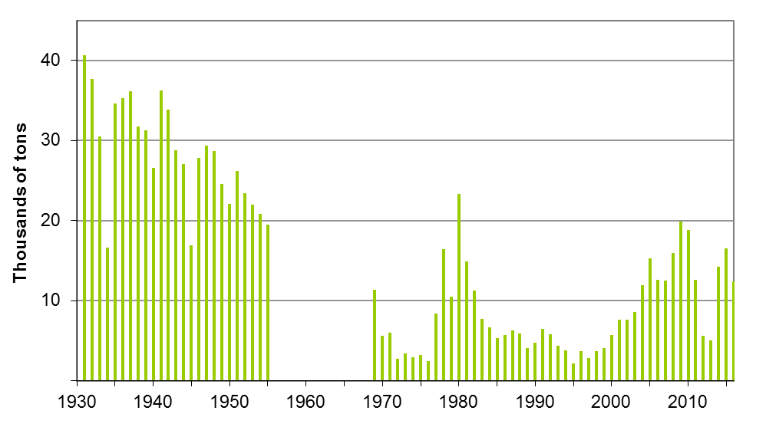
Figure 2. Historical catch of Eastern Georges Bank Haddock during 1931–1955 (Gavaris and Van Eeckhaute 1998) compared to recent catches during 1969–2016. Catch data for 1956 to 1968 were not available by unit area.
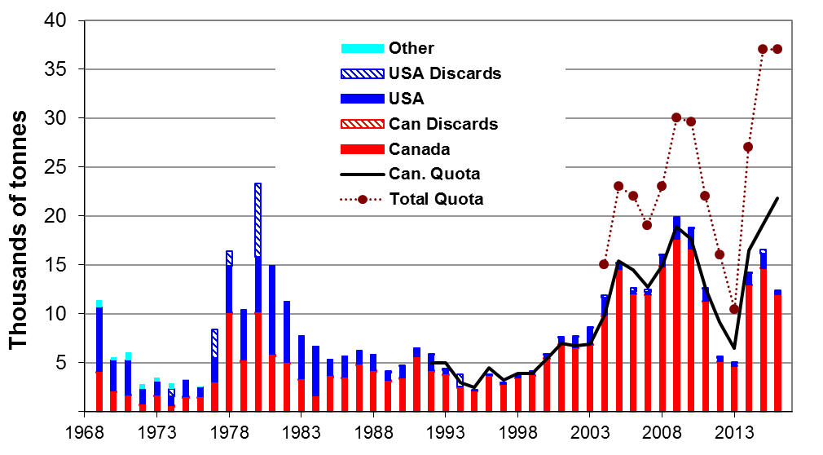
Figure 3. Nominal catches of Eastern Georges Bank Haddock during 1969–2016.

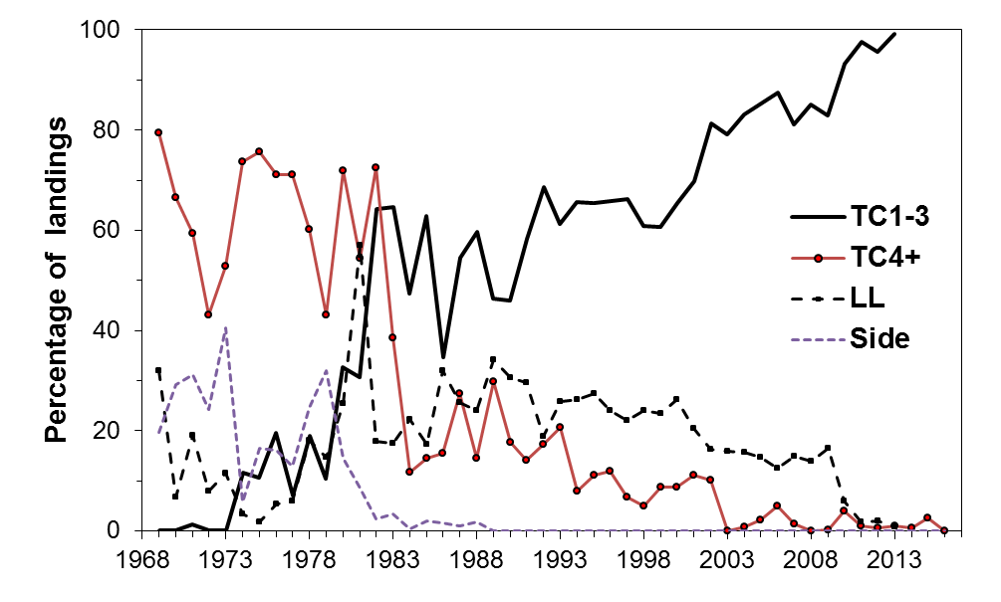
Figure 4. Percentage of annual landings (t) by gear type for the Canadian EGB Haddock fishery, 1969– 2016. TC 1–3 = otter trawl tonnage class 1–3; TC 4+ = otter trawl tonnage class 4+; LL = longline; Side = side otter trawl.
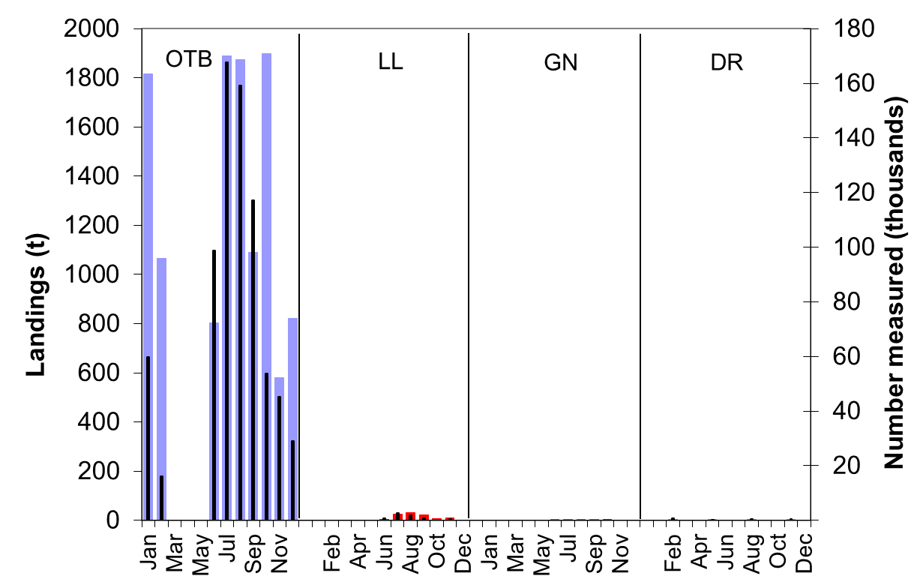
Figure 5. Haddock landings by the Canadian commercial groundfish fishery and discards from the scallop fishery from Eastern Georges Bank by month and gear in 2016 (wide bars) with sampling levels (narrow bars). Landings from the gillnet fishery were very low and no samples were available. OTB = otter trawl bottom, LL = longline, GN = gill net, DR = scallop dredge.
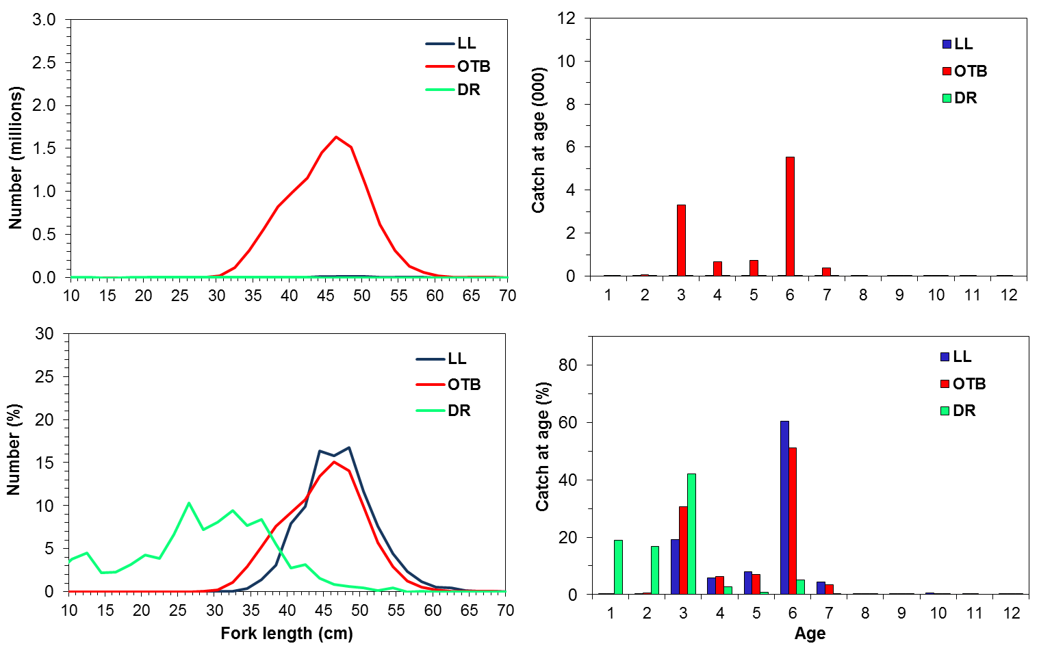
Figure 6. Canadian Eastern Georges Bank Haddock fishery catch at size (left panels) and catch at age (right panels) in numbers and percentage by gear category for 2016. OTB = otter trawl bottom, LL = longline, DR = scallop dredge.
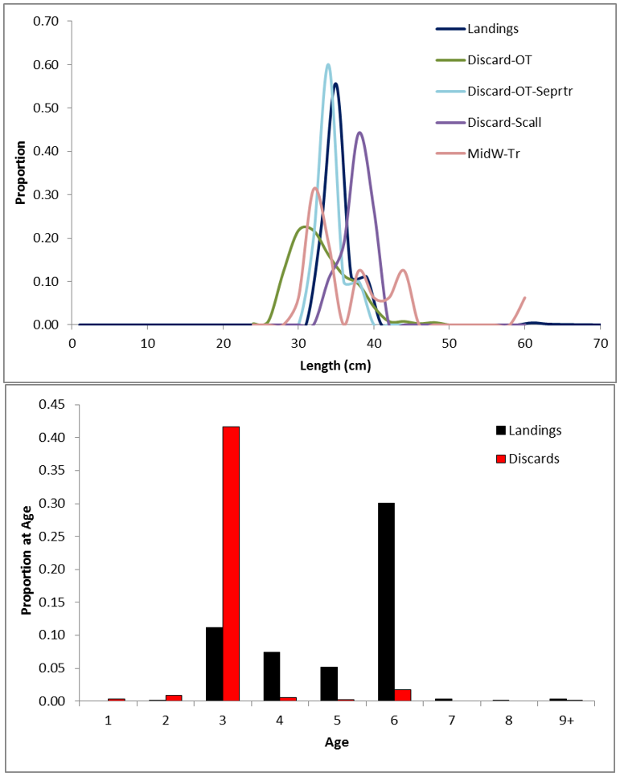
Figure 7. USA Eastern Georges Bank Haddock fishery catch at size (top panel) and catch at age (bottom panel) as a proportion for landings and discards in 2016.
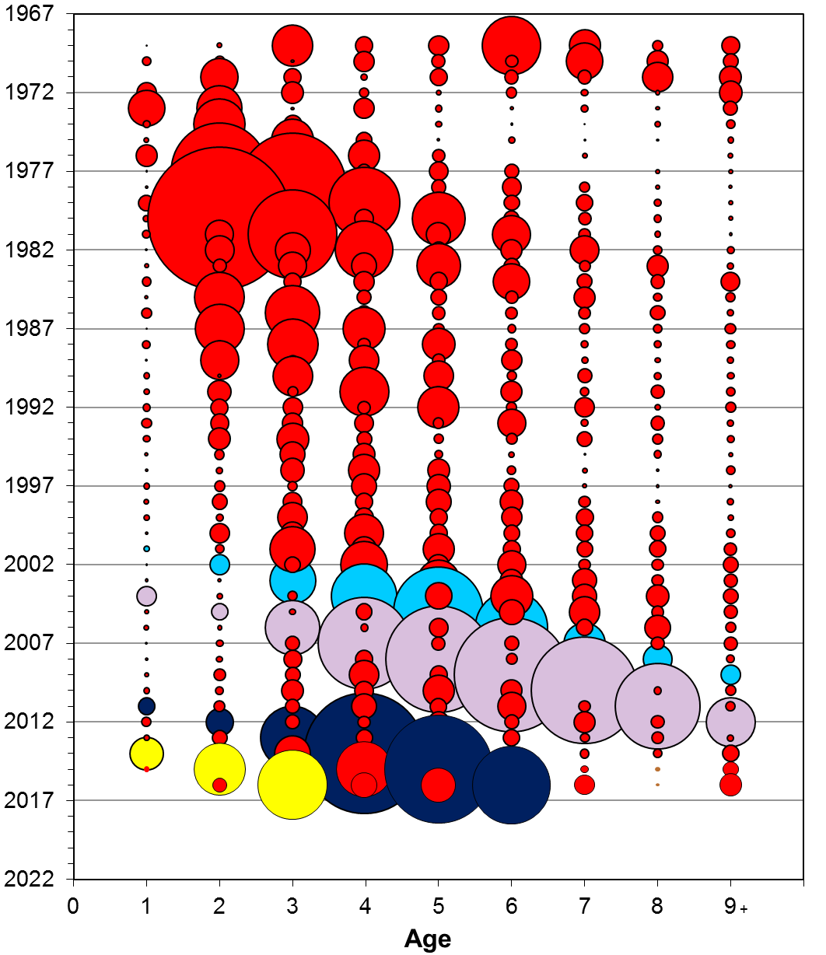
Figure 8. Total commercial catch at age (numbers) of Eastern Georges Bank Haddock during 1969–2016. The 2000, 2003, 2010 and 2013 year classes are indicated in blue, purple, dark blue, and yellow respectively. The bubble area is proportional to catch magnitude.
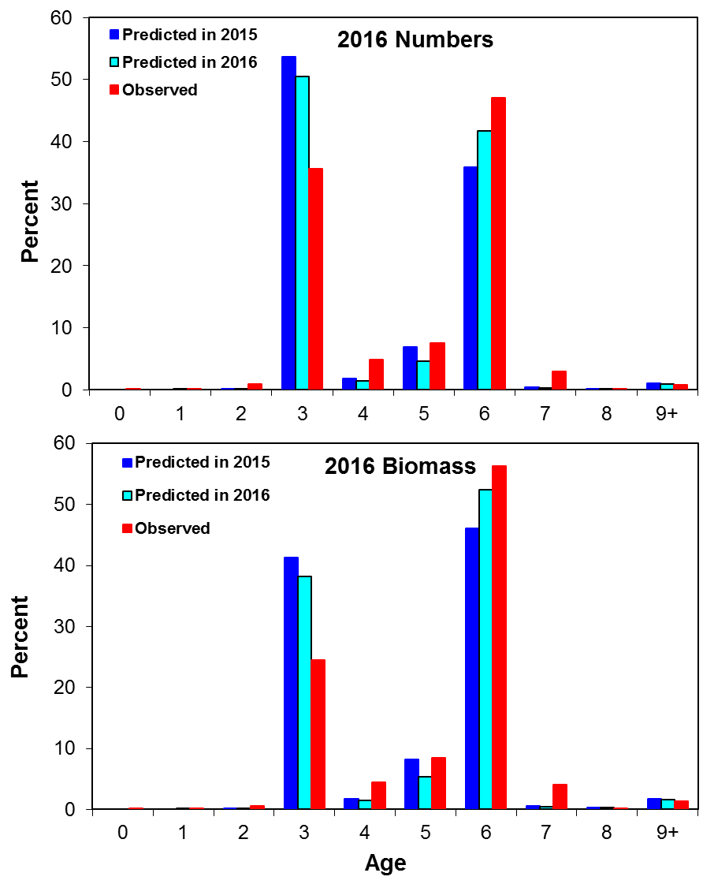
Figure 9. Percent composition in numbers and biomass of Eastern Georges Bank Haddock based on 2016 observed landings, predicted in 2015, upon which the quota was based, and predicted in 2016.
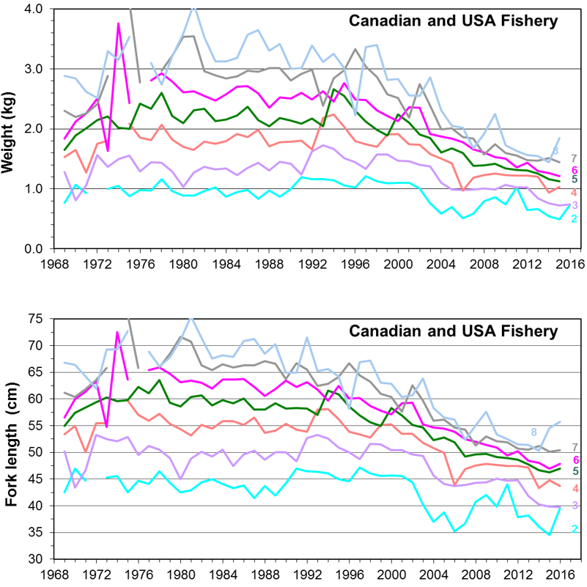
Figure 10. Average weights at age (Upper Panel) and lengths at age (Lower Panel) for Eastern Georges Bank Haddock from the combined Canadian and USA commercial groundfish fishery for 1969–2016.
Figure 11. Stratification scheme used for National Marine Fisheries Service (NMFS) surveys. The Eastern Georges Bank management area is indicated by shading.
Figure 12. Stratification scheme used for the Canadian Department of Fisheries and Oceans (DFO) survey. The Eastern Georges Bank management area is indicated by shading.
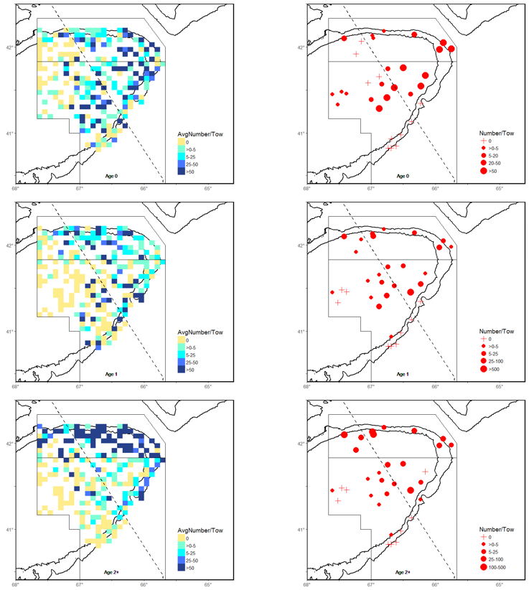
Figure 13. Distribution of Eastern Georges Bank Haddock abundance (number/tow) as observed from the NMFS fall survey for ages 0, 1 and 2+. The squares (left panels) are shaded relative to the average survey catch for 2004 to 2015. The expanding symbols (right panels) represent the 2016 survey catches. Length based conversion coefficients have been applied since the 2009 survey to make them comparable to surveys undertaken by the Albatross IV.
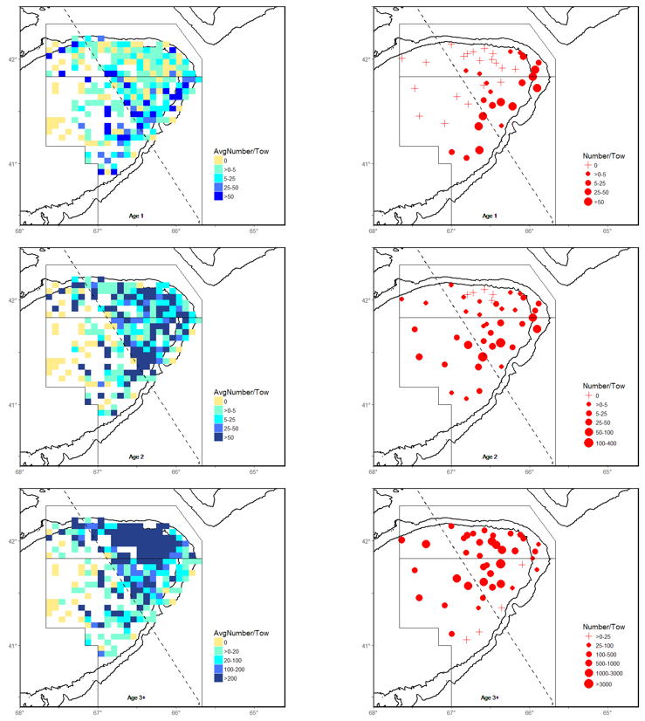
Figure 14. Distribution of Eastern Georges Bank Haddock abundance (number/tow) as observed from the DFO winter survey for ages 1, 2 and 3+. The squares (left panels) are shaded relative to the average survey catch for 2004 to 2016. The expanding symbols (right panels) represent the 2017 survey catches.

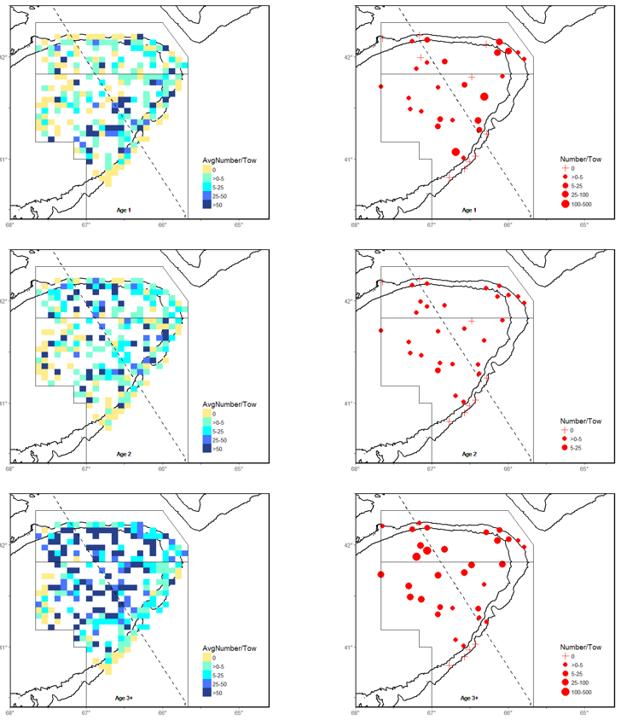
Figure 15. Distribution of Eastern Georges Bank Haddock abundance (number/tow) as observed from the National Marine Fisheries Service spring survey for ages 1, 2 and 3+. The squares (left panels) are shaded relative to the average survey catch for 2005 to 2016. The expanding symbols (right panels) represent the 2017 survey catches. Length based conversion coefficients have been applied since the 2009 survey to make them comparable to surveys undertaken by the Albatross IV.

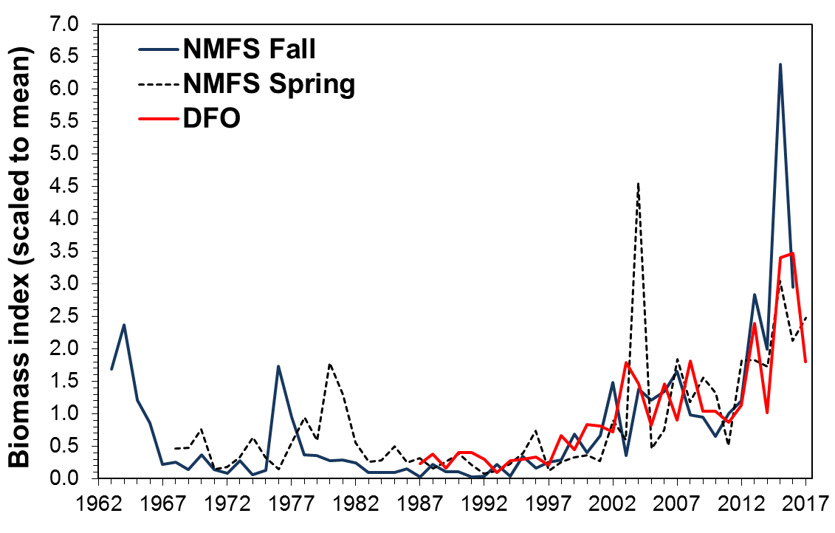
Figure 16. Scaled total biomass indices from NMFS fall (1963–2016), NMFS spring (1968–2017) and DFO (1987–2017) research surveys for Eastern Georges Bank. Biomass conversion coefficients have been applied to the NMFS surveys to adjust for changes in door type (BMV vs Polyvalent; 1968–1984), vessel (Delaware II vs Albatross IV; 1968–2008) and vessel/net (Albatross IV vs Henry B. Bigelow; Yankee 36 vs 4 seam-3 bridle; 2009–2017).

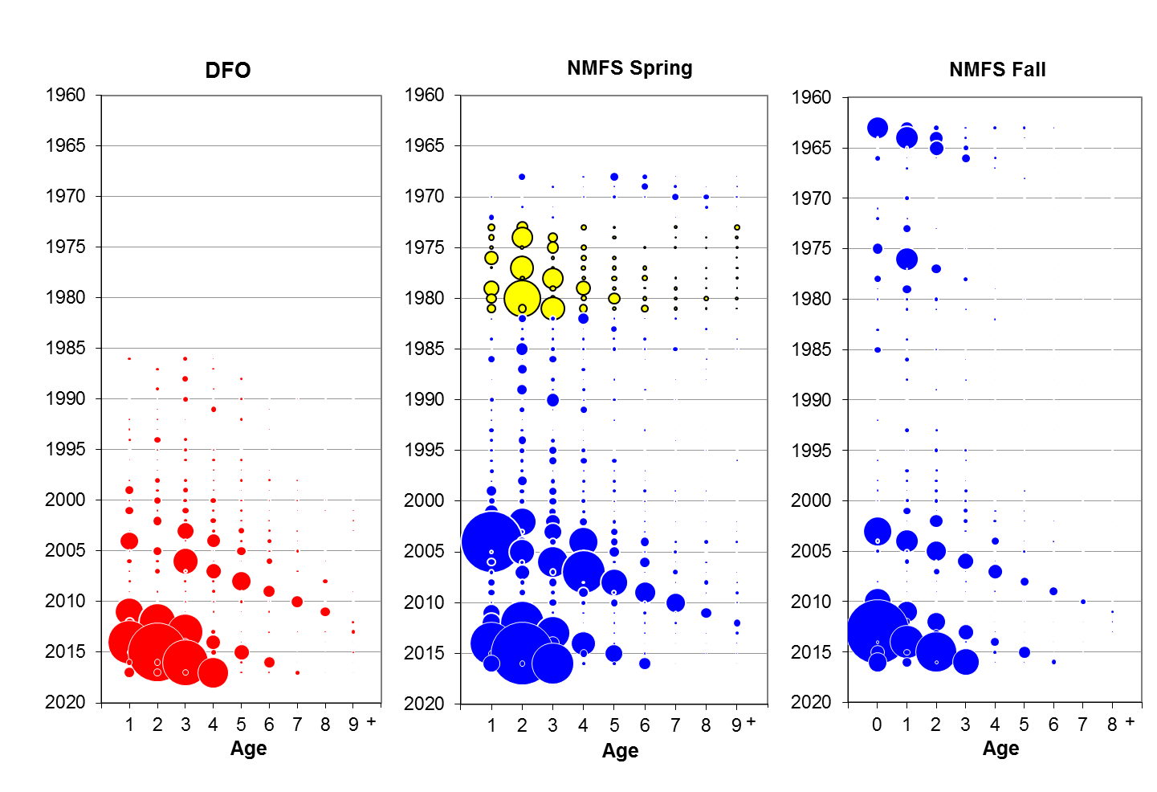
Figure 17. Estimated abundance at age (numbers in 000's) of Eastern Georges Bank Haddock for the Canadian Department of Fisheries and Oceans (DFO) for 1986 to 2017, the National Marine Fisheries Service (NMFS) spring survey for 1968 to 2017, and the NMFS fall survey for 1963 to 2016. Bubble area is proportional to magnitude (see Tables 18–20). Conversion factors to adjust for changes in door type and survey vessel were applied to the NMFS surveys. From 1973–81 (yellow circles), a 41 Yankee trawl was used for the NMFS spring survey while a 36 Yankee was used in the other years. Length based conversion coefficients have been applied to the NMFS surveys since the 2009 survey to make them comparable to surveys undertaken by the Albatross IV. Symbol size has not been adjusted between surveys for the catchability of the survey.
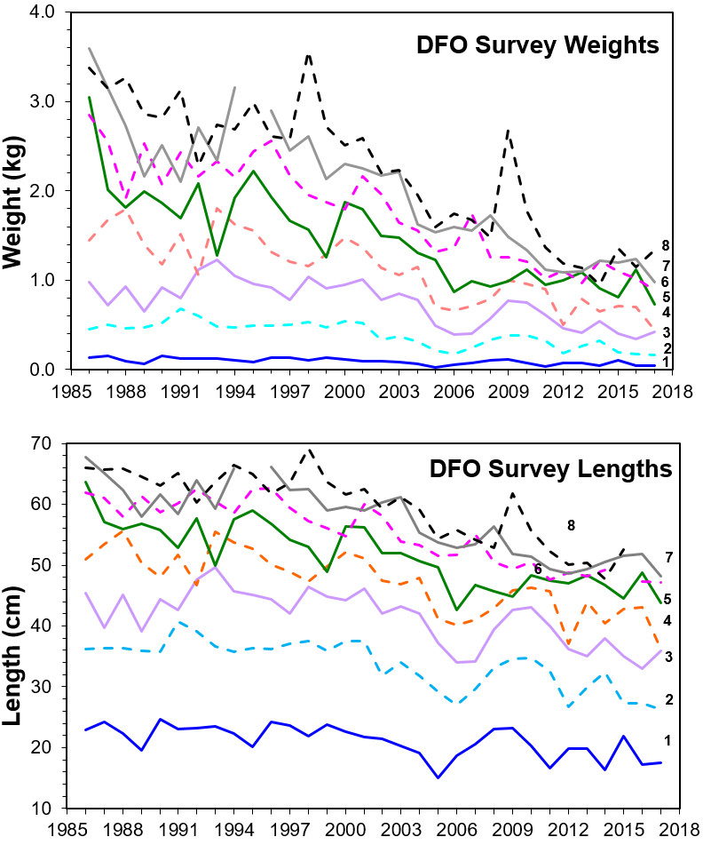
Figure 18. Average weights (upper panel) and lengths (lower panel) at age for Eastern Georges Bank Haddock derived from DFO winter surveys during 1986–2017.

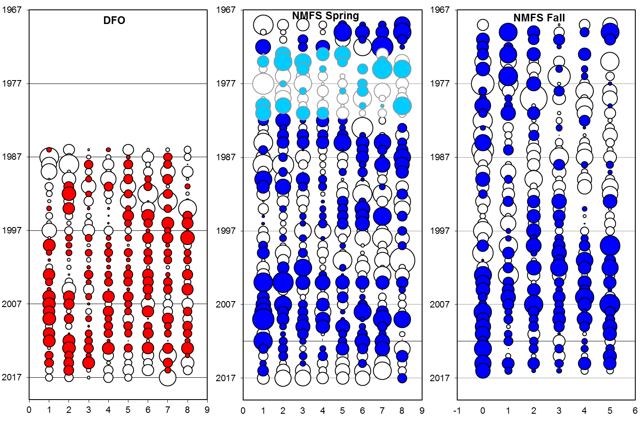
Figure 19. Residuals of survey abundance indices by year and age group from the DFO survey (1986–2017), the NMFS spring survey (1969–2017), and the NMFS fall survey (1969–2016) for Eastern Georges Bank Haddock. Solid symbols indicate positive values (i.e., model predicts lower abundance than surveys), open symbols indicate negative values (i.e., model predicts higher abundance than surveys). Bubble area is proportional to magnitude. From 1973–81 (light blue circles), a Yankee 41 trawl was used for the NMFS spring survey while a Yankee 36 trawl was used in the other years.
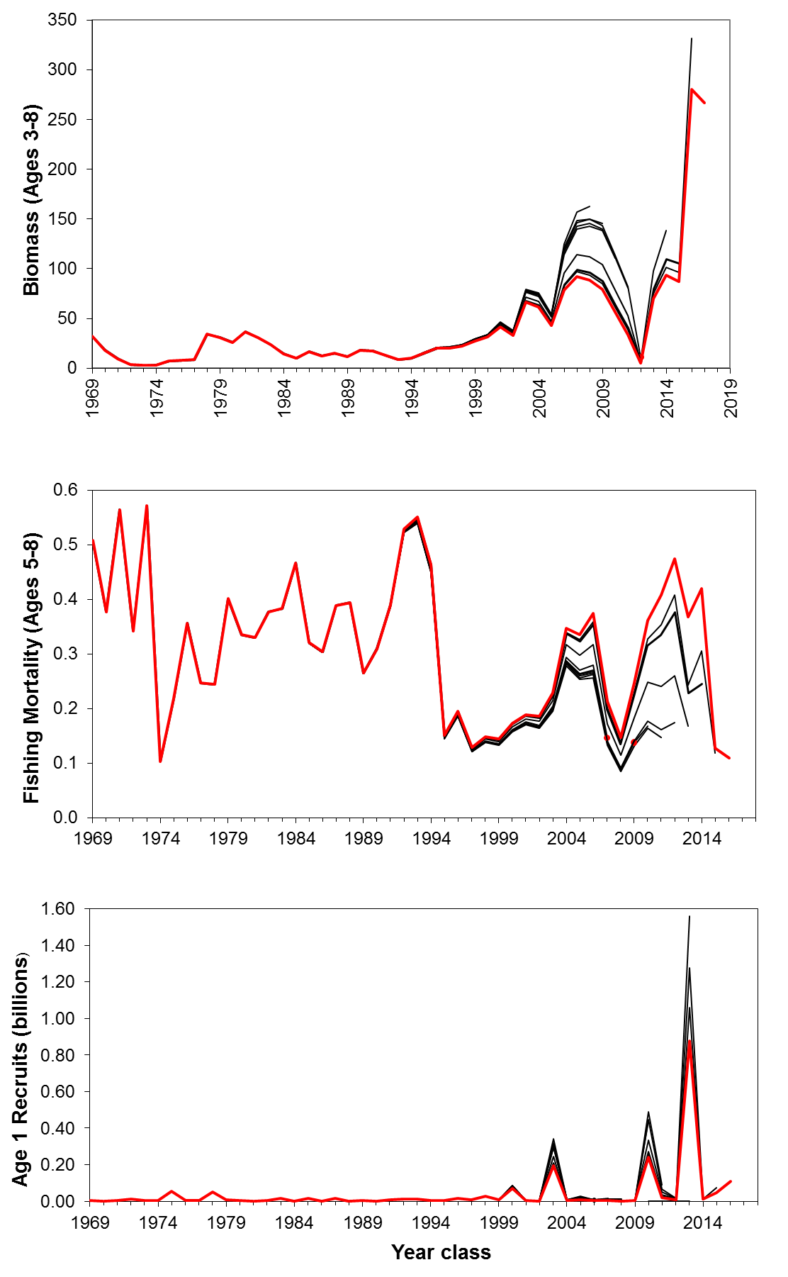
Figure 20. Retrospective results from virtual population analysis for Eastern Georges Bank Haddock for biomass (ages 3–8), fishing mortality (ages 5–8), and recruitment (age 1) as successive years of data are removed from the assessment. The most recent assessment results are indicated in red.
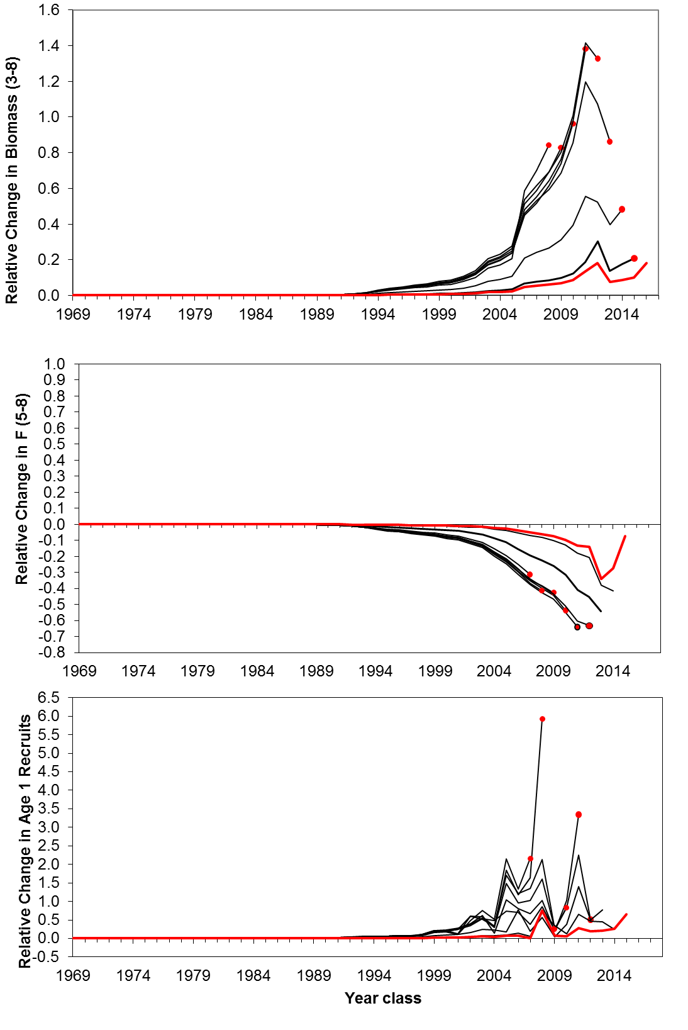
Figure 21. Relative retrospective results from virtual population analysis for Eastern Georges Bank Haddock for biomass (ages 3–8), fishing mortality (ages 5–8), and recruitment (age 1) as successive years of data are removed from the assessment. Changes are relative to the 2017 assessment.
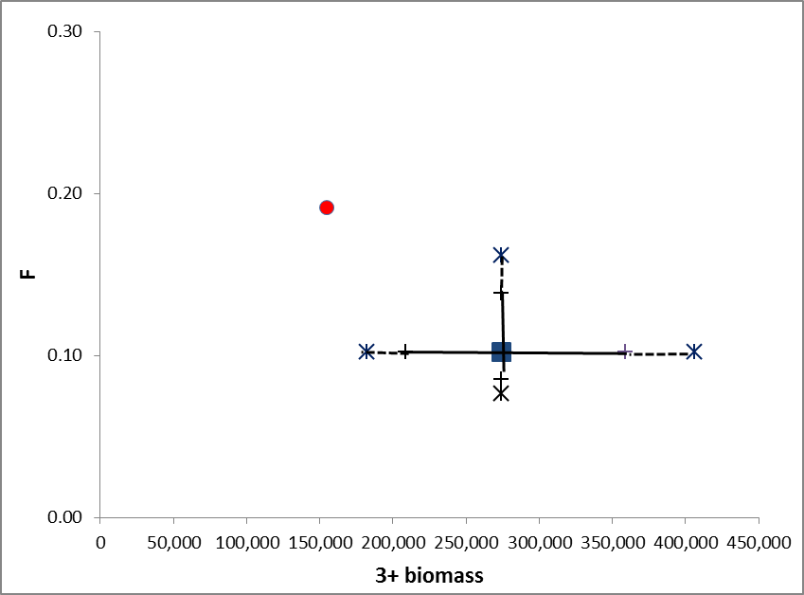
Figure 22. Estimate of fishing mortality (F) on ages 5 to 8 and ages 3+ biomass estimated using the Benchmark vital population analysis (VPA) formulation (blue square) and the rho adjusted value (red circle). The solid lines show the 80% confidence interval around the benchmark estimate, while the dotted lines show the 95% confidence interval. (Note: The % rho adjustment value of 0.564 for ages 3–8 biomass was used to adjust the age 3+ biomass estimate at the beginning of 2017).
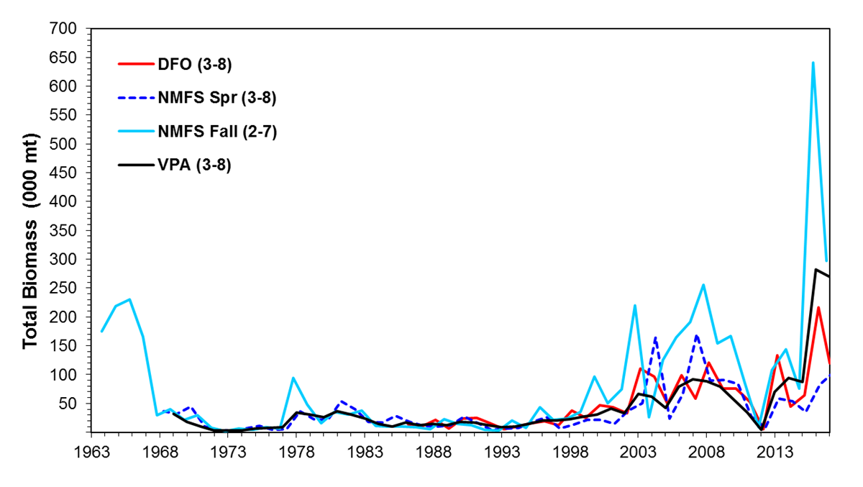
Figure 23. The 1969 to 2017 Eastern Georges Bank adult Haddock (ages 3-8) biomass from Virtual Population Analysis compared with the survey adult biomass (scaled with catchabilities) for ages 3–8 (DFO and NMFS spring) and ages 2–7 (NMFS fall).
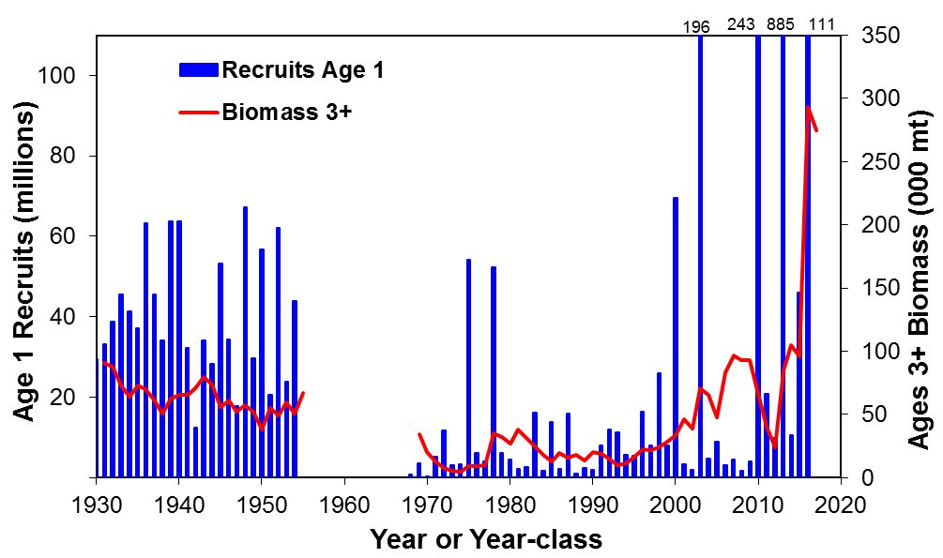
Figure 24. Beginning of year adult (3+) biomass and number of age 1 recruits for Eastern Georges Bank Haddock during 1931–1955 and 1969–2017.
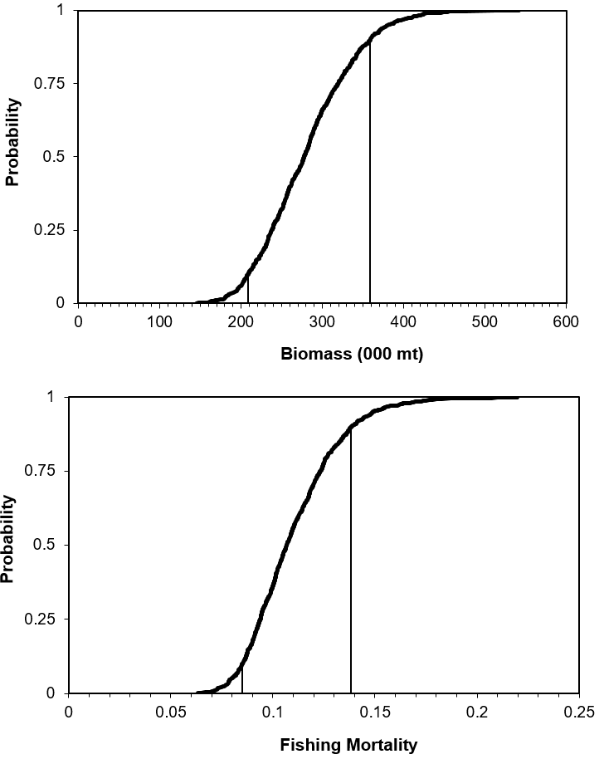
Figure 25. Cumulative probability distribution with 80% confidence intervals for 2017 age 3+ biomass (000 mt) and 2016 ages 5–8 fishing mortality (F) for Eastern Georges Bank Haddock. CI for biomass = 208,936–359,156 mt; CI for F = 0.08–0.14.
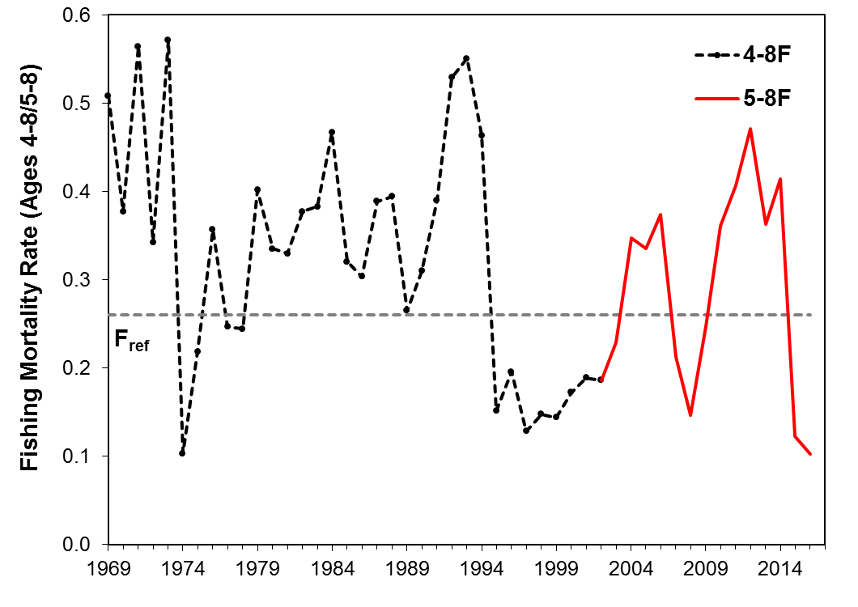
Figure 26. Fishing mortality rate (F; weighted by population) for Eastern Georges Bank Haddock ages 4+ and 5+ during 1969–2016 and the fishing mortality threshold reference established at F_{ref} = 0.26.

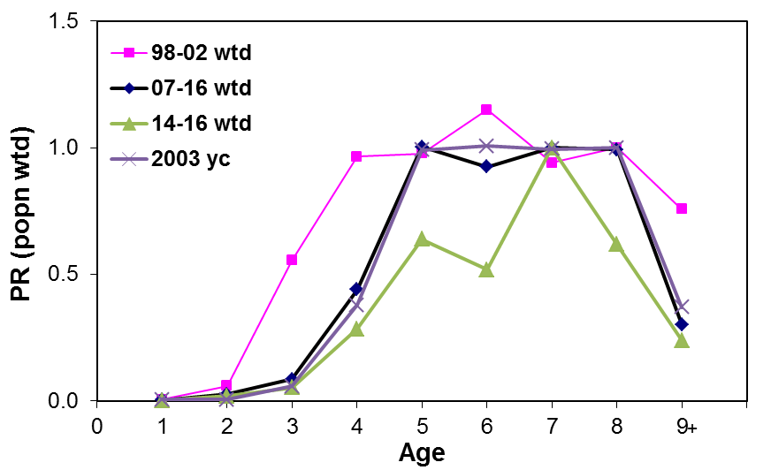
Figure 27. Partial recruitment of Eastern Georges Bank Haddock for the population weighted average of 1998–2002, 2007–2016, 2014–2016 and for the 2003 year class. The partial recruitment is normalized to ages 4–8 for years before 2003 and to ages 5–8 for years after 2002.
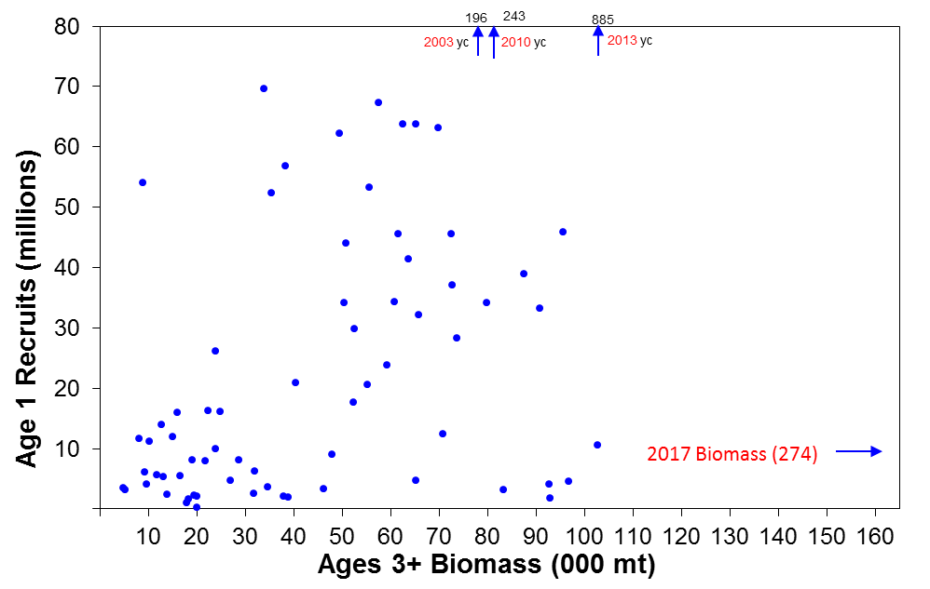
Figure 28. Relationship between Eastern Georges Bank adult (ages 3+) Haddock biomass during 1931-1955 and 1969–2016 and recruits at age 1. The large year classes since 2000 are labeled in red font.
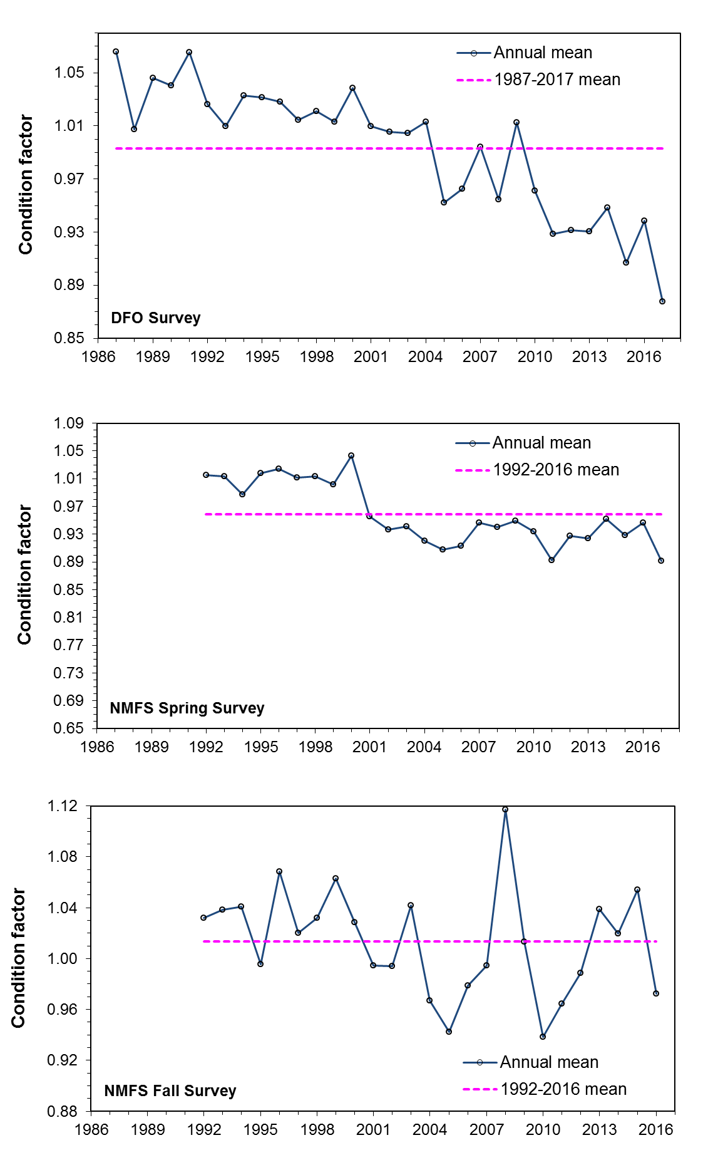
Figure 29. Annual mean condition as indicated by Fulton’s K (W/L³) for Eastern Georges Bank Haddock (30–70 cm FL) from the DFO survey (1986–2017; top panel), NMFS Spring Survey (1992–2017; middle panel) and NMFS fall survey (1992–2016; lower panel). The pink dashed line is the mean value for the survey time series.
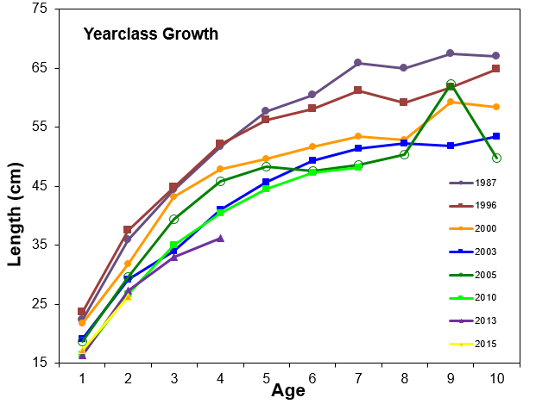
Figure 30. Mean length at age for selected year classes of Eastern Georges Bank Haddock sampled from the DFO survey.
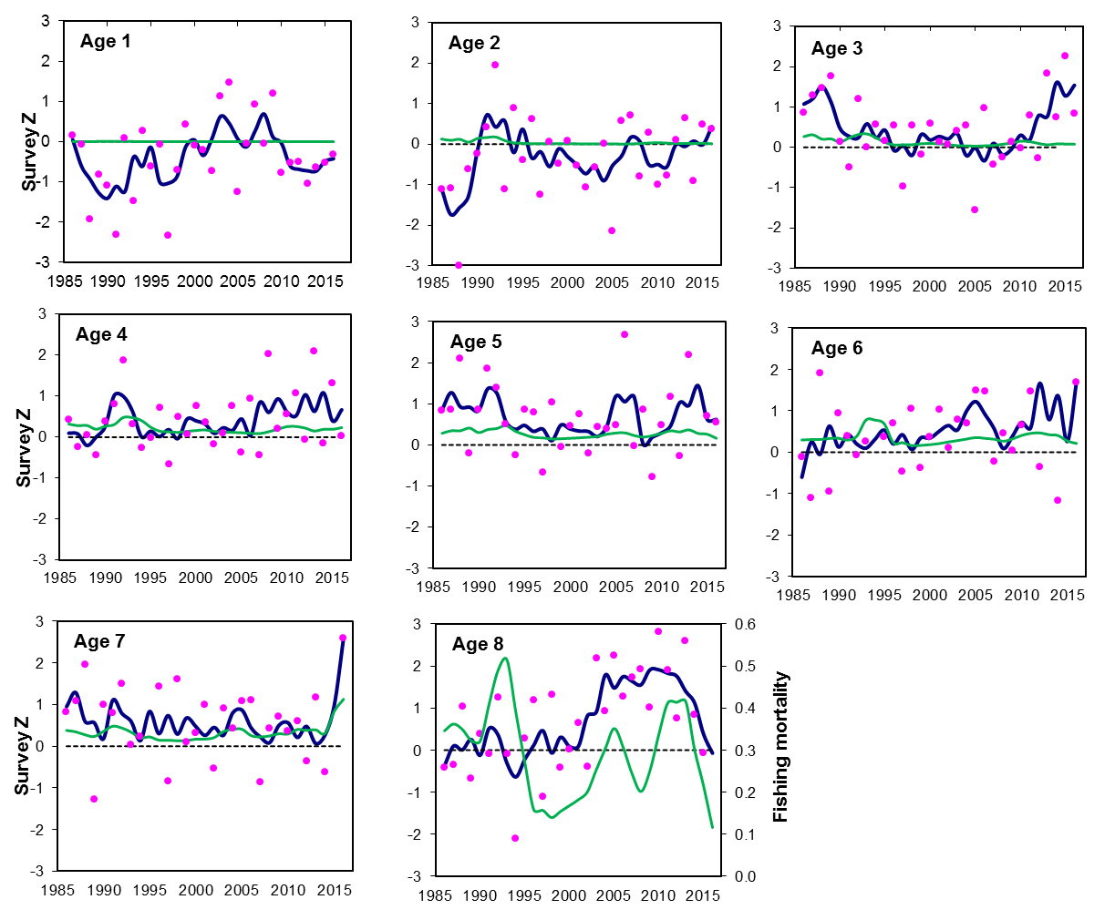
Figure 31. Eastern Georges Bank Haddock total mortality (Z; 3-year smooth, navy blue line and pink circles are the annual z value) for ages 1–8 from DFO survey catch at age data, 1986–2016 compared to F for age 1–8 (F; 3-year smooth, green line) calculated from the 2017 VPA model output.
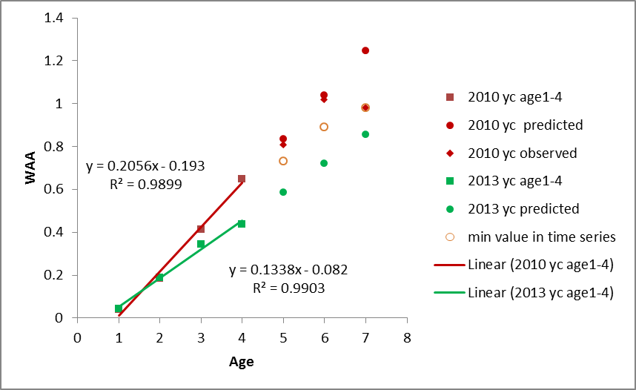
Figure 32. Linear regression model examining the relationship between survey weight and age of Eastern Georges Bank Haddock. Solid squares represent observed values for ages 1–4 (red for 2010 year class [yc] and green for 2013 yc). Solid circles represent predicted values from the linear regression function. Open circles represent the minimum weight value in the time series (1969–2017). Diamonds represent the observed data for the 2010 yc based on the survey.
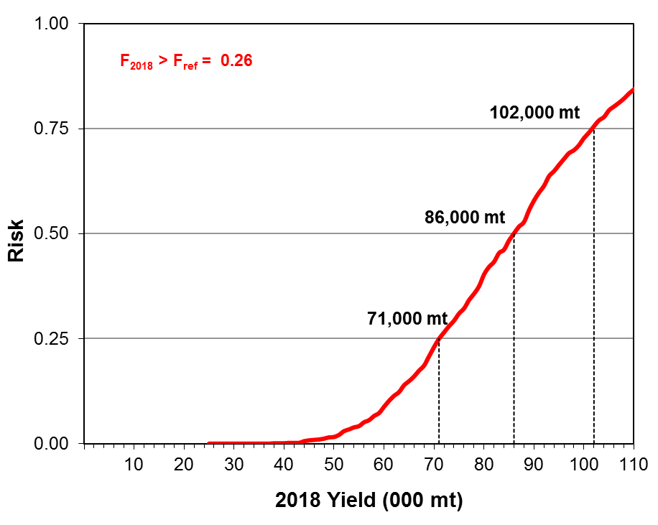
Figure 33. Risk of 2018 fishing mortality exceeding F_{ref} = 0.26 for Eastern Georges Bank Haddock for increasing catch quotas.
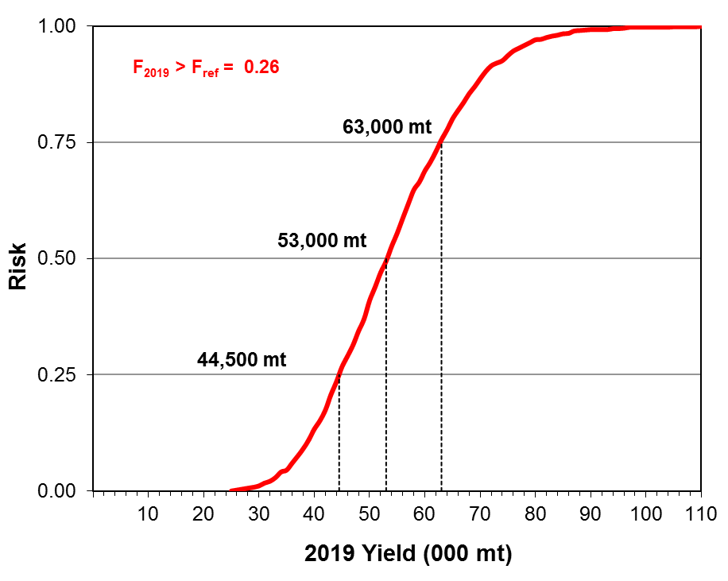
Figure 34. Risk of 2019 fishing mortality exceeding F_{ref} = 0.26 for Eastern Georges Bank Haddock for increasing catch quotas.
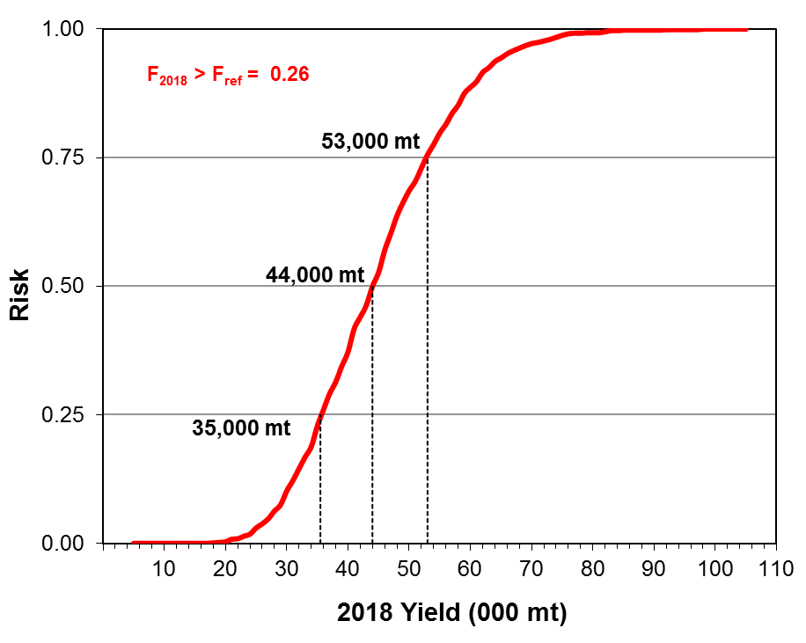
Figure 35. Sensitivity risk analysis of 2018 fishing mortality exceeding F_{ref} = 0.26 for Eastern Georges Bank Haddock for increasing catch quotas. A rho adjustment (0.564) was applied to down weight the 2017 population estimates prior to conducting risk calculations.
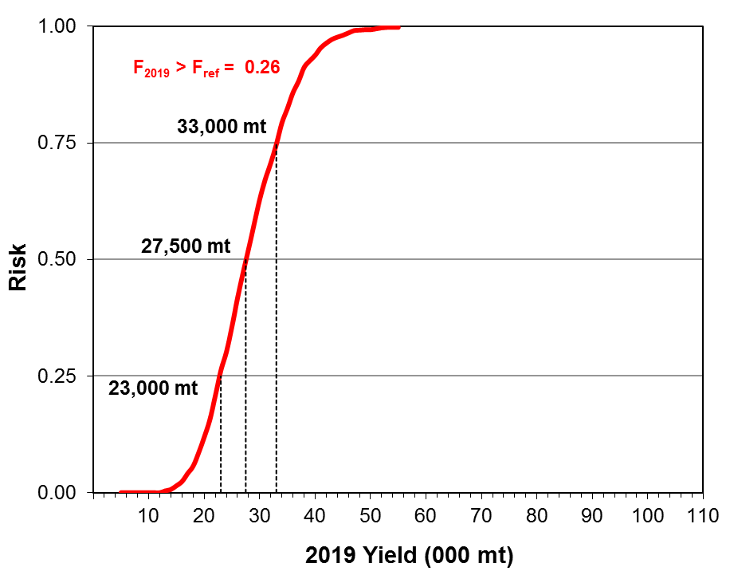
Figure 36. Sensitivity risk analysis of 2019 fishing mortality exceeding F_{ref} = 0.26 for Eastern Georges Bank Haddock for increasing catch quotas. A rho adjustment (0.564) was applied to down weight the 2017 population estimates prior to conducting risk calculations.

Appendices
Appendix A. Comparison of contemporary estimates of F_{40%} and F_{0.1} to current F_{ref} for Eastern Georges Bank Haddock
The current fishing mortality reference (F_{ref}) of 0.26 for EGB Haddock was adopted by TMGC in 2003 (TMGC 2003). This value was calculated from per-recruit analysis and by coincidence F_{0.1} = F_{40%} = 0.26. Since 2003, both survey and fishery data have shown substantial fish growth changes (Figure A1). Together with continued changes in fishery management measures in both countries, there was some concern if the F_{ref} = 0.26 is still reflective of the current fishery.
Using the output from a VPA run updated to 2015, the fishery partial recruitment (PR) was calculated from the population number weighted average of fishing mortality. It showed that PR changed around 2002 due to fish growth, fishery minimum size, and mesh size changes. The fully recruited age changed from age 4 to age 5 (Figure A2). Considering the declining trends in weight-at-age since 2002 (Figure A1) and changes in PR (Figure A2), there were two runs completed for the contemporary estimates of F_{40%} and F_{0.1}. The most recent 5 year (2011–2015) and longer time series (2002–2015) average of PR (weighted by population) and fish growth data were used for the calculation of F_{0.1} and F_{40%}, respectively. The data input for the two runs are shown in Table A1.
Using the two different time period data, both F_{0.1} and F_{40%} were greater than the current F_{ref} of 0.26 with F_{40%} values lower than F_{0.1} for both the 5 year average, and long time-series average (Table A2), which reflects the impact of PR and fish growth changes.
To illustrate the sensitivity of F_{0.1} and F_{40%} to the assumed PR on older ages, and in particular the plus group, two sensitivity cases were examined for both the 5 year and the longer time-series average inputs. For the 5-year average, sensitivity case 1 set PR at ages 9+to 0.7 (equal to the PR at ages 7 and 8, so only slight doming), while sensitivity case 2 set PR at ages 7 and older to 1 (flat selectivity). For the longer time-series average, sensitivity case 1 set PR at ages 9+to 0.7 (for comparison with the 5-year average run), while sensitivity case 2 set the PR at ages 9+to 1. The estimated values for F_{0.1} and F_{40%} reduce substantially as selectivity on the older ages increases from the severe dome (PR = 0.2 or 0.3), to a slight dome (PR = 0.7), to fully selected (PR = 1.0).
The sensitivity runs show that PR at older ages can be very influential on F_{0.1} and F_{40%.} It is important to keep the consistency for the PR between F_{ref} calculation, VPA model output, and projection. Otherwise, the F_{ref} might lose its intended meaning, which could lead to increased risk or precaution. If a dome-shaped PR was used in the F_{ref} calculation, a projection using flat topped PR would result in a risk of catch exceeding F_{ref}. On the other hand, if the F_{ref} calculation was based on flat-topped PR, a dome-shaped PR at older ages in the projection would lead to forgo yield.
The above analysis showed that the current F_{ref} = 0.26 is more conservative. In order to be consistent with the assessment model, normally F_{ref} is re-calculated at benchmark meetings. The analysis here is for information only, as F_{ref} is a negotiated value at TMGC.
Table A1. Data inputs for the per-recruit analysis using a 5-year (2011–2015) average (A) and longer time-series (2002–2015) average (B) for partial recruitment (PR), fishery weights at age (WAA), and spawning stock weights at age.
A) |  |  |  |  |  | B)
Age | M | PR | Fishery Weight | Spawning Weight | Maturity | Age | M | PR | Fishery Weight | Spawning Weight | Maturity
1 | 0.2 | 0 | 0.271 | 0.065 | 0 | 1 | 0.2 | 0 | 0.361 | 0.073 | 0
2 | 0.2 | 0.02 | 0.674 | 0.256 | 0 | 2 | 0.2 | 0.02 | 0.735 | 0.288 | 0
3 | 0.2 | 0.1 | 0.877 | 0.485 | 1 | 3 | 0.2 | 0.2 | 1.049 | 0.587 | 1
4 | 0.2 | 0.4 | 1.125 | 0.710 | 1 | 4 | 0.2 | 0.5 | 1.299 | 0.837 | 1
5 | 0.2 | 0.7 | 1.235 | 0.952 | 1 | 5 | 0.2 | 1 | 1.496 | 1.083 | 1
6 | 0.2 | 1 | 1.315 | 1.081 | 1 | 6 | 0.2 | 1 | 1.666 | 1.338 | 1
7 | 0.2 | 0.7 | 1.491 | 1.143 | 1 | 7 | 0.2 | 1 | 1.825 | 1.496 | 1
8 | 0.2 | 0.7 | 1.605 | 1.203 | 1 | 8 | 0.2 | 1 | 1.995 | 1.667 | 1
9+ | 0.2 | 0.2 | 1.801 | 1.440 | 1 | 9+ | 0.2 | 0.3 | 2.276 | 1.962 | 1
Table A2. Contemporary estimates for fishing mortality (F_{40% and} F_{0.1)} using the 5-year (2011–15) average and longer time-series (2002–2015) average of spawning weights at age (WAA), fisheries WAA and partial recruitment (PR). Two sensitivity analyses were explored for each time-series average case.
Time period | F_{0.1} | F_{40%}
5 year average (2011–2015) | 0.63 | 0.55
(Sensitivity 1) 5 year average, PR(age 9+) = 0.7 | 0.44 | 0.51
(Sensitivity 2) 5 year average, PR(ages 7 to 9+) = 1.0 | 0.34 | 0.47
14 year average (2002–2015) | 0.45 | 0.38
(Sensitivity 1) 14 year average, PR(age 9+) = 0.7 | 0.36 | 0.36
(Sensitivity 2) 14 year average, PR(age 9+) = 1.0 | 0.31 | 0.35
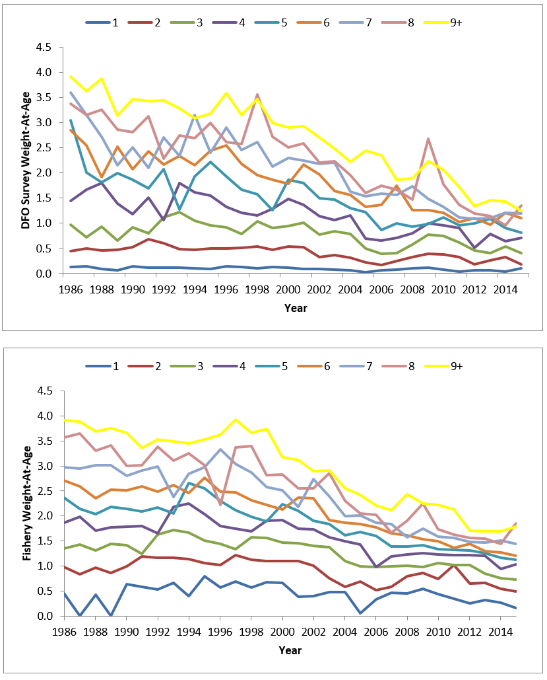
Figure A1. Eastern Georges Bank Haddock weights at age from the DFO Survey (upper panel) and fisheries (lower panel) for 1986–2015.
Figure A2. Average partial recruitment of Eastern Georges Bank Haddock for three time blocks (1993-2002, 2002–2015,and 2011–2015).
Appendix B. Data and model changes to the Eastern Georges Bank Haddock assessment framework from 1998 to 2017.
Assessment  Year | Change
1998 | Framework:  Random error in catch at age negligible.  Error in abundance indices assumed independent and identically distributed after taking the natural logarithms.  Annual natural mortality rate (M) = 0.2.  Fishing mortality (F) on age 8 = weighted F on ages 4 to 7.  9+ age group calculated but not calibrated to indices.  In Q1 of first year, 9+ based on assumption that F9+ = popn weighted F4-8. In Q1 of subsequent years, 9+ abundance calculated as sum of age 8 and 9+ at end of last quarter of previous year.  Quarterly catch at age: 0,1,2…8,9+; 1969.0, 1969.25, 1969. 75, 1970.0…1996.75.  DFO survey: ages 1,2,3…8; 1986.16, 1987.16…1998.0.  NMFS spring (Yankee 36): age 1,2,3…8; 1969.29, 1970.29…1997.29.  NMFS spring (Yankee 41): age 1,2,3…8; 1973.29, 1974.29…1981.29.  NMFS fall: 0,1,2…5, 1969.69, 1970.69…1997.69.  Zero survey observations treated as missing data.
1999 | Minor differences in the handling of zero terminal catches for a year class were implemented as a refinement to the software to afford more flexibility.
2003 | NMFS spring (Yankee 36): age 1,2,3…8; 1969.29, 1970.29…2003.25. (In previous years, the last survey available was the same year as the last catch at age year.)  Catch of 0 was assumed for the 1st quarter of 2003 and the population calculated to beginning of 2003.25.
2005 | Discards ages 1 and older from Canadian scallop fishery included in catch at age but age 0 set to zero.  Population calculated to beginning year 2005.  NMFS and DFO spring surveys in 2005 set to time = 2005.00.
2007 | Discards at age 0 included in catch at age.
2008 | 1) an annual catch at age instead of a quarterly catch at age.  2) revised survey timing: DFO spring from 0.16 to 0.17, NMFS spring from 0.29 to 0.28 and the NMFS fall survey from 0.69 to 0.79.  3) a change from ages 4 to 7 to 5 to 7 (weighted by population numbers) used to estimate oldest age F from 2003 to present.
2009 | USA 2007 catch corrected from previous year (calculation error).  The landings at age for 2006 to 2007 were recalculated.  USA landings for 1994 to 2007 revised using new methodology. (Effect was negligible.)  USA landings at age from 1991 to 2005 were revised to reflect the recalculated landings using a scalar adjustment.  USA discards recalculated using ratio of discarded Haddock to kept of all species for 1989 to 2007.  Discards at age were not revised for 1989 to 2000 as amounts were low, except for 1994 (old = 258 vs new = 1,021 mt). No adjustment to the 1994 discards at age was made due to the uncertainty of this estimate.  Discard at age estimates for 2001 to 2007 were revised by a scalar.  2009 NMFS spring survey not used (no conversion factors).
2010 | 9+ group in catch at age expanded to 9 to 16+; ages 15 and 16 dropped; 9+ group reconstructed from ages 9 to 14.  Revisions made to USA landings, Canadian scallop discards and USA groundfish fishery discards at age. Largest change for 1994 discards from 258 mt to 1279 mt.
2011–2013 | No additional changes.  Note that the 2010 fall survey was used at twice its actual value in the 2011 and 2012 assessments. The effect on the 2012 assessment results are as follows:  - 2010 yc declined from 589 M to 532 M  - 1+ population declined from 644,586 K to 597,434 K  - 3+ population declined from 57,745 to 55,964 K  - 3+ biomass declined from 70,679 mt to 68,521 mt  - risk analysis for 2013 F_{ref} catch declined by 700 mt from 10,400 mt to 9,700 mt
2014 | NMFS 2012 spring survey:  For the 2012 and 2013 assessments the survey results did not incorporate some lengths for which there were no ages. The numbers involved were small. Updated values also reflect an increase in the number of tows, changes to the numbers per tow and a large increase in the numbers aged.  NMFS 2011 fall survey:  The NMFS 2011 fall survey used incorrect stratum area values for strata 5Z3 and 5Z4 for the 2012 and 2013 assessments. Updated values also reflect changes to the numbers per tow.  Canadian scallop discards:  Revised 2005 to 2012 to reflect updated values due to change from freezer trawler equivalents to hours x meters as new effort measure and other data changes. Largest percent difference from previous values for age/year was 19%. Largest annual change was 7%. Canadian scallop discards contribute a very small amount to the total catch.
2015 | Retrospective pattern which emerged in 2014 persisted in 2015
2016 | Haddock Interim Report, full assessment not conducted.
2017 | Retrospective pattern which emerged in 2014 persisted in 2017.  Projection inputs changed for beginning and fisheries weight-at-ages for 2013 year class to take into account the slower growth of this year class.

Appendix C. Comparison of EGB Haddock TRAC catch advice, TMGC quota decision, actual catch, resulting fishing mortality and biomass changes. All catches are calendar year catches. In the “Results” column, values in italics are assessment results in the year immediately following the catch year; values in normal font are results from the 2017 assessment. This table was kindly provided by Tom Nies (New England Fisheries Management Council) in 2011 and updated to the 2013 assessment. Updates from 2013 were performed by Jamie Cournane (New England Fisheries Management Council).
TRAC | Catch Year |  | TRAC Analysis/Recommendation |  |  | TMGC Decision |  |  | Actual Catch/ Compared to Risk Analysis | Results |  | Comments²
TRAC |  |  | Amount | Rationale/Biomass |  | Amount | Rationale
1999¹ | 1999 |  | 6,300 mt | F_{0.1} |  | NA | NA |  | 4,093 mt | Below F_{0.1} |  | -
2000¹ | 2000 |  | 8,800 mt | F_{0.1} |  | NA | NA |  | 5,774 mt | Below F_{0.1} |  | -
2001¹ | 2001 |  | 9,700 mt | F_{0.1} |  | NA | NA |  | 7,597 mt | Below F_{0.1} |  | -
2002¹ | 2002 |  | 10,700 mt | F_{0.1} |  | NA | NA |  | 7,623 mt | Below F_{ref} = 0.26 |  | -
Transition to TMGC process in following year; note catch year differs from TRAC year in following lines
F’s below are based on Age 5+
2003 | 2004 |  | (1) 20,000 mt  (2) 8,000 mt | (1) Low risk of exceeding F_{ref}  (2) Neutral risk of biomass decline |  | 15,000 mt | Low risk of exceeding F_{ref} and reduction in biomass > 10% |  | 11,919 mt  Low risk of exceeding F_{ref} | F₂₀₀₄ = 0.17  Age 3+ biomass decrease of 27% 2004 to 2005  3+ B₂₀₀₅ = 49,900 mt  F₂₀₀₄ = 0.347  Age 3+ biomass decreased 25% 2004 to 2005  3+ B₂₀₀₅=47,900 mt |  | In projection, PR on age 4 (2000 year class) was set to 1. Realized was 0.3. Fully recruited ages now 5–8.
2004 | 2005 |  | 26,000 mt | Neutral risk of exceeding F_{ref}  Adult biomass will increase substantially  3+ B₂₀₀₆ = 513,700 mt |  | 23,000 mt | Low risk of exceeding F_{ref}  Adult biomass will increase substantially |  | 15,257 mt  Low risk of exceeding F_{ref} | F₂₀₀₅ = 0.29  Age 3+ biomass increase of 142% 2005 to 2006  3+ B₂₀₀₆ = 122,700 mt  F₂₀₀₅ = 0.335  Age 3+ biomass increased 75% 2005 to 2006  3+ B₂₀₀₆ = 83,300 mt |  | Higher F due to lower realized PR and weights at age for 2003 year class and lower weights for 2000 year class.  Large biomass increase due to 2003 year class.
2005 | 2006 |  | 22,000 mt/18,000 mt | Neutral/low risk of exceeding F_{ref}  3+ B₂₀₀₇ = 157,400 mt |  | 22,000 mt | Neutral risk of exceeding F_{ref} |  | 12,630 mt  Low risk of exceeding F_{ref} | F₂₀₀₆ = 0.36  Age 3+ biomass increase of 26% 2006 to 2007  3+ B₂₀₀₇ =145,300 mt  F₂₀₀₆ = 0.373  Age 3+ biomass increased 15% 2006 – 2007  3+ B₂₀₀₇ = 96,800 mt |  | Higher F due to lower realized PR and weights at age for 2003 year class and lower weights for 2000 year class.
2006 | 2007 | 19,000 mt/16,000 mt |  |  | Neutral/low risk of exceeding F_{ref}  3+ B₂₀₀₈ = 161,900 mt | 19,000 mt |  | Neutral risk of exceeding F_{ref} | 12,510 mt  Low risk of exceeding F_{ref} |  | F₂₀₀₇ = 0.14  Age 3+ biomass increase of 4% 2007 – 2008  3+ B₂₀₀₈ = 158,100 mt  F₂₀₀₇ = 0.212  Age 3+ biomass decreased 4% 2007 to 2008  3+ B₂₀₀₈ = 93,000 mt | 2003 year class specific values for projection inputs.
2007 | 2008 | 26,700 mt/  23,000 mt |  |  | Neutral/low risk of exceeding F_{ref}  3+ B₂₀₀₉ = 145,700 mt | 23,000 mt |  | Low risk of exceeding F_{ref} | 16,003 mt  Low risk of exceeding F_{ref} |  | F₂₀₀₈ = 0.09  Age 3+ biomass increase of 7% 2008 to 2009  3+ B₂₀₀₉ = 155,600 mt  F₂₀₀₈ = 0.147  Age 3+ biomass decreased < 1% 2008 to 2009  3+ B₂₀₀₉ = 92,800 mt | 2003 year class specific values for projection inputs.
2008 | 2009 | 33,000 mt  /28,000 mt |  |  | Neutral/low risk of exceeding F_{ref}  3+ B₂₀₁₀ = 125,500 mt | 30,000 mt |  | Low to neutral risk of exceeding F_{ref} | 19,855 mt  Low risk of exceeding F_{ref} |  | F₂₀₀₉ = 0.13  Age 3+ biomass decrease of 21% 2009 to 2010  3+ B₂₀₁₀ = 125,100  F₂₀₀₉ = 0.247  Age 3+ biomass decreased 40% 2009 to 2010  3+ B₂₀₁₀ = 66,200 mt | 2003 year class specific values for projection inputs.
2009 | 2010 | 29,600 mt/  25,900 mt |  |  | Neutral/low risk of exceeding F_{ref}  3+ B₂₀₁₁ = 94,700 mt | 29,600 mt |  | Low to neutral risk of exceeding F_{ref} | 18,794 mt  Low risk of exceeding F_{ref} |  | F₂₀₁₀ = 0.148  Age 3+ biomass decrease of 28% 2010 to 2011  3+ B₂₀₁₁ = 93,400 mt  F₂₀₁₀ = 0.361  Age 3+ biomass decreased 40% 2010 to 2011  3+ B₂₀₁₁ = 40,400 mt | 2003 and 2005 year class specific values for projection inputs.
2010 | 2011 | 22,000 mt/  19,000 mt |  |  | Neutral/low risk of exceeding F_{ref}  3+ B₂₀₁₂ = 67,800 mt | 22,000 mt |  | Neutral risk of exceeding F_{ref} | 12,656 mt  Low risk of exceeding F_{ref} |  | F₂₀₁₁ = 0.135  Age 3+ biomass decrease of 29% 2011 to 2012  F₂₀₁₁ = 0.407  Age 3+ biomass decreased 36% 2011 to 2012  3+ B₂₀₁₂ = 23,900 mt | 2003 and 2005 year class specific values for projection inputs.
2011 | 2012 | 16,000 mt/  13,900 mt |  |  | Neutral/low risk of exceeding F_{ref}  Adult biomass will increase substantially from 2012 to 2013 (2010 year class )  3+ B₂₀₁₃ = 188,700 mt | 16,000mt |  | Neutral risk of exceeding F_{ref} | 5,633 mt  Low risk of exceeding F_{ref} |  | F₂₀₁₂ = 0.157  Age 3+ biomass increased 193% 2012 to 2013  3+ B₂₀₁₃ = 183,600 mt  F₂₀₁₂ = 0.471  Age 3+ biomass increased 350% 2012 to 2013  3+ B₂₀₁₃ = 85,000 mt | 2003, 2005 and 2010 year class specific values for projection inputs.  PR₉₊ for projection higher than model estimate.
2012 | 2013 | 10,400 mt/  9,300 mt |  |  | Neutral/low risk of exceeding F_{ref}  Adult biomass will increase substantially from 2012 to 2013 (growth of 2010 year class)  3+B₂₀₁₄ = 306,200mt | 10,400 mt |  | Neutral risk of exceeding F_{ref} | 5,066 mt  Low risk of exceeding  F_{ref} |  | F₂₀₁₃ = 0.157  Age 3+ biomass increased 28% 2013 to 2014  3+ B₂₀₁₄ = 160,300 mt  F₂₀₁₃ = 0.363  Age 3+ biomass increased 25% 2013 to 2014  3+ B₂₀₁₄ = 105,000 mt | 2003 year class values for 2010 year class inputs.  Model estimate for PR₉₊ used for projection.
2013 | 2014 | 31,500 mt/  27,000 mt |  |  | Neutral/low risk of exceeding F_{ref}  Adult biomass will decrease slightly from series maximum projected for 2014.  3+B₂₀₁₅ = 240,000 mt | 27,000 mt |  | Low risk of exceeding F_{ref} | 16,470  Low risk of exceeding  F_{ref} |  | F₂₀₁₄ = 0.229  Age 3+ biomass decreased 7% 2014 to 2015  3+ B₂₀₁₅ = 117,000 mt  F₂₀₁₄ = 0.415  Age 3+ biomass decreased 10% 2014 to 2015  3+ B₂₀₁₅ = 95,600 mt | 2003 year class values for 2010 year class inputs.  Model estimate for PR₉₊ used for projection.
2014 | 2015 | 44,000 mt/ 37,000mt |  |  | Neutral/low risk of exceeding F_{ref}  Adult biomass will increase substantially from 2015 to 2016  3+B₂₀₁₆ = 231,200 mt | 37,000 mt |  | Low risk of exceeding F_{ref} | 19,200  Low risk of exceeding  F_{ref} |  | Interim Update  No estimates available.  F₂₀₁₅ = 0.122  Age 3+ biomass increased 300% 2015 to 2016  3+ B₂₀₁₆ = 293,300 mt | 2013 year class downsized to size of 2010 year class for projection.
2015 | 2016 | 37,500 mt/  32,000 mt |  |  | Neutral/low risk of exceeding F_{ref}  Adult biomass will increase by 10% from 2016 to 2017  3+B₂₀₁₇ = 522,000 mt | 37,000 mt |  | Neutral/low risk of exceeding F_{ref} | 21,830  Low risk of exceeding  F_{ref} |  | F₂₀₁₆ = 0.102  Age 3+ biomass decreased 5% 2016 to 2017  3+ B₂₀₁₇ = 274,500 mt | Persistent retrospective pattern
2016 | 2017 | 81,000 mt/  66,000 mt |  |  | Neutral/low risk of exceeding Fref  Adult biomass will not increase from 2017 to 2018  3+B₂₀₁₇ = 463,900 mt | 50,000 mt |  | Low risk of exceeding F_{ref} | N/A |  | N/A | Persistant retrospective pattern
Prior to implementation of US/CA Understanding
²Comments by L. Van Eeckhaute

